

**ACKNOWLEDGEMENT**

I would like to express my profound gratitude to my FYP supervisor, Mrs. Zaireeda Fauzee, for her unwavering support, invaluable guidance, and astute suggestions throughout my research journey. Her expertise and dedication have been indispensable in the successful completion of this thesis. Additionally, I extend my sincere appreciation to my second marker, Dr. Julia Juremi, for her valuable feedback and constructive remarks that have enabled me to refine my work and elevate the quality of my research.

To my family, I am eternally grateful for your boundless love, encouragement, and understanding. Your steadfast belief in my abilities and your unwavering support have laid the foundation of my academic accomplishments. Without your love and support, I could not have come this far.

Lastly, I would like to express my gratitude to my close friends, especially the few in the cybersecurity field for their invaluable support and camaraderie. Their expertise, insights, and encouragement have contributed significantly to my development as a professional, and a brother. I wish them the absolute best in their future endeavors.

Thank you all for your vital roles in helping me achieve this significant milestone in my academic career.

Table of Contents

**1.0** **INTRODUCTION** 7

1.1 Background of The Study 7

1.2 Problem Context 9

1.2.1 Rising cost of Cybersecurity solutions for SMEs in Malaysia 10

1.2.2 Cybersecurity Solutions require specialized Training 10

1.2.3 Challenges Faced by SMEs in Malaysia Due to the Shortage of Cybersecurity Specialists 11

1.3 Rationale 12

1.4 Potential Benefits 12

1.4.1 Tangible Benefits: 13

1.4.2 Intangible Benefits: 13

1.5 Target Users 13

1.6 Scope & Objectives 13

1.6.1 Aim: 14

1.6.2 Objectives: 14

1.6.3 Deliverables: 14

1.6.4 Nature of Challenges 15

1.7 OVERVIEW OF IR 17

1.8 PROJECT PLAN 18

**2.0** **LITERATURE REVIEW** 22

2.1 Introduction 22

2.2 Domain Research 23

2.2.1 Basic Network Architecture 23

2.2.2 Typical Network Architecture of SMEs. 30

2.2.3 Addressing Cyber Threats to Malaysian SMEs 32

2.3 Similar Systems 56

2.3.1 PiVPN 56

2.3.2 pfSense 58

2.3.3 Firewalla 61

2.3.4 Comparative Analysis between Similar Products 64

2.4 Summary of Domain Research 66

**3.0** **TECHNICAL RESEARCH** 67

3.1 Programming Languages 67

3.1.1 Python 67

3.1.2 Bash Language 70

3.1.3 Suricata Declarative Language 72

3.2 IDE (Integrated Development Environment) 75

3.2.1 Visual Studio 2019 75

3.2.2 Mousepad (Ubuntu) 76

3.3 Libraries 78

3.4 Operating Systems 79

3.4.1 Raspbian (Raspberry Pi OS) 79

3.4.2 Windows 11 80

3.4.3 Kali Linux 2023 – Kali Purple 81

3.4.4 Ubuntu 22.04 – Jammy Jellyfish 82

3.4.5 Debian 11 83

3.5 Software 84

3.5.1 GParted 84

3.5.2 Suricata 85

3.5.3 Telegram 87

3.6 Hardware 89

3.6.1 Raspberry Pi 4 Model B 89

3.6.2 Kingston A400 2.5 SATA III 240GB SSD 90

3.7 Summary of Technical Research 92

**4** **SYSTEM DEVELOPMENT METHODOLOGY** 93

4.1 Proposed Methodologies 93

4.1.1 Scrum Methodology 93

4.1.2 Rapid Methodology 97

4.2 Comparison of Proposed Methodologies 102

4.2.1 Justification 103

4.3 Implementation of Selected Methodology in SENSI 105

**5.0** **RESEARCH METHODS** 107

5.1 Introduction 107

5.2 Design 108

5.3 Summary 113

**6.0** **REQUIREMENTS VALIDATION** 114

6.1 Analysis of Interviews 115

6.2 Summary 127

**7.0** **SYSTEM ARCHITECTURE** 128

7.1 Introduction 128

7.2 Abstract Architecture 129

7.2.1 System Design 129

7.2.2 Suricata as NIDPS 132

7.2.3 SENSI Management Bash Script 135

7.2.4 configurator.py 148

7.2.5 peachpatrol.py 149

7.2.6 Network Architecture for SENSI 151

7.2.7 Interface Design 156

**8.0** **PROJECT PLAN** 157

8.1 Details of the Release Plan 157

8.2 Features 158

8.2.1 Customizing Raspberry Pi and Raspberry Pi OS to better host Suricata. 158

8.2.2 Integration of Suricata as NIDPS (Network Intrusion Detection & Prevention System) 159

8.2.3 Integration of Telegram API for Alert System 159

8.2.4 Python3 Scripts for Automation 160

8.2.5 Bash Script Interface for System Configuration 160

8.3 Test Plan 162

8.3.1 Unit Testing 162

8.3.2 Functional Test Plan 165

8.3.3 User Acceptance Testing 166

**9.0** **IMPLEMENTATION** 167

9.1 RPi & Raspbian OS Customization 167

9.1.1 Raspberry Pi Boot Order & SSD File System Configuration 167

9.2 Suricata NIDPS Implementation 171

9.2.1 suricata.yaml 171

9.2.2 Suricata Rules 178

9.2.3 Suricata Threshold Configuration 179

9.2.4 Suricata Configuration Test 180

9.2.5 Suricata as a daemon (suricata.service) 181

9.3 PeachPatrol 183

9.4 configurator.py 190

9.5 SENSI Management System 192

9.5.1 Update OS 193

9.5.2 See Available Updates 196

9.5.3 Update Raspberry Pi Firmware 197

9.5.4 View Latest Logs 198

9.5.5 Run Configurator 199

9.5.6 Activate Telegram Notification Service 201

9.5.7 Test Suricata Configuration 202

9.5.8 Exit 203

9.6 Overall Cost of Implementation 204

9.7 Sample Codes - Main Functions 206

9.7.1 PeachPatrol Python3 Script 206

9.7.2 Configurator Python3 Script 207

9.7.3 SENSI Management System Bash Script 209

**10.0** **SYSTEM VALIDATION** 214

10.1 Unit Testing 214

10.1.1 Raspberry Pi & Raspbian OS Configuration Test Plan 214

10.1.2 Suricata Integration Test Plan 214

10.1.3 Telegram API Integration Test Plan 215

10.1.4 Configurator.py 215

10.1.5 Peachpatrol.py 216

10.1.6 Bash Script Test Plan 216

10.2 Functional Test Plan 218

10.2.1 Network Threat Detection 218

10.2.2 Alert Notification Test Plan 218

10.3 User Acceptance Testing 220

10.3.1 Summary of User Acceptance Testing 224

**11.0** **Conclusion & Reflections** 225

11.1 Critical Evaluation 225

11.2 Limitations of SENSI 226

11.3 Future Evolutions and Enhancements Suggestions 227

11.3.1 Multiple Raspberry Pi 4s in a TCP Master-Slave Architecture 227

11.3.2 Integration of PulledPork and BARNYARD2 227

11.3.3 NMAP-based Active Threat Hunting 228

11.3.4 Cleaner Notifications 228

11.4 Conclusion 229

**REFERENCES** 230

**APPENDICES** 246

**SENSI POSTER** 246

**PPF** 247

**ETHICS FORM** 258

**LOG SHEETS** 262

**THESIS CONFIDENTIALITY** 268

**LIBRARY CATALOGUING FORM** 269

# **INTRODUCTION**

## Background of The Study

Small and medium-sized enterprises (SMEs) play a crucial role in the Malaysian economy, accounting for 97.4% of all businesses and contributing significantly to the country's gross domestic product (GDP) (MSME INSIGHTS 2021, 2021). As per the SME Annual Report 2020 published by the Ministry of Entrepreneur Development and Cooperatives, SMEs contributed 38.9% to Malaysia's GDP in 2019, employing 8.4 million people, and contributing 17.3% to the country's total exports (Performance of SMEs, 2019). The reliance of Malaysian GDP on the SME GDP can be seen below on figure 1.



Figure 1: Malaysian SME performance mapped with GDP from 2001 – 2019 (Performance of SMEs, 2019).

Despite their importance to the Malaysian economy, SMEs are increasingly facing cyber threats that can compromise their security and damage their reputation, resulting in significant financial losses. Cybersecurity Ventures estimates that cybercrime will cost businesses worldwide over $10.5 trillion by 2025 – $ 3 trillion up from 2015 (Morgan, 2020). SMEs are particularly vulnerable to cyber threats due to their limited resources and lack of expertise in cybersecurity, making them easy targets for cybercriminals.

Recent years have seen a rise in cyber-attacks on SMEs in Malaysia and around the world, driven by factors such as the increasing digitization of business processes, the growing adoption of cloud services, and the rise of remote work. According to the Cyber Security Malaysia's 2021 Annual Report, there were 10,016 reported cybersecurity incidents affecting Malaysian organizations in 2021, up from with SMEs accounting for 63.3% of these incidents. These attacks can take many forms, including phishing attacks, ransomware, and insider threats, and can lead to data theft, business disruption, and reputational damage (MyCERT General Statistics 2021, 2021).

As a result, there is a pressing need for affordable and effective cybersecurity solutions that can help SMEs protect their networks and assets from cyber threats. This thesis aims to address this need by developing a mobile security hub that leverages the power of Raspberry Pi, Suricata, Telegram and custom Python scripts to provide SMEs with a comprehensive and affordable network security solution. The proposed mobile security hub – *“Small Enterprise Network Security Infrastructure”* (code name SENSI), will serve as an all-in-one device that can be deployed on any network to provide real-time monitoring, detection, and response to cyber threats. The Raspberry Pi, a low-cost and easily accessible computing platform, will serve as the foundation of the hub, running the Suricata intrusion detection system to monitor network traffic for suspicious activity. Custom Python scripts will be developed to interact with Suricata to automate responses to identified threats, send notifications to administrators, and provide additional security measures. Suricata notifications will be delivered via Telegram Messaging platform.

## Problem Context

### Rising cost of Cybersecurity solutions for SMEs in Malaysia

The information derived from research done by Puteri Fadzline under “The Challenges and Solutions of Cybersecurity Among Malaysian Companies” suggests that budget can be a significant challenge for organizations in establishing cybersecurity systems, and this is especially true for small and medium-sized enterprises (SMEs) in Malaysia (Fadzline, 2019). Many SMEs operate on tight profit margins and cannot afford to spend a significant amount of their budget on cybersecurity. As a result, they may be more vulnerable to cyber threats since they are less likely to invest in cybersecurity measures.

A statement made by the CEO of ViewQwest, Vignesa Moorthy – a Singaporean ISP (Internet Service Provider), highlights the fact that many cybersecurity solutions available in Malaysia are designed for large enterprises, and there are few options that cater specifically to the needs of SMEs (BusinessToday, 2022). This creates a gap in the market for affordable and accessible cybersecurity solutions that can help SMEs protect their business from cyber threats. SMEs require cost-effective solutions that do not require significant upfront investments in hardware, and they need support from service providers who can offer managed services to address the potential lack of in-house cybersecurity expertise. Given the growing importance of cybersecurity in today's digital landscape, it is crucial for service providers to step up and offer solutions that cater to the specific needs of SMEs in Malaysia.

This highlights the economic constraints faced by SMEs in Malaysia when it comes to investing in cybersecurity solutions. The high cost of cybersecurity solutions, coupled with the limited financial resources of many SMEs, can make it challenging for them to prioritize cybersecurity in their budget allocation.

### Cybersecurity Solutions require specialized Training

The complexity of cybersecurity solutions and the need for technical expertise to implement and manage them effectively. Cybersecurity solutions often require the use of advanced technologies and tools, such as firewalls, intrusion detection systems, and encryption software, which can be challenging for non-technical staff to understand and implement (Fadzline, 2019). In many cases, organizations may invest in cybersecurity solutions but fail to use them effectively, either because they lack the necessary technical expertise or because the solutions are too complex for their staff to understand. This can leave the organization vulnerable to cyber threats, as they may not be fully protected against potential attacks (Bruijn & Janssen, 2017).

### Challenges Faced by SMEs in Malaysia Due to the Shortage of Cybersecurity Specialists

According to the (ISC)² 2022 Cybersecurity Workforce Study, the APAC region cybersecurity workforce faces a shortage of skilled professionals, with 43% of participants feeling their organizations lack sufficient cybersecurity talent ((ISC)2 Cybersecurity Workforce Study 2022, 2022). In Malaysia, nearly 60% of businesses agree that their company's lack of cybersecurity skills is challenging for their organization – as a report by Sophos indicates. The same report shows that 68% of companies in Malaysia have difficulty recruiting candidates with the necessary skills. Sophos' report continues to state that it found that nearly 60% of Malaysian businesses agree that their organization doesn't have the team in place to properly detect, investigate, and respond to security incidents (TheEdgeMarkets, 2021). Moreover, according to Datuk Dr Amirudin Abdul Wahab, Malaysia only has one cybersecurity professional for every 2,600 Internet users, indicating a significant gap in cybersecurity professionals in the country (Meikeng, 2020). It is reported that below-market compensation for entry-level roles, mismatched expectations for graduates, and high attrition rates in the broader technical job market are some of the factors contributing to the shortage of talent and high turnover rates. In Malaysia, this shortage is further exacerbated by competition from large multinational corporations that often offer higher salaries and more attractive benefits packages than SMEs. As a result, it can be challenging for SMEs to attract and retain skilled cybersecurity professionals, leaving them without a dedicated security department to manage their cybersecurity needs (BusinessToday, Changing the Conversation on the Cybersecurity Talent Shortage, 2023).

## Rationale

The need for affordable, accessible, and easy-to-implement cybersecurity solutions is vital for SMEs in Malaysia. As they face unique challenges such as limited financial resources, shortage of skilled cybersecurity professionals, and a lack of tailored cybersecurity solutions, it is essential to explore innovative approaches to address these issues. This thesis aims to develop a comprehensive yet cost-effective mobile security hub that not only conforms to Malaysian IT security regulations but is also designed specifically for the needs of SMEs. By leveraging open-source resources, such as Raspberry Pi, Suricata, Telegram, and custom Python scripts, the proposed system will ensure unrestricted use and minimal specialized training requirements, allowing businesses to effectively protect their network infrastructure without incurring significant financial burdens associated with proprietary solutions.

Ultimately, the rationale behind this thesis is to address the pressing cybersecurity challenges faced by SMEs in Malaysia by proposing a comprehensive and tailored solution that is not only affordable and accessible but also easy to deploy and manage, even by non-technical staff. The findings of this thesis could help SMEs in Malaysia to better understand their unique cybersecurity challenges, identify effective solutions to manage cyber threats, and contribute to the larger conversation on cybersecurity for SMEs in developing countries. This, in turn, can inform policies and initiatives aimed at improving cybersecurity for these businesses.

## Potential Benefits

### Tangible Benefits:

* Increase in the number of skilled cybersecurity professionals in Malaysia.
* Improved cybersecurity posture of SMEs in Malaysia.
* Reduced cyber threats and risks for SMEs in Malaysia.
* Potential increase in revenue for SMEs due to improved cybersecurity measures.
* Increased trust and confidence in the Malaysian business ecosystem by customers and investors.

### Intangible Benefits:

* Improved reputation and image of Malaysia as a country that prioritizes cybersecurity.
* Strengthened relationships between Malaysian SMEs and their customers, suppliers, and stakeholders.
* Increased awareness and knowledge of cybersecurity among Malaysian SMEs and the broader community.
* Increased innovation and competitiveness among Malaysian SMEs due to better cybersecurity measures.

## Target Users

* Cybersecurity professionals.
* IT professionals.
* Business owners and managers of SMEs.
* Academics and researchers in the field of cybersecurity and business management.

## Scope & Objectives

### Aim:

The aim of this project is to create a Network Security system that conforms to the Malaysian IT Security regulations for Small-Medium Enterprises. The proposed System will be designed and developed using open-source resources to ensure unrestricted use and minimal specialized training requirements. This will allow businesses to effectively protect their network infrastructure without incurring significant financial burdens associated with proprietary solutions.

### Objectives:

* To implement a variety of open-source security tools such as IDS (Intruder Detection Systems), IPS (Intruder Prevention Systems), and Telegram and custom python3 scripts on-to a unanimous platform.
* To implement a notification mechanism for security operations through a phone number.
* To prevent and detect varieties of attacks:
* DDoS
* Worms
* Trojans
* Botnets
* Ransomware
* Rootkits
* Adware
* Phishing

### Deliverables:

SENSI – Small Enterprise Network Security Infrastructure comes with a range of tools that meets most security demands and compliance requirements. Intruder Detection System (IDS) and Intruder Prevention System (IPS), as a combination provide vast number of security options – which translate to a large number different of security solutions to match individual needs. Upon successful completion of this System, the user will have a Rasberry Pi mother unit which could be connected to the main network. The user can then decide to either let the software automatically configure the security parameters or make those changes manually. If the user decides to manually configure the software, an external display will be required.

Planned functionalities for SENSI are:

* Raspberry Pi 4 Model B platform to power the System.
* Suricata for network IDS and IPS.
* Telegram-based threat notification system.
* Furthermore, the System will be able to detect and prevent a variety of cyberthreat. These are as follows:
* 5 types of DDoS attacks:
* SYN Flood attacks.
* ICMP Flood attacks.
* UDP Flood attacks.
* HTTP Flood attacks.
* DNS amplification attacks
* 6 types of malware signatures:
* Worms
* Trojans
* Botnets
* Ransomware
* Rootkits
* Adware

### Nature of Challenges

A significant challenge in developing the SENSI project is managing the technical complexity associated with integrating Raspberry Pi, Suricata, Telegram, and custom Python3 scripts into a cohesive network security solution. Addressing hardware compatibility, software optimization, and integration issues requires a deep understanding of the technologies involved and a thorough approach to problem-solving.

Another challenge stems from the limited hardware resources of Raspberry Pi devices. Restricted processing power and memory, compared to traditional servers, could pose difficulties in handling resource-intensive security tasks or managing larger networks. To address this challenge, the SENSI solution needs to be optimized to ensure efficient resource usage and consider implementing SWAP SPACE technologies to increase the overall Random Access Memory available to the System.

Ensuring the reliability and stability of the SENSI solution is crucial for its success. Developing robust error handling and fault tolerance mechanisms is essential to maintain system stability under various network conditions, usage patterns, and potential attacks. Thoroughly testing and validating the SENSI solution's performance, accuracy, and reliability in detecting and mitigating cyber threats presents another challenge. Access to diverse network environments and real-world threat data is required to ensure the solution is effective in practice.

Lastly, as a bachelor's degree thesis project, time and resource constraints could impact the overall quality and effectiveness of the SENSI solution. Adopting effective project management techniques, prioritizing tasks, and leveraging any available resources, such as open-source tools or libraries, can help accelerate development and testing.

In conclusion, understanding and addressing these challenges is crucial to the successful development and implementation of the SENSI project. By acknowledging these obstacles and outlining strategies to overcome them, a robust and effective network security solution for SMEs in Malaysia can be created.

## OVERVIEW OF IR

In this research, we investigate the current state of cybersecurity practices among small and medium-sized enterprises (SMEs) and identify potential gaps and requirements for a proposed cybersecurity solution. Through a mixed-methods approach, we conducted a questionnaire and interview with SME owners and IT specialists to gather data on their cybersecurity practices, including risk management, employee training, vulnerability assessments, incident response plans, and network security infrastructure.

My findings suggest that many SMEs lack dedicated cybersecurity personnel and sufficient training programs for their employees. Furthermore, the majority of the respondents do not have regular vulnerability assessments or malware response plans in place. These insights have informed the development of a proposed solution, called SENSI (Small Enterprise Network Security Infrastructure), which utilizes Raspberry Pi 4 Model B and Suricata application, along with custom Python3 scripts and Telegram Messaging application to create a mobile security hub. The SENSI system is designed to improve the network security infrastructure of the network it is connected to.

The proposed SENSI system addresses the identified gaps in cybersecurity practices and aims to enhance the overall cybersecurity posture of SMEs. This research highlights the importance of proactive cybersecurity measures and the need for accessible and comprehensive cybersecurity solutions tailored to the unique needs of SMEs. The SENSI system has the potential to improve the cybersecurity practices of SMEs, ultimately helping to safeguard their business operations and sensitive data.

## PROJECT PLAN

|  |  |  |  |  |
| --- | --- | --- | --- | --- |
| **Tasks** | **Duration (Days)** | **Start Date** | **End Date** | **Status** |
| **SEMESTER 1** | | | | |
| *Project Proposal Form* | 9 | 19-Nov-20 | 27-Nov-20 | Submitted |
| *Chapter 1: Introduction of Study* | 7 |  |  | Completed |
| *Background of the Study* | 1 | 5/02/2023 | 6/02/2023 | Completed |
| *Problem Context* | 1 | 7/02/2023 | 8/02/2023 | Completed |
| *Rationale* | 1 | 9/02/2023 | 10/02/2023 | Completed |
| *Potential Benefits* | 1 | 11/02/2023 | 12/02/2023 | Completed |
| *Target Users* | 1 | 13/02/2023 | 14/02/2023 | Completed |
| *Scope and Objectives* | 1 | 15/02/2023 | 16/02/2023 | Completed |
| *Overview of Investigation Report* | 1 | 16/02/2023 | 17/02/2023 | Completed |
| *Chapter 2: Literature Review* | 12 |  |  |  |
| *Introduction* | 1 | 18/02/2023 | 19/02/2023 | Completed |
| *Domain Research* | 8 | 20/02/2023 | 28/02/2023 | Completed |
| *Similar Systems* | 3 | 01/03/2023 | 04/03/2023 | Completed |
| *Summary* | 1 | 05/03/2023 | 06/03/2023 | Completed |
| *Chapter 3: Technical Research* | 1 |  |  |  |
| *Programming Language* | 1 | 07/03/2023 | 08/03/2023 | Completed |
| *Interactive Development Environment (IDE)* | 0 | 07/03/2023 | 08/03/2023 | Completed |
| *Libraries and Frameworks* | 0 | 07/03/2023 | 08/03/2023 | Completed |
| *Operating System* | 0 | 07/03/2023 | 08/03/2023 | Completed |
| *Chapter 4: System Development Methodology* | 2 |  |  |  |
| *Proposed System Development Methodology* | 1 | 09/03/2023 | 10/03/2023 | Completed |
| *Comparison and Justification of Selected Methodology* | 1 | 11/03/2023 | 12/03/2023 | Completed |
| *Implementation of Selected Methodology in Project* | 0 | 11/03/2023 | 12/03/2023 | Completed |
| *Chapter 5: Research Methods* | 1 |  |  |  |
| *Introduction* | 1 | 13/03/2023 | 14/03/2023 | Completed |
| *Design* | 1 | 14/03/2023 | 15/03/2023 | Completed |
| *Summary* | 0 | 14/03/2023 | 15/03/2023 | Completed |
| *Chapter 6: Requirements Validation* | 1 |  |  |  |
| *Analysis of Data* | 1 | 16/03/2023 | 17/03/2023 | Completed |
| *Summary* | 0 | 16/03/2023 | 17/03/2023 | Completed |
| *Last Check Before Submission* | 1 | 17/03/2023 | 17/03/2023 | Completed |
| **SEMESTER 2** | | | | |
| *Chapter 7: System Architecture* | 20 | 01/05/2023 | 20/05/2023 | Completed |
| *System Design* | 11 | 01/05/2023 | 11/05/2023 | Completed |
| *Chapter 9: Implementation* | 40 | 12/05/2023 | 20/06/2023 | Completed |
| *Raspbian OS Experiments* | 4 | 12/05/2023 | 15/05/2023 | Completed |
| *Suricata Experiments* | 15 | 16/05/2023 | 30/05/2023 | Completed |
| *Python3 Experiments* | 14 | 31/05/2023 | 13/06/2023 | Completed |
| *Telegram API Experiments* | 6 | 14/06/2023 | 19/06/2023 | Completed |
| *Final Implementations* | 9 | 20/06/2023 | 28/06/2023 | Completed |
| *Chapter 10: System Validation* | 10 | 29/06/2023 | 09/07/023 | Completed |
| *Suricata Alert Triggers* | 5 | 29/06/2023 | 04/07/2023 | Completed |
| *Python3 script Tests* | 4 | 05/07/2023 | 08/07/2023 | Completed |
| *Telegram Notifications Testing* | 1 | 9/07/2023 | 9/07/2023 | Completed |
| *Chapter 11: Conclusion & Reflection* | 1 | 10/07/2023 | 10/07/2023 | Completed |
| *Document Finalization* | 8 | 11/07/2023 | 18/07/2023 | Completed |
| *Final Check before Submission* | 2 | 19/07/2023 | 20/07/2023 | Completed |

# **LITERATURE REVIEW**

## Introduction

The literature review serves as a critical foundation for this thesis, providing an in-depth analysis of the existing body of knowledge related to the mobile security hub for SMEs in Malaysia. It is designed to examine relevant literature and identify the gaps in research that this thesis aims to address. The literature review is organized into two main sections: domain research and similar systems. The domain research section will focus on essential concepts and principles that underpin the proposed mobile security hub, while the similar systems section will analyze existing solutions to identify their strengths and weaknesses.

In the domain research section, we will delve into three key areas: basic network architecture, network security architecture of SMEs, and threats to SMEs in Malaysia. By examining the basic network architecture, we will establish a foundational understanding of the structure and components that constitute a typical network, which is crucial for comprehending the context in which the proposed mobile security hub will operate. Next, we will discuss the network security architecture of SMEs, exploring the unique requirements and challenges faced by these businesses in maintaining a secure network environment. This will provide valuable insights into the specific security needs of SMEs in Malaysia and help inform the design of the proposed mobile security hub. Lastly, we will investigate the various threats to SMEs in Malaysia, highlighting the types of cyberattacks that are most prevalent in the region and the potential impact they can have on SMEs' operations and reputation.

The similar systems section of the literature review will examine existing cybersecurity solutions that have been developed for SMEs or share similarities with the proposed mobile security hub. By analyzing these systems, we will identify their strengths, weaknesses, and opportunities for improvement, which will help inform the design and development of the proposed solution. This comparative analysis will not only provide insights into the current state of cybersecurity solutions for SMEs but also contribute to a better understanding of the unique challenges faced by SMEs in Malaysia and how the proposed mobile security hub can address those challenges.

Through the literature review, this thesis will establish a solid foundation for the development of the mobile security hub and demonstrate how the proposed solution is grounded in existing research and best practices, while also addressing the specific needs and challenges faced by SMEs in Malaysia.

## Domain Research

### Basic Network Architecture

#### **Introduction:**

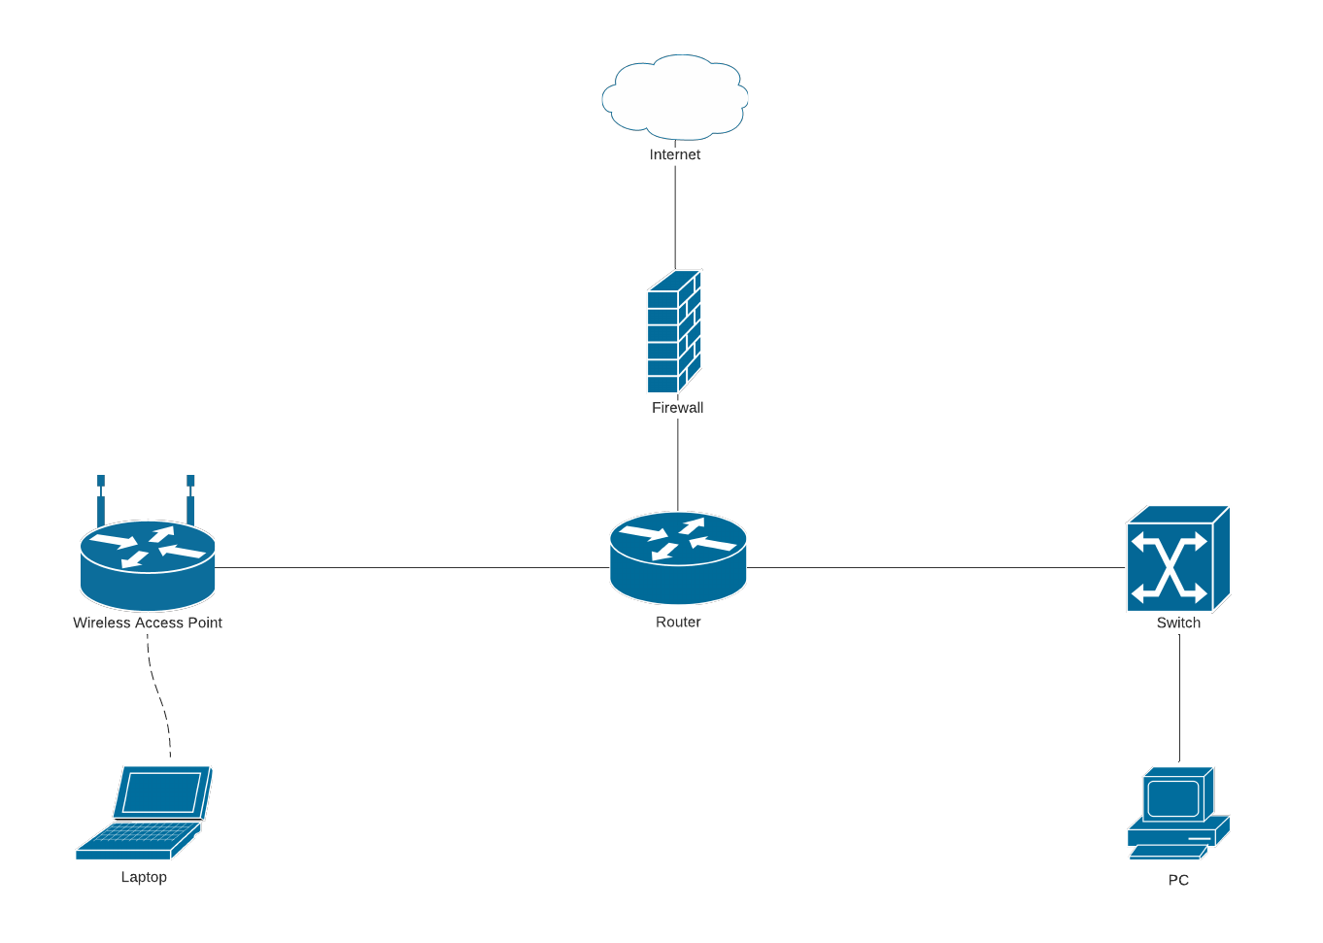

Figure 2: Basic Network Infrastructure (Network diagram templates and examples, 2022).

While basic network architecture (figure 2) can provide a framework for communication, resource sharing, and centralized management, it can also have significant security vulnerabilities. These vulnerabilities can make it easier for malicious actors to gain unauthorized access to the network, steal sensitive data, and launch attacks on connected devices.

A typical basic network infrastructure consists of several components that work in unison to facilitate communication and resource sharing among devices. Network devices, such as ***routers***, ***switches***, and ***firewalls***, play a critical role in connecting and securing various devices within the network. End devices, including ***computers***, ***laptops****,* ***smartphones***, ***printers***, and other equipment, are the primary points of user interaction and connect to the network to access and share resources.

In addition to these devices, cabling is an essential component of network infrastructure, enabling data transmission between devices on the network through ***wired*** *(****Ethernet****)* or ***wireless*** *(****Wi-Fi****)* connections. Network protocols, such as ***TCP/IP*** and ***HTTP***, serve as the foundation for communication and information exchange across the network by providing a set of rules and standards that govern device interactions. Furthermore, infrastructure services like ***Domain******Name******System*** *(****DNS****)* and ***Dynamic******Host******Configuration******Protocol*** *(****DHCP****)* play a crucial role in managing the network. They are responsible for assigning IP addresses to devices, resolving domain names to IP addresses, and ensuring the efficient routing of data packets across the network, thus contributing to the overall stability and performance of the network infrastructure.

#### **Types of Networks:**

There are several types of networks, including LAN (Local Area Network), WAN (Wide Area Network), MAN (Metropolitan Area Network), WLAN (Wireless Local Area Network), and VPN (Virtual Private Network). Each of these networks has its unique characteristics and uses, and organizations can choose the type that best suits their needs.

* ***Local Area Network (LAN):***

A LAN is a network that connects devices within a limited geographical area such as a building, office, or campus. LANs typically use Ethernet cables, Wi-Fi, or a combination of both to connect computers, servers, printers, and other devices. The purpose of a LAN is to enable data sharing, resource sharing, and communication among devices in the network. LANs are commonly used in small to medium-sized businesses, schools, and homes (Bourgeois, 2016).

* ***Wide Area Network (WAN):***

A WAN is a network that spans a large geographical area and connects multiple LANs or other networks. WANs can be used to connect computers and devices in different cities, states, or countries. WANs typically use leased lines, satellite links, or the internet to connect remote networks. WANs are used by large organizations, corporations, and government agencies to connect their regional or global offices (Bourgeois, 2016).

* ***Metropolitan Area Network (MAN)****:*

A MAN is a network that covers a metropolitan area such as a city or a town. A MAN is typically larger than a LAN but smaller than a WAN. MANs are used to connect different LANs in a city or to provide high-speed internet access to businesses and organizations in a metropolitan area (Bourgeois, 2016).

* ***Wireless Local Area Network (WLAN)****:*

A WLAN is a type of LAN that uses wireless communication to connect devices. WLANs are typically used in environments where it is difficult or impractical to use cables, such as in a coffee shop, airport, or hotel. WLANs use Wi-Fi technology to enable devices to connect to the network wirelessly (Bourgeois, 2016).

* ***Virtual Private Network (VPN)****:*

A VPN is a secure network that uses the internet to connect remote users or networks to a private network. VPNs are commonly used by businesses and organizations to provide secure access to their network resources from remote locations or to connect multiple offices or data centers securely. VPNs use encryption and other security measures to protect the privacy and confidentiality of data transmitted over the network (Bourgeois, 2016).

#### **Functions of Networks:**

The following are the main functions of a network architecture:

***Communication*:** One of the primary functions of a network is to enable devices to communicate with each other. Networks provide a platform for users to share data, files, and other resources such as printers, scanners, and storage devices. By enabling communication between devices, networks allow users to collaborate and work together more efficiently. For example, team members can share files, send messages, and work on documents in real-time using a network ( Busch, 2022) (IBM, What is networking?, 2023).

***Resource sharing***: Another important function of networks is resource sharing. Networks allow users to share resources such as printers, scanners, and storage devices. This helps to reduce the cost of hardware and software for organizations as they can purchase a limited number of devices and share them across the network. Resource sharing also increases the efficiency of the network as users can access the resources they need without having to purchase them individually. For example, multiple users can share a printer connected to a network, eliminating the need for each user to have their own printer ( Busch, 2022) (IBM, What is networking?, 2023).

***Centralized management***: Networks can be managed centrally, making it easier to monitor and control access to resources. Centralized management allows administrators to control access to resources, limit bandwidth usage, and monitor network activity. This helps to ensure that network resources are used efficiently and that security protocols are followed. Centralized management also makes it easier to troubleshoot network issues and ensure that the network is running smoothly (IBM, What is networking?, 2023).

***Remote access***: Networks allow users to access resources and applications remotely, providing flexibility and mobility. This is especially important in today's world, where many organizations have employees working from home or remote locations. Remote access enables users to access resources and applications from anywhere with an internet connection. This provides flexibility and mobility, allowing users to work from home, on the go, or from a different office location. Remote access also reduces the need for physical office space and can help to reduce costs for organizations. For example, employees can access their work email, files, and applications from their home computer using a VPN connection to the organization's network (IBM, What is networking?, 2023).

Basic network architecture is an essential element of modern computing infrastructure. It provides the framework for communication, resource sharing, and centralized management, enabling organizations to operate efficiently and effectively. Understanding the different types of networks, their components, and their functions is crucial for designing and implementing a network architecture that meets the organization's needs.

#### **How secure is a basic network infrastructure?**

While basic network architecture can provide a framework for communication, resource sharing, and centralized management, it can also have significant security vulnerabilities. These vulnerabilities can make it easier for malicious actors to gain unauthorized access to the network, steal sensitive data, and launch attacks on connected devices. One of the most significant security vulnerabilities in basic network architecture is the lack of encryption. Data transmitted over the network is often sent in plaintext, making it vulnerable to interception and eavesdropping. Without encryption, sensitive information such as passwords, credit card numbers, and personal information can be easily stolen (Abdel Hakee, Hussein, & Kim, 2022).

Another security vulnerability in basic network architecture is the lack of access controls. In many cases, users have unrestricted access to network resources, making it easier for them to compromise security accidentally or intentionally. Without proper access controls, attackers can gain unauthorized access to sensitive data and resources. Basic network architecture also tends to lack adequate security monitoring and detection mechanisms. Without these mechanisms, it is difficult to detect and respond to security breaches in a timely manner. This can give attackers more time to exploit vulnerabilities and cause more damage ( Firch, 2023).

Finally, basic network architecture can be vulnerable to attacks such as denial-of-service (DoS) attacks, in which attackers flood the network with traffic, causing it to crash. These attacks can disrupt network services and cause significant damage to the organization (Fadzline, 2019).

Overall, while basic network architecture can provide a framework for communication and resource sharing, it is important to address the security vulnerabilities that come with it. Organizations should implement security best practices such as encryption, access controls, security monitoring, and intrusion detection to protect their networks and sensitive data. Additionally, they should stay informed about the latest security threats and vulnerabilities and take proactive measures to address them.

***Lack of network segmentation***: Network segmentation involves dividing a large network into smaller subnets to limit the spread of malicious traffic. When a network is not segmented, it is easier for attackers to move around undetected, compromising the entire network. For example, if a hacker gains access to one device on an unsegmented network, they can potentially move laterally to gain access to other devices and sensitive data. Segmentation can help prevent this by isolating different parts of the network and limiting the spread of threats (Landsberger, 2020) (Cociorba, 2016).

***Weak passwords*:** Weak passwords make it easy for attackers to gain access to the network. This is particularly dangerous if privileged accounts such as administrator accounts have weak passwords. Attackers can use brute force attacks or password cracking tools to guess or crack weak passwords. To prevent this, it is important to use strong passwords, enforce password policies that require complex passwords, and implement two-factor authentication wherever possible (Rosenberg, 2017).

***Lack of network monitoring***: Without network monitoring, it is difficult to detect and respond to security threats in real-time. Network monitoring involves using tools such as IDS and SIEM systems to monitor the network for suspicious activity. These tools can help detect anomalies and unusual patterns of behavior, indicating a potential security threat. Network monitoring can also help identify and respond to security incidents quickly, minimizing the impact of a security breach (IBM, 2022).

***Lack of patch management***: Software vulnerabilities are often exploited by attackers to gain access to a network. To address this, software vendors release security patches and updates to fix vulnerabilities. However, failing to apply patches in a timely manner leaves the network vulnerable to known security vulnerabilities. It is important to have a patch management process in place that ensures software updates and patches are applied promptly (RAPID7, 2023).

The security of a basic network infrastructure can be compromised due to several factors, such as lack of network segmentation, weak passwords, lack of network monitoring, and lack of patch management.

#### **Threats to A Basic Network in Depth**

Basic network architecture can be vulnerable to a wide range of security risks, which can compromise the confidentiality, integrity, and availability of network resources and data. In this section, we will discuss some of the specific security risks that threaten basic network architecture.

***Malware:*** Malware is one of the most common security risks that threaten basic network architecture. Malware is software that is designed to disrupt, damage, or gain unauthorized access to a network or device. Malware can be delivered through email attachments, malicious websites, or infected software. Once installed, malware can steal sensitive data, damage files, and compromise network security (Cociorba, 2016) (IBM, 2022) (Comptia, 2023).

***Phishing attacks***: Phishing attacks are another common security risk that threaten basic network architecture. Phishing attacks are social engineering attacks in which attackers use fake emails or websites to trick users into providing sensitive information such as usernames and passwords. Once attackers have this information, they can use it to gain unauthorized access to the network and sensitive data (IBM, What is networking?, 2023) (Comptia, 2023).

***Insider threats***: Insider threats are a significant security risk for basic network architecture. Insider threats occur when employees or contractors with access to the network misuse or steal sensitive data. This can include accessing sensitive data without authorization, sharing sensitive data with unauthorized parties, or intentionally deleting or modifying data (Comptia, 2023).

***Network eavesdropping***: Network eavesdropping is a security risk that occurs when attackers intercept and monitor network traffic. Eavesdropping can allow attackers to gain access to sensitive information such as login credentials, credit card numbers, and personal information (Wan, 2021).

***Distributed Denial of Service (DDoS) attacks***: DDoS attacks are a type of security risk that can disrupt network services and cause significant damage to the organization. In DDoS attacks, attackers flood the network with traffic, causing it to crash or become unavailable. DDoS attacks can prevent legitimate users from accessing network resources and can cause significant downtime and revenue loss (Cloudflare, 2023).

It is obvious that basic network architecture is vulnerable to a wide range of security risks. To mitigate these risks, organizations must implement security best practices such as malware protection, phishing awareness training, access controls, and encryption. Additionally, organizations should conduct regular security assessments and stay informed about the latest security threats and vulnerabilities.

### Typical Network Architecture of SMEs.

#### **Introduction**

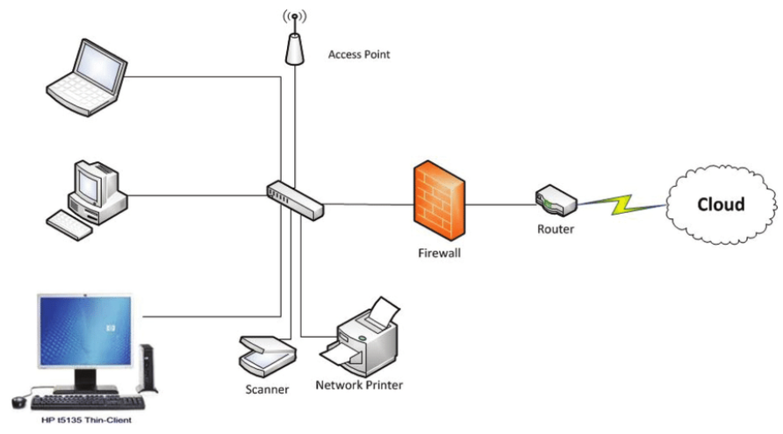

Figure 3: Basic network architecture of an SME (Aljawarneh, 2011).

The architecture of a small business network (figure 3) is often more intricate than that of basic networks, owing to the specific requirements and unique needs of the organization. One contributing factor to this complexity is the increased number of devices typically found in small businesses. These networks often need to accommodate various devices, such as computers, printers, scanners, phones, security cameras, and more. Additionally, organizations with multiple locations may require more sophisticated network architecture to securely connect different sites and facilitate resource sharing across the network. Specialized applications or software utilized by small businesses can further complicate network architecture, as they may necessitate particular configurations and network settings. Security requirements also play a significant role in the complexity of small business network architecture. Compliance with industry regulations or the need to protect sensitive customer data can demand the implementation of advanced security measures, such as firewalls, intrusion detection and prevention systems, and granular access controls. Furthermore, the growing prevalence of cyber threats targeting small businesses makes robust network security even more essential. Finally, scalability is a critical consideration when designing network architecture for small businesses. As these organizations grow and expand, their networks must be able to accommodate increased demands and additional devices without compromising performance or security. In conclusion, the elevated complexity of small business network architecture calls for advanced network design and configuration to ensure secure, reliable, and efficient business operations (JuniperNetworks, 2021).

#### **Security of Typical SME Network**

Small business network architecture is often susceptible to security risks due to several factors, which can severely impact operations, reputation, and finances. The following reasons contribute to the lack of security in small business network architecture:

* ***Limited IT resources:*** small businesses often have limited staff and budget for IT, making robust security implementation challenging (nces.gov, 2023).
* ***BYOD policies:*** Allowing employees to use their own devices for accessing company networks can introduce security risks if the devices are not properly secured or monitored (FCC, 2023).
* ***Third-party vendors:*** Working with third-party vendors for services such as cloud storage or web hosting can pose security risks if the vendors' security measures are inadequate (Todd & M. Rahman, 2022).
* ***Lack of awareness:*** Small businesses may be unaware of the latest security threats and necessary mitigation strategies, making them more vulnerable to attacks (FCC, 2023).
* ***Inadequate security policies:*** A lack of well-defined security policies or procedures can leave businesses vulnerable to insider threats and attacks that exploit human error or negligence (Kaspersky, 2023).
* ***Limited security expertise:*** Small businesses might lack the in-house expertise to identify and address security risks or respond to incidents effectively (Clifton & David, 2013).
* ***Legacy systems:*** Using outdated systems or software can introduce vulnerabilities that attackers can exploit to gain access to the network (CertNZ, 2023).

In conclusion, small businesses must proactively address security vulnerabilities by implementing strong security policies, regularly updating software and systems, investing in modern security solutions, and training employees in cybersecurity best practices. Implementing regular security assessments and access controls can help businesses stay ahead of potential threats and maintain secure networks. Overall, it is crucial for small businesses to be aware of these risks and take the necessary steps to implement robust security measures to protect their networks and assets.

### Addressing Cyber Threats to Malaysian SMEs

This section discusses various cyber threats specific to SMEs in Malaysia, including Business Email Compromise and insider threats, among others. The following is an in-depth analysis of each cyber threat and its potential impact on SMEs.

#### **Ransomware Crisis in Malaysia**

The impact of ransomware attacks on Malaysian SMEs can be severe, including financial loss from paying the ransom, the cost of recovering from the attack, lost productivity, damage to the organization's reputation, and potential legal consequences if sensitive customer data is compromised.

The ransomware crisis in Malaysia has become increasingly concerning in recent years, with a significant number of organizations falling victim to cyberattacks. In 2022, ransomware attacks in Malaysia rose 16% year-on-year, with a total of 555 million attacks blocked, according to cybersecurity firm Trend Micro Inc. The number of detected malware surged by 71% in 2022 to over 50 million. These growing issues have resulted in potentially severe economic consequences, with the Malaysia Cyber Security Strategy 2020-2024 report estimating that cyberthreats could lead to economic losses of up to RM51 billion (Trend Micro, 2021) (Murugiah, 2023).

The increase in cybercrime incidents has been particularly evident in the financial sector. As cited in an article by The Edge Markets, Sophos found that 52% of financial services organizations paid ransoms to restore their data, which is higher than the global average across all industries at 46%. However, paying the ransom does not guarantee the complete recovery of the encrypted data, with only 10% of those who paid retrieving all their data (Murugiah, 2023).

MyCERT, the Malaysia Computer Emergency Response Team, reported that there were 648 cases of malicious code attacks (including ransomware) in 2021 and 593 cases in 2020. These attacks have targeted various industries, with the government, healthcare, and manufacturing sectors experiencing the most ransomware incidents. An 86% increase in backdoor malware detections reveals threat actors trying to maintain their presence inside networks for future attacks (ConditionZebra, 2022).

Some notable examples of ransomware attacks in Malaysia include:

Maybank, which advised its customers to refer to MyCERT's advisory about a fraud campaign called SMSSpy, involving Android malware used to steal victims' online banking credentials (Yeoh, 2022).

iPay88, one of the largest online payment providers in Malaysia, suffered a cybersecurity breach in which consumer credit card data may have been compromised (Tay, 222).

The rising number of ransomware attacks in Malaysia highlights the urgent need for stronger cybersecurity defenses and increased awareness among organizations and individuals. Trend Micro Malaysia's managing director, Goh Chee Hoh, emphasizes that to manage risk effectively across a rapidly expanding attack surface, stretched security teams need a more streamlined, platform-based approach (Murugiah S. , 2022).

#### **What Is Ransomware?**

Ransomware is a form of malicious software that encrypts a victim's files, rendering them inaccessible until a ransom is paid, usually in the form of cryptocurrencies like Bitcoin. Ransomware attacks have become a significant concern for organizations worldwide, including SMEs in Malaysia. In recent years, ransomware attacks have grown in sophistication and frequency. Attackers employ various techniques, such as phishing emails, exploiting software vulnerabilities, and utilizing malicious websites to deliver ransomware payloads. Once inside a system, the ransomware encrypts critical data, such as documents, databases, and other essential files, effectively paralyzing the business operations (CISA.GOV, 2023).

There are two main types of ransomware: crypto ransomware and locker ransomware. Both types share the ultimate goal of extorting money from victims by restricting access to their data or devices. Understanding the anatomy of these ransomware types can help organizations and individuals develop effective strategies for prevention, mitigation, and response (Kaspersky, 2022).

###### *2.2.3.2.1ACrypto Ransomware*

These are designed to encrypt a victim's files and data, rendering them inaccessible until a ransom is paid. At an anatomical level, crypto ransomware typically follows these steps (figure 4):

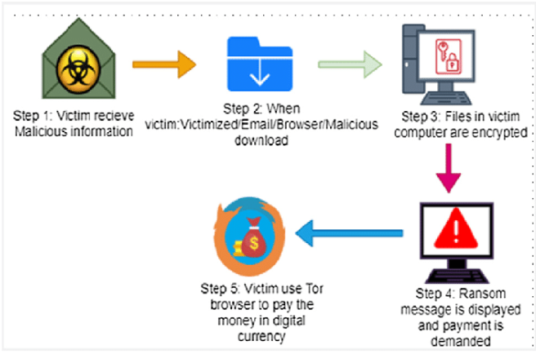

Figure 4: Stages of Crypto Ransomware (Humayun, Zaman, Alsayat, & Ponnusamy, 2020).

1. Infiltration: The ransomware enters the victim's system through various methods such as phishing emails, malicious downloads, or exploiting software vulnerabilities.
2. Execution: Once inside the system, the ransomware starts executing its payload, which includes locating and identifying target files for encryption. It may target specific file types or directories to maximize the impact on the victim.
3. Encryption: The ransomware employs strong encryption algorithms, such as AES, RSA, or a combination of both, to encrypt the victim's files. The encryption process generates a unique decryption key, which is retained by the attacker and only provided to the victim upon payment of the ransom.
4. Ransom demand: After encrypting the files, the ransomware displays a ransom note to the victim, which typically includes instructions for payment (usually in cryptocurrency) and a deadline for complying with the demand.
5. Decryption (optional): If the victim pays the ransom, the attacker may provide the decryption key to unlock the files. However, there is no guarantee that the attacker will honor this agreement, and in some cases, the decryption process may not be successful.

(Mccutchen, 2021)

*2.2.3.2.1B Locker Ransomware*

Locker Ransomware is designed to lock the victim out of their device by restricting access to the operating system and applications. At an anatomical level, locker ransomware operates as follows (figure 5):

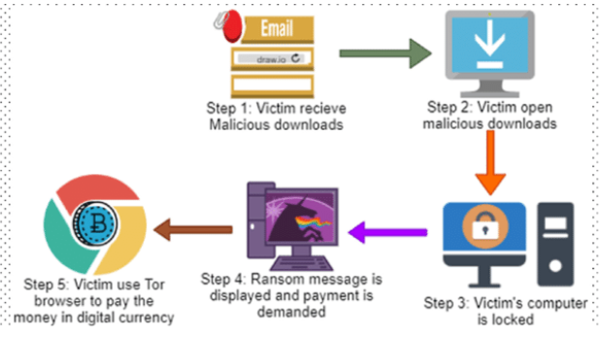

Figure 5: Stages of Locker Ransomware (Humayun, Zaman, Alsayat, & Ponnusamy, 2020).

1. Infiltration: Similar to crypto ransomware, locker ransomware gains entry to the victim's system through phishing emails, malicious downloads, or by exploiting software vulnerabilities.
2. Execution: Once inside the system, the locker ransomware modifies system settings, such as altering the boot sequence or changing the login process, to prevent the victim from accessing their device.
3. Lock screen display: The ransomware displays a lock screen, which often impersonates law enforcement or government agencies and accuses the victim of illegal activities. The screen may also include a countdown timer to add urgency to the ransom demand.
4. Ransom demand: The lock screen typically includes instructions for payment (usually in cryptocurrency) and a deadline for complying with the demand.
5. Unlocking (optional): If the victim pays the ransom, the attacker may provide a code or unlock tool to regain access to the device. However, as with crypto ransomware, there is no guarantee that the attacker will honor this agreement.

(Mccutchen, 2021)

#### **Phishing Surge in Malaysia**

Phishing attacks in Malaysia have been on the rise, posing a significant threat to businesses and individuals, particularly in the financial and e-commerce sectors. According to Business Today, Kaspersky detected a total of 195,032 payment system-related phishing activities in Malaysia in the first two quarters of 2022, with 108,755 in quarter one and 86,277 in quarter two. Furthermore, from 2020 till May 2022, a total of 48,850 online frauds were reported in Malaysia, accounting for 68% of the total 71,833 commercial crime cases reported ( Ignatius, 2022).

The increasing digitalization of financial transactions in Malaysia has made the country more vulnerable to cyberattacks. Kaspersky's anti-phishing system blocked a total of 12,127,692 malicious links in South-East Asia from January to June 2022, one million more than the 11,260,643 detected over the same period the previous year (Liew, Gan, & Lee, 2023). In the first six months of 2022, Kaspersky products detected and blocked 27,458 bank-related phishing attacks and 91,895 of the same type targeting e-commerce shops in Malaysia, according to Business Today ( Ignatius, 2022). Additionally, the New Straits Times reports that in March 2022, 41.09% of phishing attempts in Malaysia were related to payment systems, the highest detection of this threat during that period. In February 2022, 52.43% of phishing attempts in Malaysia were related to banking, payment systems, and online shopping (NewStraitsTimes, 2022).

Malaysian SMEs, which have increasingly adopted digital technologies, are particularly vulnerable to phishing attacks due to potential inadequacies in cybersecurity measures. As a result, it is crucial for Malaysian SMEs to prioritize cybersecurity and invest in adequate measures to protect themselves from the financial and reputational damage that these attacks can cause.

#### **Understanding Phishing Attacks**

**Phishing attacks** are a common method employed by cybercriminals to trick individuals into revealing sensitive information, often by impersonating trustworthy entities (TrendMicro, 2023). These attacks can have severe consequences, especially for SMEs in Malaysia, where awareness and employee training may be lacking. To better understand phishing attacks, let's examine different types and their anatomy.

*2.2.3.4.1A Email phishing:*

Email phishing is the most common type of phishing attack. The attacker sends a deceptive email to a large number of potential victims, often impersonating a well-known organization such as a bank or a popular online service (TrendMicro, 2023) (figure 6).

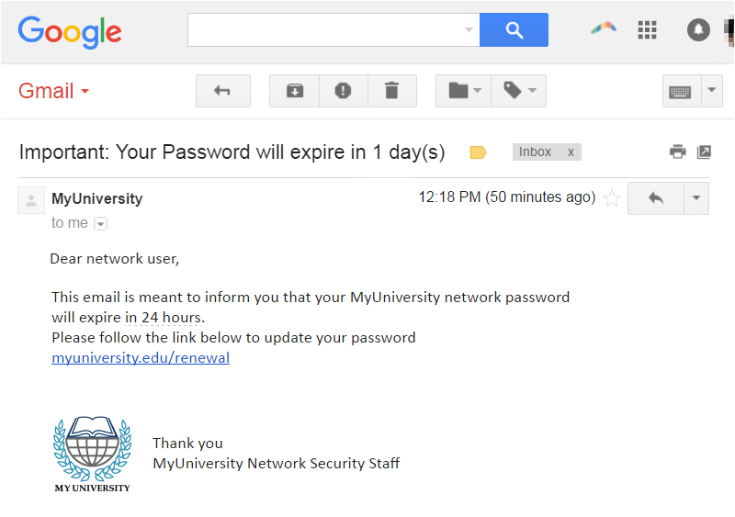

Figure 6: Email Phishing attempt (Imperva, 2023).

Anatomy of email phishing:

1. Crafting the email: The attacker creates a convincing email, often using the branding, logos, and language of the impersonated organization. The email typically contains a sense of urgency, prompting the victim to act quickly.
2. Including a malicious link or attachment: The email contains a link to a fake website designed to capture the victim's credentials or an attachment that, once opened, installs malware on the victim's device.
3. Mass distribution: The attacker sends the phishing email to numerous recipients, hoping that some will fall for the scam and provide the requested information or inadvertently download malware.

(GreatHorn, 2021)

*2.2.3.4.1B Spear phishing:*

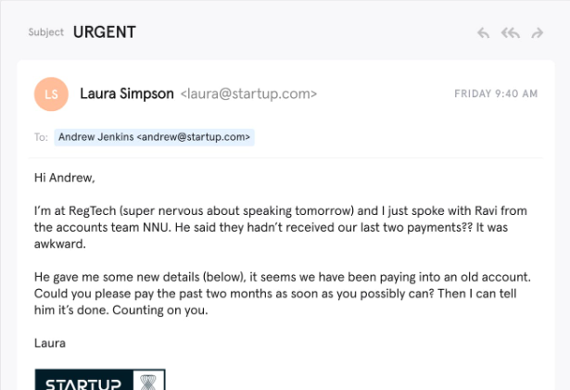

Figure 7: Spear Phishing Attempt ( Nhat, 2019).

Spear phishing is a more targeted form of phishing attack (figure 7), where the attacker focuses on a specific individual or organization. The attacker gathers information about the target to create a highly personalized and convincing phishing email (TrendMicro, 2023).

Anatomy of spear phishing:

1. Target research: The attacker researches the target, gathering information from social media, company websites, or other public sources to create a convincing pretext for the phishing email.
2. Crafting the email: The attacker crafts a personalized email, often mimicking the writing style or communication patterns of a known contact of the target. The email may reference specific events, projects, or people to gain the target's trust.
3. Including a malicious link or attachment: As with email phishing, the spear phishing email contains a link to a fake website or a malicious attachment designed to steal the victim's sensitive information or install malware on their device.

(Allodi, 2019) (Woods, 2023)

*2.2.3.4.1C Whaling:*

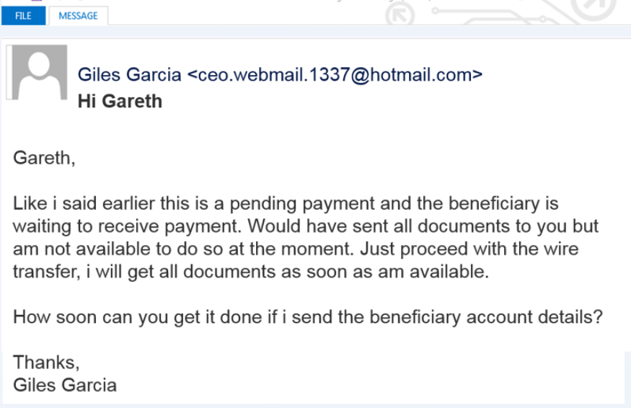

Figure 8: Whaling Attempt ( Nhat, 2019)

Whaling is a highly targeted form of phishing that focuses on high-level executives or other key individuals within an organization (figure 8). The goal is often to gain access to sensitive company information or to trick the target into authorizing fraudulent financial transactions (TrendMicro, 2023).

Anatomy of whaling:

1. Target research: As with spear phishing, the attacker researches the target, often gathering information about the target's role, responsibilities, and communication patterns.
2. Crafting the email: The attacker creates a highly convincing email, often impersonating a high-ranking executive or another person of authority within the organization. The email may contain specific details about ongoing projects or financial matters.
3. Including a malicious link or attachment: The whaling email typically contains a link to a fake website, or a malicious attachment designed to steal the target's sensitive information or install malware on their device.

(ncsc.gov, 2023)

SMEs in Malaysia may be particularly vulnerable to phishing attacks due to a lack of awareness about the risks and inadequate employee training on cybersecurity best practices. To protect against phishing attacks, it is essential to educate employees about the importance of scrutinizing emails, verifying the sender's identity, and never clicking on suspicious links or opening unexpected attachments.

#### **Rising Sophistication of Business Email Compromise Attacks**

Small and medium-sized enterprises (SMEs) in Malaysia are increasingly vulnerable to Business Email Compromise (BEC) attacks. Due to their size, SMEs often lack the resources and expertise to implement robust cybersecurity measures, making them an attractive target for cybercriminals.

In 2021, Kaspersky's Anti-Phishing system blocked a significant number of phishing links in Southeast Asia (SEA), with a considerable portion of them targeting users in Malaysia (RiseMalaysia, 2022). Since 2016, Malaysia alone recorded more than 8,000 cases of BEC scams, cybercrimes, and ransomware (Ragent, 2023). The last quarter of 2021 saw Kaspersky products preventing over 8,000 BEC attacks, with the highest number (5,037) occurring in October (RiseMalaysia, 2022). Another source reports that Kaspersky products prevented over 80,000 BEC attacks in the same quarter, with 50,037 attacks taking place in October (Farah, 2022). The discrepancy in the number of attacks could be due to different data sets or reporting methodologies.

While Trend Micro's report indicated that BEC detections fell by 11%. It also highlighted an 83% increase in BEC threats detected using its AI-powered writing style analysis feature, suggesting that BEC scams are becoming more sophisticated (sme.asia, 2022).

The increasing sophistication of BEC scams poses an even greater challenge for SMEs in Malaysia. These advanced scams can be harder to detect and can lead to significant financial losses, reputational damage, and operational disruptions for SMEs.

#### **Anatomy of Business Email Compromise**

Business Email Compromise (BEC) is a type of targeted cyberattack where the attacker impersonates an executive or employee within an organization or a trusted partner to deceive the recipient into taking specific actions, such as transferring funds or disclosing sensitive information (fbi.gov, 2023). Understanding the anatomy of a BEC attack can help organizations better defend against them. The typical stages of a BEC attack are as follows (figure 9):

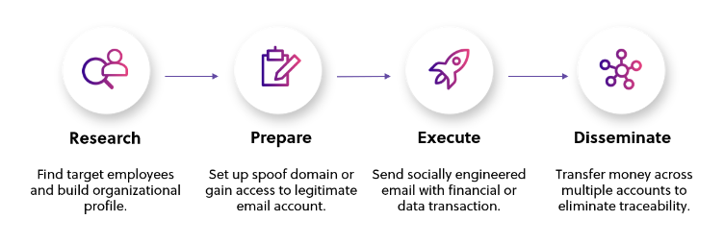

Figure 9: Stages of a Business Email Compromise attack (Amaniemedia, 2022).

1. Reconnaissance: In the initial stage, cybercriminals gather information about the targeted organization, its employees, and key executives. They may research the company's structure, financials, and ongoing projects. Social media platforms and corporate websites can provide valuable information that helps attackers select potential targets and craft convincing spear-phishing emails.
2. Social engineering and spear-phishing: After identifying their targets, attackers craft personalized spear-phishing emails that appear to come from a trusted source, such as an executive, colleague, or partner. These emails often contain a sense of urgency, making the recipient feel pressured to take action quickly. The email may request an urgent wire transfer, sensitive information disclosure, or access to company systems.
3. Infiltration: In some cases, BEC attacks may involve compromising an employee's email account to gain access to their contacts and correspondence. Attackers can use stolen credentials obtained through phishing or other means to infiltrate the target's email system. Once inside, they can monitor email traffic, gather information, and identify additional targets within the organization.
4. Impersonation and manipulation: With access to an employee's email account or by creating a spoofed email address, attackers impersonate the employee, executive, or partner to manipulate recipients. They may send email requests for money transfers, change bank account details for invoices, or request sensitive data.
5. Execution: The recipient, believing the request is legitimate, complies with the attacker's demands. This may involve transferring funds to a designated bank account, providing sensitive information, or granting access to internal systems.
6. Exfiltration and monetization: The attacker collects the transferred funds or sensitive information and either uses it for their own gain or sells it on the dark web. In the case of stolen funds, the attacker often moves the money through a series of accounts to make it more challenging to trace and recover.
7. Covering tracks: Once the attacker achieves their goal, they may delete incriminating emails or other traces of their activities to avoid detection and prolong their access to the compromised accounts.

(fbi.gov, 2023)

#### **Malware Trends in Malaysia**

Based on the cyberthreat statistics provided by MyCERT (Malaysia Computer Emergency Response Team) for the years 2020 to 2023, it is evident that malware infections, specifically those categorized as "Malicious Codes," have had a significant impact on the cybersecurity landscape in Malaysia. This growing concern for malware-related cyberthreats is particularly relevant for Small and Medium-sized Enterprises (SMEs) in Malaysia, as these organizations often have limited resources and capabilities to effectively combat such threats (MyCert, 2023).

The total number of Malicious Codes incidents detected in each year are represented in the following bar chart (figure 10).

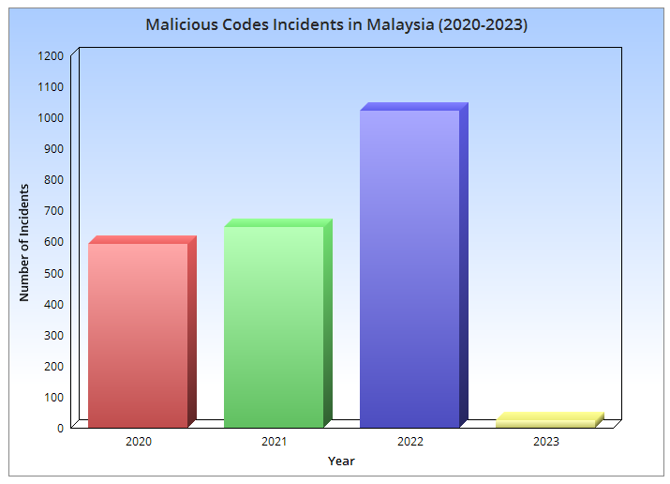

Figure 10: Bar chart representing the year and number of incidents. Data from MyCERT.

The upward trend in the number of incidents from 2020 to 2022, with a substantial increase from 648 incidents in 2021 to 1,023 incidents in 2022, highlights the heightened risk faced by SMEs in Malaysia. These businesses are especially vulnerable to malware attacks due to factors such as inadequate cybersecurity infrastructure, lack of trained personnel, and limited budgets for cybersecurity measures (MyCert, 2023).

Ransomware, a type of malware that encrypts a victim's data and demands a ransom payment for decryption, has been identified as the most common malware attack in Malaysia. SMEs are often prime targets for ransomware attacks because they may not have robust cybersecurity measures in place, making it easier for cybercriminals to infiltrate their systems. Additionally, SMEs may be more likely to pay the ransom, as they may not have the resources or expertise to recover from an attack without the decryption key (NewStraitsTimes, #TECH: Every 1 in 2 phishing attempts in Malaysia finance-related, 2022).

#### **Understanding Malware**

Malware, or malicious software, is a term used to describe various types of harmful software designed to infiltrate, damage, or extract information from a computer system without the user's consent (Cisco, 2023). At an anatomical level, malware can be broadly classified into several categories, each with its own unique characteristics and techniques to compromise systems. Below, we explore some of the most common types of malware and their inner workings:

*2.2.3.8.1A Viruses:* A computer virus is a type of malware that attaches itself to a host program or file, enabling it to spread from one system to another. When the host file is executed, the virus activates and can replicate itself, infecting other files in the process (Kaspersky, Malware & Computer Virus Facts & FAQs, 2023). Some well-known examples of viruses include the ILOVEYOU virus, which spread through email attachments and caused widespread damage in 2000 ( Root, 2022), and the Melissa virus, which also spread via email and infected thousands of computers in 1999 (fbi.gov, The Melissa Virus, 2019). Viruses can cause a range of harmful effects, such as data corruption, system crashes, or unauthorized access to sensitive information. The potentially devastating consequences of a virus infection highlight the importance of robust cybersecurity measures to protect systems and data from these malicious threats (Kaspersky, Malware & Computer Virus Facts & FAQs, 2023).

*2.2.3.8.1B Worms:* Worms are self-replicating malware that can spread independently of a host file (Cisco, What Is a Worm?, 2023). They exploit vulnerabilities in a system or network to propagate without any user interaction. Notable examples of worms include the Conficker worm, which targeted Windows operating systems in 2008 and infected millions of computers, and the Code Red worm, which spread rapidly in 2001 by exploiting a vulnerability in Microsoft's IIS web server software (Seungwon, Guofei , Reddy, & Lee, 2012). Worms can consume system resources, slow down networks, and create backdoors for other malware to enter the system.

*2.2.3.8.1C Trojans*: Named after the mythological Trojan horse, these types of malware disguise themselves as seemingly legitimate software to trick users into downloading or executing them (Kaspersky, Ransomware Attacks and Types – How Encryption Trojans Differ, 2023). Examples of notorious Trojans include Emotet, which started as a banking Trojan and evolved into a malware distribution platform, and Zeus, a highly effective Trojan that has been used to steal banking credentials and carry out various cybercrimes ( Grammatikakis, Koufos, Kolokotronis, & Vassilakis, 2021). Once activated, Trojans can provide unauthorized access to an attacker, steal sensitive information, or install additional malware onto the system. The deceptive nature of Trojans highlights the importance of user vigilance in avoiding suspicious downloads and employing robust security measures, such as antivirus software and firewalls, to protect against these insidious threats.

*2.2.3.8.1D Spyware*: Spyware is a type of malware that covertly monitors a user's activities and gathers sensitive information, such as login credentials, financial data, or browsing habits. Examples of well-known spyware include keyloggers like Ardamax, which records users' keystrokes to capture passwords and other sensitive data (Microsoft Security Intelligence, 2008), and adware like CoolWebSearch, which hijacks users' web browsers to display unwanted advertisements and collect browsing data (Microsoft Security Intelligenec, 2008). Spyware can be installed via malicious downloads, phishing emails, or even legitimate-looking software updates. The gathered data is often transmitted back to the attacker for use in identity theft, fraud, or other malicious activities.

*2.2.3.8.1E Ransomware:* Ransomware is a type of malware that encrypts a victim's files, making them inaccessible until a ransom is paid to the attacker in exchange for the decryption key. Notable examples of ransomware include WannaCry, which exploited a Windows vulnerability to infect hundreds of thousands of computers worldwide, and CryptoLocker, which pioneered the use of encryption to hold files hostage (Zhang, Zhou, & Chain , 2015). Ransomware often spreads through phishing emails, malicious downloads, or software vulnerabilities. It targets both individuals and organizations, with a particular focus on those that may be more likely to pay the ransom, such as businesses or government agencies ( Shah, Shah, & Shah , 2017).

*2.2.3.8.1F Adware:* Adware is a form of malware that generates unwanted advertisements on a user's device, often manifesting as pop-ups, banners, or redirects to malicious websites (Kaspersky, What is Adware? – Definition and Explanation, 2023). Examples of adware include Gator, which was bundled with free software and displayed targeted ads based on users' browsing habits (F-Secure, Adware:W32/Gator, 2023), and CoolWebSearch, which hijacked users' web browsers and redirected them to unwanted websites (Microsoft, 2008). Adware can be bundled with free software or installed through deceptive download links. Although adware may not always be as harmful as other types of malware, it can still degrade system performance, consume bandwidth, and compromise user privacy by tracking browsing habits and collecting personal information. To protect against adware, users should exercise caution when downloading free software, avoid clicking on suspicious links, and utilize security software with ad-blocking and anti-malware features (Kaspersky, What is Adware? – Definition and Explanation, 2023).

*2.2.3.8.1G Rootkits:* Rootkits are a type of stealthy malware that infiltrate deep into a system's core components, such as the operating system or firmware, to conceal their presence and evade detection (Kaspersky, What is Rootkit – Definition and Explanation, 2023). Examples of notorious rootkits include the Sony BMG rootkit, which was embedded in music CDs and installed itself on users' computers to prevent illegal copying (Mulligan & Perzanowski, 2008), and the Stuxnet rootkit, a highly sophisticated cyberweapon that targeted Iran's nuclear facilities by exploiting vulnerabilities in the Windows operating system (Knapp & Langill, 2014). Once installed, rootkits can provide an attacker with full control over the compromised system, enabling them to execute malicious commands, exfiltrate sensitive data, or manipulate system functions. Rootkits are particularly dangerous due to their stealthy nature and ability to bypass traditional security measures. To protect against rootkits, users should keep their operating systems and security software up to date, avoid downloading software from untrusted sources, and employ security solutions with rootkit detection capabilities ( Beegle, 2007).

#### **Rising DDoS Attack Trends and Their Impact**

Distributed Denial-of-Service (DDoS) attacks pose a significant and evolving threat to organizations worldwide, particularly small and medium-sized enterprises (SMEs) in Malaysia. These attacks involve overwhelming a target system or network with an influx of traffic, rendering it unavailable to users (Deshmukh & Devadkar, 2015). Malaysian SMEs are particularly vulnerable due to their limited cybersecurity measures and resources. Several reports have highlighted the increasing prevalence and sophistication of DDoS attacks in Malaysia and around the globe.

According to the "NSFOCUS 2020 DDoS Attack Landscape Report," in 2020, NSFOCUS detected 152,000 DDoS attacks with a combined volume of 386,500TB, representing a year-on-year decrease of 16.16% and 19.67%, respectively (BusinessToday, NSFOCUS 2020 DDoS Attack Landscape Report Warns of New Threat Vectors, 2021). However, the "Kaspersky Quarterly DDoS Report" mentioned a new level of DDoS attacks in Q2 2022, with the average duration increasing 100 times to reach 3,000 minutes compared to the previous year (Bernama, 2022). The share of smart attacks also saw a steep increase, accounting for nearly 50% of the total attacks. In the "2022 H1 Global Threat Analysis Report" by Radware, the number of malicious DDoS attacks increased by 203% during the first six months of 2022 compared to the same period in 2021, with 60% more malicious DDoS events during the first half of 2022 than the entire year of 2021 ( Lohrmann, 2022). The "Evolution of DDoS: Return of the Hacktivists" report by FS-ISAC and Akamai Technologies revealed a 22% increase in the volume of DDoS attacks targeting financial firms in 2022, with financial services in Europe experiencing a 73% increase in attacks (FS-Isac & Akamai, 2023).

These statistics emphasize the need for Malaysian SMEs to be prepared for the evolving threat of DDoS attacks. As the country continues to digitize rapidly and adopt technologies like 5G and IoT, the threat landscape becomes more complex, and new threat vectors can be exploited by cybercriminals.

#### **Understanding DDoS**

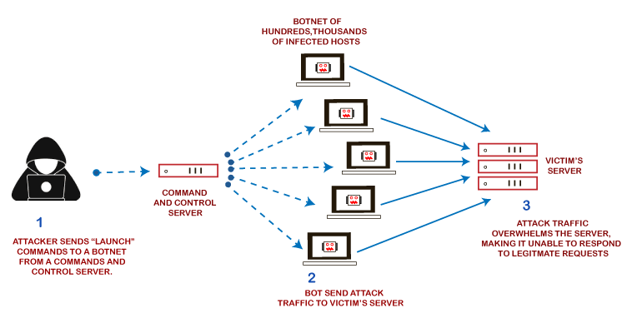

Figure 11: Simplified DDoS attack (JavaTPoint, 2023).

Distributed Denial-of-Service (DDoS) attacks can be broken down into three key components: the attacker, the attack vector, and the target. Understanding each of these elements helps to better comprehend the nature and structure of DDoS attacks (figure 11).

***The Attacker:*** The attacker is an individual or a group of individuals who initiate the DDoS attack. These attackers may have various motivations, such as political, financial, or personal reasons. They often control a network of compromised computers, known as a botnet, which can be used to launch a coordinated DDoS attack against a target (JavaTPoint, 2023).

***The Attack Vector:*** DDoS attacks can be categorized based on the type of attack vector employed (JavaTPoint, 2023). There are three primary types of DDoS attacks:

***Volume-based attacks*:** These attacks aim to consume the target's network bandwidth by generating a massive amount of traffic. The attacker overwhelms the target with data packets, making it impossible for the target to process legitimate requests. Common volume-based attacks include User Datagram Protocol (UDP) floods, Internet Control Message Protocol (ICMP) floods, and amplified reflection attacks (JavaTPoint, 2023).

***Protocol attacks*:** These attacks exploit weaknesses in the target's network protocols, exhausting server or network resources. Examples of protocol attacks include SYN floods, Ping of Death, and Smurf attacks (JavaTPoint, 2023).

***Application-layer attacks:*** These attacks target specific applications or services running on the target's servers, consuming the server's processing power and causing a disruption in service. Examples of application-layer attacks include HTTP floods, Slowloris, and DNS query floods (JavaTPoint, 2023).

***The Target:*** The target is the victim of the DDoS attack, typically an organization's website, network, or online service. The target's infrastructure is overwhelmed by the massive influx of traffic or requests, rendering it unavailable to legitimate users (JavaTPoint, 2023).

During a DDoS attack, the attacker uses the botnet to generate a flood of traffic or requests directed at the target's IP address or domain name. This flood overwhelms the target's resources, causing the target's servers or network to slow down or crash, leading to service disruption for legitimate users.

#### **Types of DDoS Attacks**

Distributed Denial-of-Service (DDoS) attacks involve overwhelming a target system or network with an influx of traffic, rendering it unavailable to users. There are various types of DDoS attacks, each exploiting different protocols and techniques to disrupt the target (Deshmukh & Devadkar, 2015). Here, we discuss five common types of DDoS attacks:

*2.2.3.11A SYN Flood Attacks:*

A SYN flood attack overwhelms a server by exploiting the TCP three-way handshake process. The attacker sends numerous SYN packets with fake IP addresses, causing the server to exhaust its resources while trying to respond with SYN-ACK packets. This prevents legitimate users from establishing connections (Zaboon, Alhammadi, & Abdullah, 2021).

*2.2.3.11B ICMP Flood Attacks:*

An ICMP (Internet Control Message Protocol) flood attack, also known as a "ping flood" or "smurf attack," targets the target system with a large volume of ICMP echo request packets (pings). The victim's system becomes overwhelmed trying to process and respond to these requests, consuming network bandwidth and resources, ultimately leading to service disruption (Zaboon, Alhammadi , & Abdullah, 2021).

*2.2.3.11C UDP Flood Attacks:*

A UDP (User Datagram Protocol) flood attack involves sending a large number of UDP packets to random ports on the target system. The victim's system attempts to process the packets by determining if any application is listening on the destination port. When no application is found, the system sends an ICMP "destination unreachable" packet back to the sender. The sheer volume of UDP packets and subsequent ICMP responses exhausts the target's resources, causing a denial of service (Zaboon, Alhammadi , & Abdullah, 2021).

*2.2.3.11D HTTP Flood Attacks:*

An HTTP flood attack targets web servers or applications by generating a high volume of HTTP requests, mimicking legitimate user traffic. The attacker may use bots or compromised devices to send GET or POST requests to the target server. As the server struggles to process the massive number of requests, its resources become depleted, and legitimate users cannot access the service (CloudFlare, 2023).

*2.2.3.11E DNS Amplification Attacks:*

A DNS (Domain Name System) amplification attack is a type of reflection attack that exploits the DNS protocol. The attacker sends a large number of DNS queries with a spoofed IP address (the target's IP) to open DNS resolvers. These resolvers respond with much larger DNS response packets sent to the target system. The amplification factor results from the size difference between the query and the response, causing a significant increase in traffic directed towards the victim (cisa.gov, 2019). The target's network becomes overwhelmed, leading to service disruption.

#### **BOTNETS & DDoS**

In recent years, Malaysia has experienced a notable increase in Distributed Denial-of-Service (DDoS) attacks, which are often facilitated by botnets (Sivalingam , 2016). Botnets are networks of compromised computers, or "drones," controlled by an attacker to carry out coordinated cyberattacks, such as DDoS attacks. In addition, malware infections play a significant role in compromising devices and turning them into botnet drones (Seungjin, Abdullah, & Jhanjhi, 2020).

Analyzing the data provided by MyCERT, the Malaysian Computer Emergency Response Team, we can gain insight into the botnet drones and malware infection landscape in Malaysia for the years 2021 and 2022 with the figures 12 and 13 below.

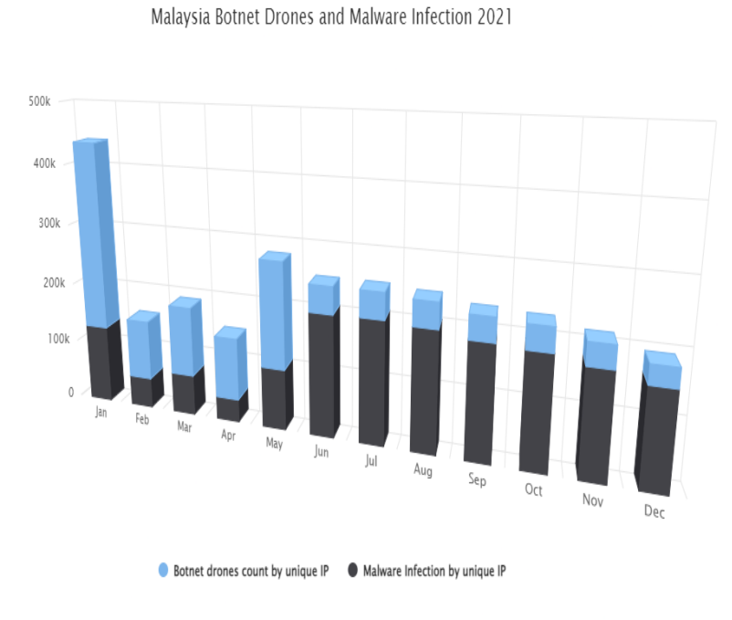

Figure 12: Botnet drones by unique IP compared with Malware infections by unique IP for 2021 (MyCert, Malaysia Botnet Drones and Malware Infection 2021, 2021).

In 2021, Malaysia witnessed 1,071,311 unique IP addresses identified as botnet drones and 1,674,954 unique IP addresses associated with malware infections as shown in figure 12 above. The total number of incidents in 2021 reached 2,746,265, indicating a substantial cybersecurity challenge for the nation. Comparatively, the data for 2022 showed a decrease in botnet drones, with 129,134 unique IP addresses identified. However, malware infections increased to 1,420,299 unique IP addresses. The total number of incidents for 2022 was 1,549,433, which, while lower than 2021, still represents a significant concern (figure 13).

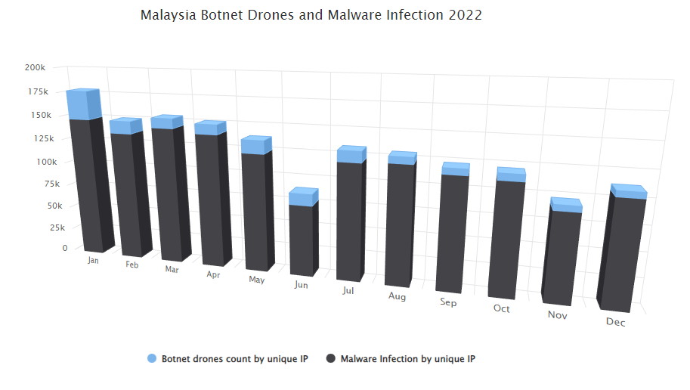

Figure 13: Botnet drones by unique IP compared with Malware infections by unique IP for 2022 (MyCert, Malaysia Botnet Drones and Malware Infection 2022, 2022).

The data from the above figure indicates that although there was a decline in botnet drone activity in 2022, the issue of malware infections remains a critical problem in Malaysia. The continued presence of botnet drones and the increasing number of malware infections can potentially lead to more DDoS attacks targeting Malaysian organizations, particularly as attackers seek to exploit the growing number of vulnerable devices.

## Similar Systems

### PiVPN

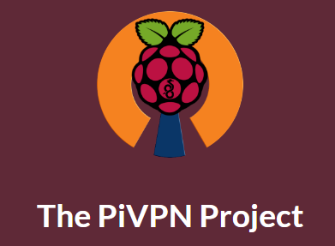

Figure 14: PiVPN logo (PiVPN, PiVPN, 2023).

PiVPN is an open-source, lightweight, and easy-to-use Virtual Private Network (VPN) solution that runs on Raspberry Pi hardware. It is designed to provide a secure and private connection for remote users to access a local network (PiVPN, 2023). PiVPN is particularly suitable for small and medium-sized enterprises (SMEs) due to its cost-effectiveness, ease of deployment, and adaptability.

PiVPN is built on top of OpenVPN and WireGuard, two popular and robust VPN protocols, offering a high level of security and performance. It simplifies the process of setting up and managing VPN servers and allows users to choose between OpenVPN and WireGuard, depending on their specific requirements and preferences (PiVPN, 2023).

Benefits of using PiVPN:

* Cost-effectiveness: PiVPN runs on Raspberry Pi hardware, which is an affordable and widely available platform. This makes it an attractive option for SMEs looking to implement a VPN solution without incurring significant costs.
* Ease of deployment: PiVPN provides an easy-to-use script for installing and configuring the VPN server, making the setup process straightforward even for users with limited technical knowledge.
* Security: By leveraging the security features of OpenVPN and WireGuard, PiVPN ensures a secure and private connection between remote users and the local network.
* Customizability: As an open-source solution, PiVPN can be customized to meet the specific needs of an organization, offering greater flexibility compared to proprietary VPN solutions.

However, it has its’ limitations such as:

* Scalability: PiVPN may not be the most suitable option for large enterprises with numerous remote users or those requiring advanced features and scalability.
* Performance: The performance of PiVPN depends on the Raspberry Pi hardware and network configuration. For organizations with high-performance requirements, it may be necessary to consider alternative VPN solutions.
* Management: PiVPN does not offer a centralized management interface, which may make it less suitable for organizations that require comprehensive monitoring and management capabilities.

(Hurera, 2021) ( Preston, 2022) (Crawford, 2019)

### pfSense

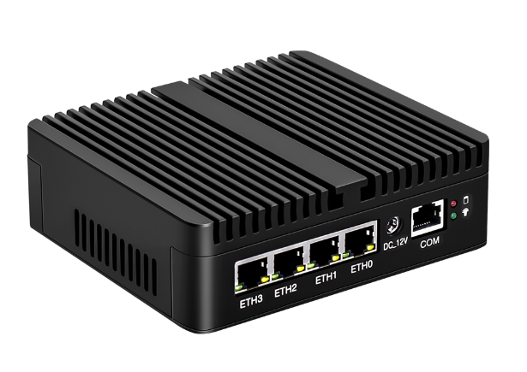

Figure 15: pfSense G30 model router (NewEgg, 2023).

pfSense is an open-source firewall and router solution based on FreeBSD, providing a robust and feature-rich network security platform for small and medium-sized enterprises (SMEs). It includes a wide range of security features such as stateful packet inspection, network address translation, VPN support, and intrusion detection and prevention systems (Netgate, 2023). These features help to protect the network from unauthorized access and malicious attacks, ensuring the safety of sensitive data and business operations.

Benefits of pfSense:

* Comprehensive Network Security

pfSense is an open-source firewall and router solution based on FreeBSD, providing a robust and feature-rich network security platform for small and medium-sized enterprises (SMEs). It includes a wide range of security features such as stateful packet inspection, network address translation, VPN support, and intrusion detection and prevention systems. These features help to protect the network from unauthorized access and malicious attacks, ensuring the safety of sensitive data and business operations.

* Scalability and Flexibility

One of the key strengths of pfSense is its scalability and flexibility, allowing it to be tailored to the specific needs of an organization. It can be deployed on various hardware configurations, ranging from low-power embedded devices to high-performance servers. This adaptability enables SMEs to choose the hardware that best fits their budget and performance requirements.

* Intuitive Web-Based Interface

pfSense comes with an intuitive web-based interface that simplifies the management and configuration of the firewall and router. This graphical user interface allows administrators to monitor network traffic, configure security policies, and manage VPN connections with ease. This user-friendly approach makes it easier for SMEs to maintain and control their network security without requiring extensive technical knowledge.

* Extensive Package System

The pfSense package system allows for the addition of third-party software packages, further extending its capabilities and features. SMEs can choose from a wide range of packages to enhance the functionality of their pfSense installation, including advanced monitoring tools, content filtering, and network management utilities.

There are some limitations and challenges associated with its use. These limitations should be considered by SMEs when deciding whether pfSense is the right solution for their network security needs.

* Hardware Requirements:

Although pfSense can be deployed on a variety of hardware configurations, it requires a dedicated system or a virtual machine with sufficient resources. For optimal performance, the hardware should meet or exceed the recommended specifications, which may add to the initial cost of deployment for some organizations.

* Technical Expertise:

While the web-based interface of pfSense simplifies configuration and management tasks, some level of technical expertise is required to set up and maintain the system effectively. Organizations with limited IT resources or knowledge may face challenges in configuring, troubleshooting, and optimizing pfSense to their specific needs.

* Complexity:

pfSense offers a wide range of features and options that can be overwhelming for inexperienced users. The complexity of the system may lead to misconfigurations or difficulties in finding the most suitable settings for a particular environment. This may increase the risk of security vulnerabilities if the configuration is not done correctly.

* Third-Party Package Compatibility:

Although the pfSense package system allows for the integration of additional features and functionalities, compatibility and support for third-party packages may vary. Some packages may not be well-maintained, and their integration may introduce stability or security issues. SMEs should carefully evaluate the reliability and reputation of third-party packages before installing them on their pfSense system.

* Limited Official Support:

As an open-source project, the primary support for pfSense comes from its community of users and developers. While this community can be a valuable resource, it may not provide the same level of responsiveness and expertise as dedicated commercial support. SMEs requiring professional assistance may need to consider paid support options, which can add to the overall cost of using pfSense.

(TrustRadius, 2023) (Medium, 2022)

### Firewalla

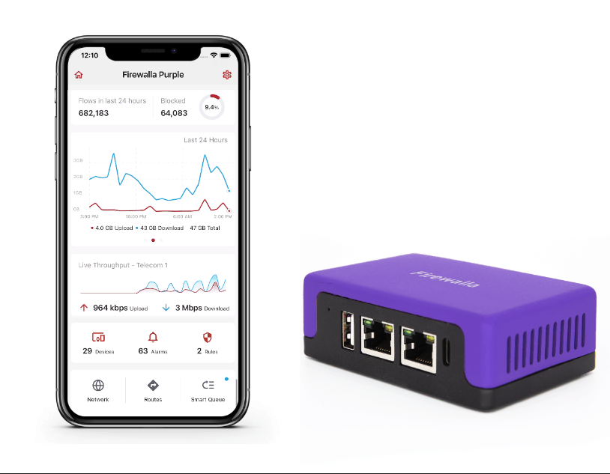

Figure 16: Firewalla Purple product with its' application (Firewalla, 2023).

Firewalla is a compact, all-in-one network security device designed to provide a simple and effective solution for protecting home and small business networks from various cyber threats. It aims to make network security more accessible and user-friendly for individuals and organizations with limited IT resources or technical expertise (Firewalla, About Firewalla, 2023).

Key features of Firewalla include:

* Intrusion Detection and Prevention System (IDPS):

Firewalla monitors network traffic for signs of malicious activity and can block suspicious connections to help protect your network from intrusions, malware, and other threats.

* Firewall:

Firewalla's built-in firewall allows users to create custom rules for controlling inbound and outbound traffic, effectively managing access to network resources and preventing unauthorized connections.

* Parental Controls and Content Filtering:

Firewalla provides tools for monitoring and controlling internet usage, including website blocking, filtering inappropriate content, and setting usage limits on a per-device basis.

* VPN Server and Client:

Firewalla offers built-in VPN functionality, allowing remote users to securely access the local network or providing a secure and private connection to the internet when using public Wi-Fi hotspots.

* Ad Blocking:

Firewalla can block ads and trackers at the network level, helping to improve browsing performance and protect user privacy.

* Device Management:

With Firewalla, users can monitor and manage connected devices, view real-time network usage, and receive notifications of potential security events.

* Easy Setup and Management:

Firewalla is designed for simplicity and ease of use, with a user-friendly mobile app for managing and monitoring the device. This makes it suitable for users with limited technical expertise or IT resources.

(Firewalla, User Manual, 2023) (Rubenking, 2022)

However, there are some limitations to consider as well:

* Limited scalability:

Firewalla's hardware is designed primarily for home and small business networks. As a result, it may not be suitable for larger networks or environments with high traffic volumes, as it may struggle to handle the increased load.

* Lack of advanced features:

Firewalla focuses on simplicity and ease of use, which means that it may not offer some of the advanced features or customization options found in more complex network security solutions like pfSense. This could be a limitation for users who require more fine-grained control or specialized functionality.

* Closed-source software:

Unlike open-source alternatives like PiVPN and pfSense, Firewalla's software is closed-source. This means that users and developers cannot review, modify, or contribute to the underlying codebase, which can limit customization options and make it more difficult to identify and address potential security vulnerabilities.

* Reliance on cloud services:

Some of Firewalla's features, such as remote management, rely on the company's cloud services. This can raise concerns about data privacy and security, as well as potential service disruptions if the company's servers experience downtime.

* Compatibility:

Firewalla is a standalone device designed to work with most routers and network configurations. However, there may be compatibility issues with certain networking equipment or configurations, which could limit its effectiveness or require additional setup steps.

* Cost:

While Firewalla is relatively affordable compared to some enterprise-level security solutions, it is still a paid product. For those on a tight budget or looking for a DIY solution, open-source alternatives like PiVPN or pfSense may be more cost-effective options.

(Rubenking, 2022)

### Comparative Analysis between Similar Products

|  |  |  |  |  |
| --- | --- | --- | --- | --- |
| **Feature** | **SENSI** | **PiVPN** | **pfSense** | **Firewalla** |
| ***Hardware Platform*** | Raspberry Pi 4 – 8GB | Raspberry Pi | Various hardware | Proprietary |
| ***Open Source*** | Yes (Suricata and Python3 scripts) | Yes | Yes | No |
| ***Ease of Deployment*** | Easy – comes pre-configured. | Easy | Moderate | Easy |
| ***Scalability*** | Moderate | Limited | High | Limited |
| ***Customizability*** | High | Moderate | High | Limited |
| ***Advanced Features*** | Depends on Suricata configuration and Python3 scripts | Basic VPN features | Comprehensive | Basic to Moderate |
| ***Cost*** | Low | Low | Varies (Hardware and support) | Moderate (Paid device) |
| ***Target Audience*** | Malaysian SMEs | SMEs, Home users | SMEs, Enterprises | Home users, SMEs |
| ***Centralized Management*** | Customizable through Python3 scripts | Not built-in | Yes | Yes (Cloud-based) |

By referring to the above comparative analysis, SENSI, built on Raspberry Pi 4 hardware and utilizing the Suricata application and custom Python3 scripts, offers a cost-effective, customizable, and targeted security solution. When compared to similar products like PiVPN, pfSense, and Firewalla, SENSI has several advantages:

* Open Source: SENSI, PiVPN, and pfSense are all open-source solutions, unlike Firewalla. This is crucial for SMEs as it allows them to avoid expensive licensing fees and have more control over their security system. Open-source solutions foster a community of developers who contribute to improving and updating the software, benefiting all users.
* Customizability: SENSI offers a high level of customizability through custom Python3 scripts, allowing Malaysian SMEs to tailor the mobile security hub to their specific needs and requirements. In contrast, PiVPN has limited customizability, while Firewalla offers even less due to its proprietary nature.
* Cost: SENSI provides a lower overall cost compared to pfSense and Firewalla due to the affordable Raspberry Pi 4 hardware platform and open-source software components. Although PiVPN is also low-cost, it may not provide all the advanced features that SENSI can offer with proper customization.
* Target Audience: SENSI is specifically designed for Malaysian SMEs, ensuring that it caters to their unique requirements and cybersecurity challenges. While pfSense and Firewalla also target SMEs, SENSI's focus on the Malaysian context adds extra value.
* Centralized Management: SENSI's centralized management capabilities, customizable through Python3 scripts, provide SMEs with a convenient way to manage their security system. This feature is not built-in for PiVPN, making SENSI more appealing to organizations that prefer a centralized approach to security.

To sum up, SENSI (Small Enterprise Network Security Infrastructure) is a promising mobile security hub solution for Malaysian SMEs, offering several advantages over PiVPN, pfSense, and Firewalla. With its open-source nature, customizability, cost-effectiveness, targeted focus on Malaysian SMEs, and centralized management capabilities, SENSI holds great potential in helping SMEs combat rising cyber threats in their unique context.

## Summary of Domain Research

In this text, we explored the challenges faced by Malaysian SMEs in the field of cybersecurity and reviewed several solutions that can help address those challenges. We introduced SENSI, a mobile security hub built on Raspberry Pi 4 hardware and utilizing the Suricata application and custom Python3 scripts, which offers a cost-effective, customizable, and targeted security solution. We compared SENSI to similar products like PiVPN, pfSense, and Firewalla, highlighting its advantages in terms of open-source nature, customizability, cost, targeted focus on Malaysian SMEs, and centralized management capabilities. Overall, SENSI seems like a promising solution for Malaysian SMEs looking to improve their cybersecurity posture, as it offers a tailored approach to the specific challenges faced by organizations in that context.

# **TECHNICAL RESEARCH**

## Programming Languages

### Python



Figure 17: Python Logo (Python, 2023).

Python is an open-source, high-level programming language created by Guido van Rossum and first released in 1991 (Python, 2023). Python has become one of the most popular programming languages due to its ease of use, readability, and versatility. In this technical report, we will explore the key features of Python, its applications, and its advantages and disadvantages.

#### **Key Features**

Python is a simple and easy-to-learn programming language designed with an easily readable and writable syntax, making it ideal for beginners. As an open-source language, its source code is freely available for everyone to use and modify. Being an interpreted language, there is no need to compile the code before execution, allowing for faster development times and easier debugging. Python is also an object-oriented language, supporting the creation and manipulation of objects, which makes it suitable for complex applications requiring modular design (Python, What is Python? Executive Summary, 2023). As a high-level language, Python is closer to human language than machine language, making it easier to read, write, and reducing the likelihood of errors. Furthermore, Python employs dynamic typing, determining the type of a variable at runtime, which simplifies code writing but may increase the risk of errors (w3schools, 2023).

#### **Applications**

Python’s versatility is utilized in various fields, such as web development, where its ease of use and availability of web frameworks like Django and Flask make it a popular choice. In data science, Python is preferred for its ability to handle large data sets, extensive libraries, and powerful visualization tools. The language is also extensively used in machine learning due to its simplicity and the availability of libraries like TensorFlow and Keras. Additionally, Python is commonly employed for scripting tasks, enabling automation of repetitive tasks and performing system administration functions (Pyhton, 2023).

#### **Advantages of Python**

Python is an easy-to-learn programming language, making it an ideal choice for beginners. It boasts a large and active community of developers and users, providing numerous resources, libraries, and tools to assist in development. This is particularly beneficial when developing custom Python scripts for applications like Raspberry Pi and Suricata, as developers can leverage existing libraries and tools to streamline the process. Python's wide range of applications spans from web development to machine learning, and its portability allows code to be run on various platforms, including Windows, Linux, and macOS. As a cross-platform language, Python code can run on diverse systems such as Raspberry Pi and other Linux-based devices, simplifying development and testing across different systems and hardware configurations. Python enables rapid prototyping, allowing developers to quickly build and test new ideas and features without extensive setup or configuration. This is especially helpful when working with Raspberry Pi and Suricata, which may require frequent testing and iteration for optimal performance. Moreover, Python's extensive library collection covers various purposes, including network automation, web development, data analysis, and machine learning, often providing the necessary tools and functions for network security projects in existing libraries, saving time and effort in custom script development (Arora, 2023).

#### **Disadvantages**

Python, while offering numerous advantages, does have some drawbacks. For instance, its performance is slower compared to languages like C++ and Java, which might pose a disadvantage for applications that demand high performance. Additionally, Python's dynamic typing feature, though making the code easier to write, raises the risk of errors and can complicate the debugging process. Furthermore, Python's Global Interpreter Lock (GIL) presents a limitation in multi-threaded applications, potentially restricting performance when executing concurrent tasks. Despite these challenges, Python remains a popular choice for many developers due to its ease of use, versatility, and extensive library support (Joy, 2021).

#### **Application of Python in Cybersecurity**

Python has become a popular choice in the field of cybersecurity due to its versatility, ease of use, and wide range of applications. Some specific applications include penetration testing, digital forensics, malware analysis, and automated security testing. Penetration testing is a critical component of cybersecurity, involving the simulation of an attacker's activities to identify system vulnerabilities before they can be exploited. Python is a popular choice for this due to its versatility and the availability of libraries and tools such as Scapy, Nmap, and Metasploit. Digital forensics, the process of collecting and analyzing digital evidence to investigate security incidents or criminal activities, also benefits from Python's versatility and the availability of libraries and tools like PyFlag and Volatility (Vidhya, 2018) (UMBC, 2022).

Malware analysis, the process of studying malicious software to identify its behavior and functionality, is another area where Python excels. Python can be used for both static and dynamic malware analysis, leveraging libraries such as YARA, PEFile, Cuckoo Sandbox, and the VirusTotal API. Automated security testing, a process that uses tools and scripts to test systems for vulnerabilities and weaknesses, also benefits Python's simplicity and ease of use. With libraries like Selenium, PyAutoGUI, Scapy, Nmap, and APIs provided by cloud providers like AWS and Azure, Python is well-suited for web application testing, network security testing, and cloud security testing. Overall, Python is a versatile and well-suited language for developing network security projects, particularly when working with Raspberry Pi and Suricata, thanks to its ease of use, large community, cross-platform compatibility, extensive libraries, and rapid prototyping capabilities (UMBC, 2022).

### Bash Language



Figure 18: Bash Logo (Das, 2019).

Bash, also known as Bourne Again Shell, was written in 1989 for the GNU Project by Brian Fox. Bash is a powerful and popular shell scripting languages due to its command-line features and scripting capabilities (What is Bash?, 2023). This technical report will delve into the key features of Bash, its applications, and its advantages and disadvantages.

#### **Key Features**

When using Bash, the user types commands into a text window which then initiates actions. This command processor can also execute commands from a script file. Like other Unix shells, Bash supports wildcard matching, piping, command substitution, variables, and control structures. Its basic syntax and keywords are taken from sh, while additional features such as history come from csh and ksh. Bash follows POSIX standards and includes several extensions (Bash Reference Manual, 2023)

#### **Applications**

Bash is a popular tool for managing system administration tasks, including managing files and processes and automating these tasks using shell scripts. It is also utilised for network programming, software development, and data manipulation. Bash scripts are frequently used to set up Unix-based systems and start and manage services and processes. Additionally, Bash is commonly used in DevOps practices to automate deployment and configuration tasks (Loshin, 2023).

#### **Advantages of Bash**

Bash is a powerful scripting language that provides a wide range of text processing and task automation features. It is built into most Unix-based systems, making it readily available. Bash scripts are portable across different Unix-based systems, which benefits system administrators and developers working in heterogeneous environments. Bash also supports command-line editing, allowing users to modify their command line while typing - particularly useful for correcting mistakes and reusing previous commands. Bash's command history feature allows users to recall and reuse previously entered commands, saving time and effort. Moreover, Bash's job control feature allows users to manage multiple processes and tasks from a single Bash session, making it a powerful tool for multitasking (Bash Reference Manual, 2023).

#### **Disadvantages of Bash Language**

While Bash offers many advantages, it also has some limitations. For instance, Bash is less powerful and flexible than other scripting languages like Python or Perl regarding complex data manipulation or mathematical operations. Bash scripts can also become complex and challenging to maintain when they grow in size and complexity. Furthermore, Bash does not support multi-threading, which can limit its performance in concurrent tasks. Despite these limitations, Bash remains a popular choice for many system administrators and developers due to its powerful command-line features and scripting capabilities (Jit, 2023).

#### **Applications of Bash in Cybersecurity**

Bash is widely used in the field of cybersecurity for a variety of tasks. These include system monitoring, network scanning, and penetration testing. Bash scripts can be used to automate monitoring system logs for suspicious activity, scanning networks for open ports and vulnerabilities, and simulating attacks to test the effectiveness of security measures. Bash is also used in digital forensics to automate the collecting and analysing digital evidence. Furthermore, Bash is often used for automating security testing, leveraging tools like Nmap, Wireshark, and Metasploit. Overall, Bash is a versatile and powerful tool for cybersecurity, particularly for tasks involving system administration, network management, and security testing (BRATHWAITE, 2021).

### Suricata Declarative Language

SDL (Suricata Declarative Language), also known as Suricata Rule Language is a declarative language that describes the conditions that must be met for a rule to trigger. The language is designed to be easy to read and write, so even users with limited programming experience can create effective rules. Suricata rules are typically written in a text editor using a syntax that is specific to Suricata and Suricata. Each rule consists of two main parts: the rule header and the rule options (Leblond, 2022) (Camisso, 2021).

The rule header specifies the conditions that must be met for the rule to trigger. This includes information such as the protocol, source IP address, destination IP address, source port, and destination port. For example, the following rule header would trigger if a packet with a source IP address of 192.168.1.1 and a destination IP address of 10.0.0.1 is detected:

***alert ip 192.168.1.1 any -> 10.0.0.1 any***

The rule options specify additional criteria that must be met for the rule to trigger. This can include things like specific content in the packet payload, the direction of the traffic, and the severity of the alert. For example, the following rule option would trigger if the packet payload contains the string "password":

***content:"password"; nocase; classtype:policy-violation;***

#### **Advantages of Suricata’s Declarative Language**

Suricata’s rule language is very much similar to its sister-NIDS declarative rule language – Suricata. They vastly share the same rulesets and rule engines, with added points to Suricata as it has a language server. Declarative rule language offers several advantages over traditional imperative languages like C and Python. By allowing users to focus on the desired outcome rather than the specific steps to achieve it, Suricata's declarative language makes it easier for users to create effective rules without needing extensive programming expertise. This approach also makes the language more flexible and adaptable, enabling rules to be easily modified or extended to address changing security threats without the need for rewriting large amounts of code. Furthermore, Suricata's declarative language enables more efficient execution of rules, as the Suricata engine can optimize performance using specialized algorithms for pattern detection. This results in faster and more accurate identification of security threats, making Suricata's declarative language a powerful tool for network security professionals ( Salgueiro, 2012) .

## IDE (Integrated Development Environment)

In the development of custom Python3 scripts for the SENSI (Small Enterprise Network Security Infrastructure) project, two distinct tools will be employed to optimize the programming and testing processes: Visual Studio 2019 and Mousepad in Kali Linux. Each of these tools serves a specific purpose in the project and will be used in different stages of the development process.

### Visual Studio 2019

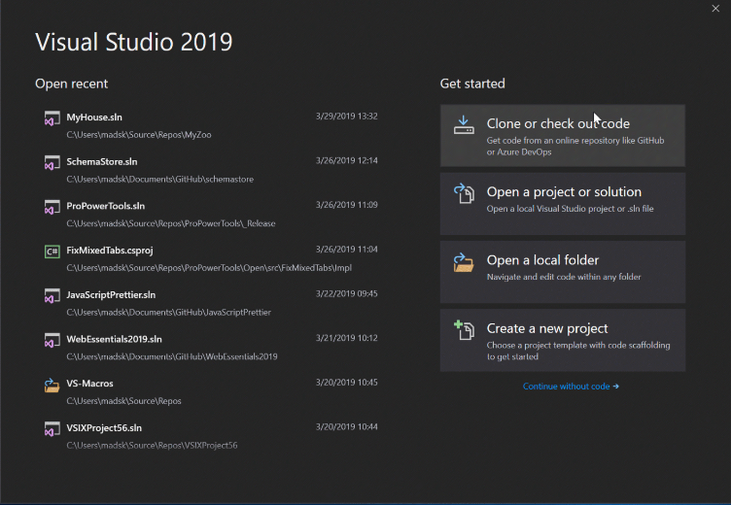

Figure 19: Visual Studio 2019 start screen.

Visual Studio 2019 is a fully featured Integrated Development Environment (IDE) developed by Microsoft (figure 19). It supports a wide range of programming languages, including Python, and offers a comprehensive suite of tools for editing, debugging, and managing code (Microsoft, It’s how you make software, 2023). In the context of the SENSI project, Visual Studio 2019 will be the primary tool for writing and editing the custom Python3 scripts. Its powerful features, such as code completion, syntax highlighting, and error detection, will assist in creating high-quality, efficient, and reliable code. Furthermore, Visual Studio 2019 provides advanced memory management and debugging capabilities, which will be invaluable in identifying and resolving any performance issues or bugs within the custom scripts (Microsoft, Measure memory usage in Visual Studio (C#, Visual Basic, C++, F#), 2023).

### Mousepad (Ubuntu)

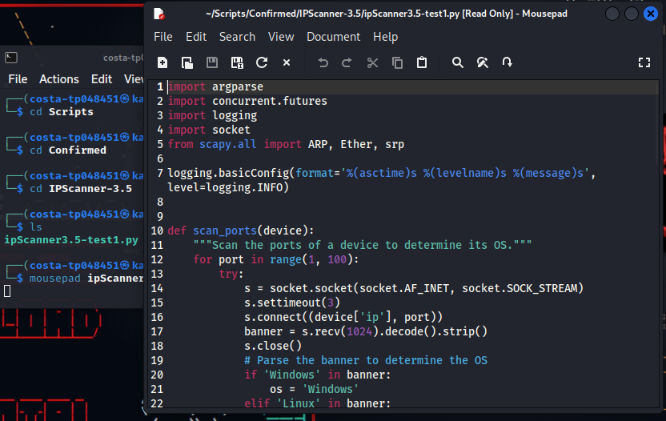

Figure 20: Mousepad running within Kali Linux VM.

While Visual Studio 2019 is a robust IDE, Mousepad in Ubuntu serves a different purpose in the development process. Mousepad is a lightweight text editor included in the Ubuntu distribution, and although it is not an IDE itself, it can be effectively used for editing scripts (Mousepad Developers, 2023). For the SENSI project, Mousepad will be utilized for live testing purposes in a simulated Raspberry Pi OS environment. This will allow for the rapid testing and tweaking of the custom scripts in a setting that closely resembles the target platform. By using Mousepad in Ubuntu, the development process can be streamlined, and potential issues can be identified and addressed more efficiently.

In summary, Visual Studio 2019 and Mousepad in Ubuntu will be employed as complementary tools in the development of custom Python3 scripts for the SENSI project. Visual Studio 2019 will provide a comprehensive IDE for coding, error checking, and memory management, while Mousepad in Ubuntu will serve as a lightweight text editor for live testing in a simulated Raspberry Pi OS environment. Together, these tools will facilitate an efficient and effective development process, resulting in a robust and reliable mobile security hub for Malaysian SMEs.

## Libraries

For the purpose of creating custom python scripts for multiple purposes, a handful of libraries are being used. These libraries play a crucial role in providing the necessary functionality for network interface scanning, user interaction, and processing. Here's a summary of the libraries used:

* ***NETIFACES***: This library provides a simple and straightforward method to get the list of network interfaces on a device, including their IP addresses and subnet masks.
* ***IPADDRESS***: The ipaddress library is used to create, manipulate, and operate on IPv4 and IPv6 addresses and networks.
* ***RE***: The re (Regular Expression) library provides functions to perform string searches and substitutions using regular expressions.
* ***OS***: The os module allows for the manipulation of system-dependent functionality, such as reading or writing to the environment, manipulating paths, and handling files.
* ***REQUESTS***: This library allows you to send HTTP requests using Python, making HTTP requests simpler and more human-friendly.
* ***WATCHDOG***: This library provides an API to monitor file system events.
* ***QUEUE***: This module implements multi-producer, multi-consumer queues for python scripts.
* ***THREADING***: This module is created on the lower-level thread module and allows for multi-threaded script management and creation.

Each of these libraries plays a crucial role in providing the necessary functionality for network interfacing, event observation, and threaded operation. They offer the scripts the ability to efficiently interact with the operating system, observe directories for changes, handle network interface information, and manage multithreaded operations.

## Operating Systems

In the development and implementation of the Small Enterprise Network Security Infrastructure (SENSI) project, the selection and utilization of appropriate operating systems play a crucial role. As each operating system possesses its unique characteristics and strengths, understanding their specific applications within the project ensures seamless integration and optimal performance. This section will provide a personalized introduction to the three operating systems employed in the SENSI project: Raspbian (Raspberry Pi OS), Windows, and Kali Purple. We will explore their individual capabilities and the rationale behind their incorporation into the project, emphasizing their relevance to script development, testing, and overall system functionality.

### Raspbian (Raspberry Pi OS)



Figure 21:Raspbian OS logo (Raspbian, 2023).

Raspbian is a free, open-source operating system based on Debian, specifically optimized for Raspberry Pi devices. It is lightweight, fast, and includes a wide range of pre-installed software packages to get started quickly (Raspbian, 2023). For this project, Raspbian is used as the primary operating system for the Raspberry Pi, which serves as the hardware platform for the Small Enterprise Network Security Infrastructure (SENSI) project. Raspbian is an ideal choice due to its compatibility with Raspberry Pi, its extensive community support, and its ability to run various open-source security tools and custom scripts required for the project.

The Raspberry Pi 4 serves as the core platform for the SENSI project, making Raspbian an ideal choice. Raspbian provides a stable environment for deploying Suricata and custom Python3 scripts while ensuring seamless compatibility with Raspberry Pi hardware. Additionally, its extensive community support and regular updates ensure that the SENSI project remains up to date with security patches and performance improvements.

### Windows 11

Windows 11 is a widely used commercial operating system developed by Microsoft. It offers a user-friendly interface, excellent hardware and software support, and a vast ecosystem of applications and development tools. In this project, Windows is utilized for creating custom Python scripts using the Visual Studio 2019 IDE. The choice of Windows is due to its compatibility with popular development tools, familiarity among users, and ease of use for script development and error checking.

For the SENSI project, Windows is primarily utilized for script development and debugging. Visual Studio 2019, a powerful and versatile IDE, runs on Windows and provides essential tools for code editing, error checking, and memory management. By using Windows as the development environment, SENSI benefits from the robustness and convenience of Visual Studio 2019 to create high-quality custom Python3 scripts for the project.

### Kali Linux 2023 – Kali Purple



Figure 22: Kali Purple logo (Kali Linux, 2023).

Kali Purple is a version of Kali Linux that is tutored towards offensive security as well as defensive security. Other than the addition of new defensive security tools added in reference to the NIST framework, Kali Purple bares the same identity as other versions of Kali Linux. It is a free, open-source operating system specifically designed for penetration testing, security auditing, and digital forensics. It is based on Debian and comes pre-loaded with numerous security and hacking tools, making it a popular choice among cybersecurity professionals (Kali, 2023). In this project, Kali Purple is used for testing the custom Python scripts and enhancing the Suricata intrusion detection system. The choice of Kali Purple is motivated by its focus on security, its extensive collection of pre-installed security tools, and its ability to simulate a Raspberry Pi OS environment using Mousepad for live testing purposes.

The SENSI project leverages Kali Purple for evaluating the custom Python3 scripts and Suricata enhancements in a controlled environment that simulates real-world cybersecurity scenarios. By employing Kali Linux for testing purposes, the project ensures that its security measures are thoroughly vetted and ready for deployment in the target environments.

### Ubuntu 22.04 – Jammy Jellyfish



Figure 23: Ubuntu 22.04 desktop interface.

Ubuntu 22.04, also known as Jammy Jellyfish, is a popular open-source operating system developed by Canonical Ltd. It is based on the Debian architecture and is widely recognised for its user-friendly interface, robust performance, and extensive software libraries (Ubuntu 22.04.2 LTS, 2023). In the SENSI project, Ubuntu is primarily employed for the development process and to establish a secure SSH connection to the Raspberry Pi of the SENSI system.

Ubuntu 22.04 offers a comprehensive suite of development tools, making it an ideal choice for creating custom Python scripts. It is compatible with a wide range of IDEs, including but not limited to Visual Studio Code, PyCharm, and Atom, which provide essential tools for code editing, error checking, and memory management. The choice of Ubuntu is motivated by its stability, ease of use, and the extensive support it offers for development tools.

In the SENSI project, Ubuntu's role is not limited to development. It is also connected to the Raspberry Pi of the SENSI system via SSH, a secure protocol used to manage systems and applications remotely - this allows for the efficient deployment, management, and troubleshooting of the SENSI system, further enhancing the project's overall productivity and effectiveness.

Ubuntu 22.04 also boasts a vast ecosystem of applications and libraries, which can be easily installed and managed using the built-in package manager, APT - this makes it easier for developers to access and install the necessary tools and libraries for their projects, thereby speeding up the development process and reducing the time to deployment (Ubuntu 22.04.2 LTS, 2023).

### Debian 11

Debian 11, also known as "Bullseye", is a robust and versatile operating system that serves as an excellent platform for creating a simulation environment for developing SENSI - this is primarily due to its compatibility with Raspbian OS, which is based on Debian and runs on Raspberry Pi.

One of the key features of Debian 11 is its extensive software support. It includes over 59,551 software packages updated from the previous version, providing a wide array of tools and libraries for developers (Debian 11 bullseye released, 2021) - this makes it an ideal environment for testing and developing new applications, such as SENSI, before deploying them on a Raspberry Pi running Raspbian OS.

Furthermore, Debian 11 has made significant strides in terms of security. It comes with a new feature called "Reproducible Builds", which ensures that the source code used to build a given package always produces the same binary, thereby enhancing the transparency and trustworthiness of the software (Debian 11 bullseye released, 2021).

## Software

### GParted

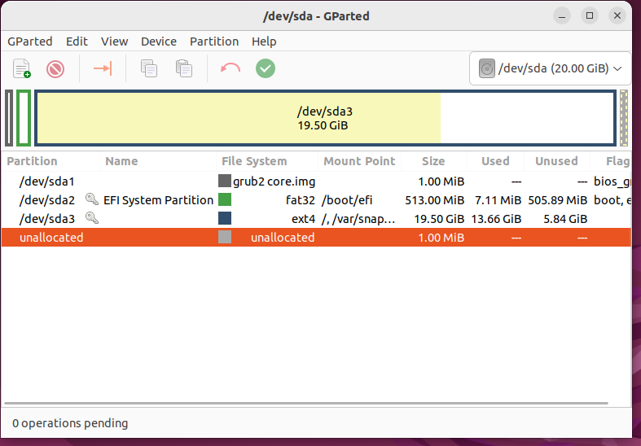

Figure 24: GParted user interface.

GParted, an acronym for GNOME Partition Editor, is a free and open-source application with a graphical interface for managing disk partitions. It is a powerful tool enabling users to perform various actions on their disk partitions without losing data (About, 2023). These actions include creating, deleting, resizing, moving, checking, and copying partitions and their file systems - this makes GParted an invaluable tool for preparing SSDs for operating systems like Raspbian OS and for better-integrating file systems.

In the context of the SENSI project, GParted was primarily used to prepare the SSD for the Raspbian OS. Given that Raspbian OS is based on Debian, GParted's compatibility with this operating system made it an ideal choice for this task. By using GParted, the team could resize, format, and manage the partitions on the SSD, ensuring that it was configured correctly for installing the Raspbian OS.

Moreover, GParted's ability to manipulate various file systems, such as btrfs, exfat, ext2/ext3/ext4, fat16/fat32, hfs/hfs+, linux-swap, lvm2 pv, nilfs2, ntfs, reiserfs/reiser4, udf, ufs, and xfs, made it a versatile tool for integrating the file systems in the SENSI project. This versatility allowed the team to work with different file systems and ensure their seamless integration, thereby enhancing the overall efficiency and effectiveness of the project (Features, 2023).

### Suricata



Figure 25: Suricata Logo (Suricata Logo, 2023).

Suricata is a high-performance Network IDS, IPS, and Network Security Monitoring engine. It is open-source and owned by the Open Information Security Foundation (OISF). Suricata is a crucial SENSI feature, providing Intrusion Detection System (IDS) and Intrusion Prevention System (IPS) functionality.

#### **Features of Suricata**

***Multi-Threading***: Suricata is designed to use modern multi-core, multi-threaded processors, and architecture fully. This feature allows it to quickly process substantial amounts of data, making it suitable for high-performance networks (Complete list of Suricata Features, 2023).

***Protocol Recognition***: Suricata can recognise various protocols, including but not limited to HTTP, TLS, SSH, and SMTP. This feature allows it to detect anomalies in the expected behaviour of these protocols, which could indicate a potential security threat (Complete list of Suricata Features, 2023).

***Intrusion Detection and Prevention***: As an IDS, Suricata monitors network traffic for suspicious activity and sends alerts. As an IPS, it can also prevent detected threats by blocking them from the network (Complete list of Suricata Features, 2023).

***File Extraction***: Suricata can extract files from network traffic for analysis. This feature can help identify malicious files being transferred over the network (Complete list of Suricata Features, 2023).

***Scriptable Interaction***: Suricata supports Lua scripting, allowing users to write their detection signatures and other scripts (Complete list of Suricata Features, 2023).

#### **Importance of Suricata**

Suricata's importance lies in its ability to provide robust network security. Its IDS and IPS functionality allow it to detect and prevent a wide range of threats, from simple malware to complex zero-day attacks. By monitoring network traffic and analysing it for suspicious activity, Suricata can identify potential threats before they cause damage. Its multi-threading capability allows it to handle high volumes of network traffic without sacrificing performance, making it suitable for protecting large, high-traffic networks (Complete list of Suricata Features, 2023).

In the context of SENSI, Suricata is the main feature providing IDS and IPS functionality -this makes SENSI a powerful tool for network security, capable of protecting networks from a wide range of threats.

### Telegram



Figure 26: Telegram Logo.

Telegram is a cloud-based instant messaging app that provides APIs for developers and users to create specialised bots that can interact with users and perform other case-specific functions. In the context of SENSI, Telegram is used as an alert system for Suricata-logged alerts triggered by Suricata rules. This integration allows for real-time notifications of potential security threats, enhancing the system's responsiveness.

#### **Features of Telegram**

***Cloud-Based***: Telegram is cloud-based, which means that users can access their messages from multiple devices and retain their data even if they lose their devices (Telegram Applications, 2023).

***Secure***: Telegram offers end-to-end encryption for voice calls and optional end-to-end encrypted "secret" chats between two online users (Security, 2023).

***Bots***: Telegram allows developers to create bots that can interact with users. These bots can be programmed to perform various tasks, such as sending notifications, providing updates, or even conducting transactions (Bot API, 2023).

#### **Importance of Telegram in SENSI**

In SENSI, Telegram is used as an alert system for Suricata logged alerts. When Suricata rules are triggered, indicating potential security threats, alerts are sent to administrators via a Telegram bot in real-time - this allows administrators to quickly respond to potential security threats, enhancing the system's security.

By leveraging Telegram's instant messaging capabilities and bot API, SENSI can provide real-time, automated security alerts. This improves the system's responsiveness and allows administrators to manage and respond to threats more efficiently.

## Hardware

### Raspberry Pi 4 Model B

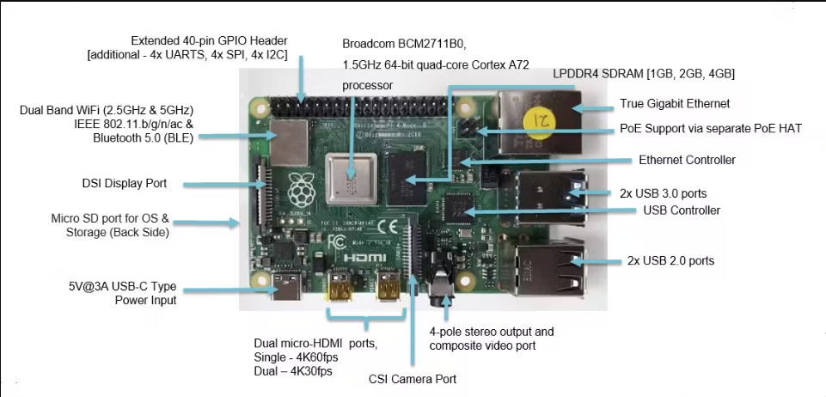

Figure 27: Raspberry Pi 4 Model B architecture (Allan, 2019).

The Raspberry Pi 4 Model B is a highly agile and powerful single ARM minicomputer that serves as the housing unit of the SENSI system. It is built around the Broadcom BCM2711, a Quad-core Cortex-A72 (ARM v8) 64-bit SoC running at 1.5GHz to 1.8GHz (Raspberry Pi 4 Tech Specs, 2023). The Raspberry Pi 4 Model B offers a variety of RAM options; however, the SENSI system built is on the 8GB LPDDR4-3200 SDRAM (Raspberry Pi 4 Tech Specs, 2023) version, providing flexibility in terms of memory capacity based on the specific needs of the SENSI system.

The Raspberry Pi 4 Model B supports a spectrum of network connectivity, such as dual-band WLAN (2.4GHz and 5.0GHz) with IEEE 802.11ac, and Bluetooth 5.0 (Raspberry Pi 4 Tech Specs, 2023). This allows for robust and flexible network connectivity, which is crucial for the SENSI system’s monitoring and alerting functions. The device also includes Gigabit Ethernet and two USB 3.0 ports, which can transfer data up to 10x faster than their USB 2.0 counterparts (Raspberry Pi 4 Tech Specs, 2023). It also comes equipped with a standard 40-pin GPIO header, fully backwards compatible with various industry sensors (Raspberry Pi 4 Tech Specs, 2023). This allows for potential expansion and integration with other hardware components if needed. The device also supports up to 4K UHD native output over 2 HDMI ports (Raspberry Pi 4 Tech Specs, 2023), although some of these features may not be directly helpful in the SENSI system as it is designed to operate primarily in headless mode.

The choice of the Raspberry Pi 4 Model B as the powerhouse for the SENSI system was driven by several promising factors. Its powerful processing capabilities, modern memory configurations, rich network connectivity options, and compatibility with various Debian-based software make it an ideal choice. Furthermore, its cost-effectiveness and the extensive community support for Raspberry Pi devices add to its appeal.

### Kingston A400 2.5 SATA III 240GB SSD



Figure 28: Kingston A400 SSD (A400 SATA SSD, 2023)

The Kingston A400 SSD is a solid-state drive (SSD) that offers a significant upgrade over conventional hard drives and SD cards, particularly in speed, reliability, and durability. With 240GB of storage, it provides ample space for the necessary software, system backups, and logs at an extremely competitive price making it an excellent choice for the SENSI system.

Operating on advanced 3D NAND technology, the A400 SSD offers robust read and write speeds of up to 500MB/s and 450MB/s, respectively. This is a notable leap over the maximum speed of around 100MB/s commonly offered by SD cards. Such superior speeds are not just about numbers; they translate into tangible benefits for the SENSI system, such as faster boot times, reduced application load times, and smoother system operation - this becomes particularly crucial considering the SENSI system's requirements for continuous threat detection and alert operations (A400 SATA SSD, 2023).

Alongside its superior speed, the A400 SSD stands out for its durability and reliability. Unlike the slight, delicate build of SD cards prone to damage and data loss, SSDs are robust and designed to withstand physical shocks better. The absence of mechanical parts in traditional hard drives makes SSDs less susceptible to sudden failures, decreasing the risk of unexpected system downtime—a critical factor in maintaining consistent network security. Regarding capacity and efficiency, the A400 SSD again outperforms SD cards. Offering a substantial 240GB of storage, the SSD can effectively manage and store the substantial logs generated by the SENSI system. Furthermore, SSDs require less power to operate than traditional hard drives, leading to greater energy efficiency—a consideration that holds considerable weight for cost-sensitive SMEs.

Given these benefits, the justification for choosing the Kingston A400 SSD over an SD card becomes clear. While the compactness and portability of SD cards might seem attractive, they need to catch up on critical parameters such as speed, durability, and reliability. In contrast, the A400 SSD offers superior speed for real-time network threat detection and response, outstanding durability to minimize system failure risk and ample storage capacity for practical data storage and processing. Its energy efficiency is a bonus, further reducing operational costs. Hence, the Kingston A400 SSD is a decisively superior choice for the SENSI system over an SD card.

## Summary of Technical Research

The technical research section of the Small Enterprise Network Security Infrastructure (SENSI) project focuses on three key areas: hardware, scripting languages, software and operating systems. The Raspberry Pi 4 is chosen as the core hardware platform due to its affordability, compact size, and energy efficiency. The scripting languages used in the project are Python3 and Suricata rules, with Python3 being the primary language for custom script development and Suricata rules for creating custom intrusion detection rules.

Five operating systems are utilized in the SENSI project: Raspbian (Raspberry Pi OS), Windows, Kali Purple, Ubuntu and Debian. Raspbian serves as the primary operating system for the Raspberry Pi, chosen for its compatibility with the device, extensive community support, and ability to run open-source security tools and custom scripts. Windows, Ubuntu and Debian are employed for script development and debugging, utilizing the Visual Studio 2019 IDE for its compatibility with popular development tools, user familiarity, and ease of use. Finally, Kali Purple is used for testing custom Python scripts and enhancing the Suricata intrusion detection system due to its focus on security, pre-installed security tools, and ability to simulate a Raspberry Pi OS environment for live testing purposes.

# **SYSTEM DEVELOPMENT METHODOLOGY**

## Proposed Methodologies

### Scrum Methodology

The Scrum framework is a widely adopted Agile methodology that provides a structured approach to software development while maintaining the flexibility, collaboration, and adaptability inherent in Agile principles (Scrum, 2023)zz`. As a proven and effective project management method, Scrum is particularly suitable for the Small Enterprise Network Security Infrastructure (SENSI) project, offering a clear roadmap for development while accommodating the ever-changing landscape of cybersecurity threats and requirements.

Scrum revolves around iterative and incremental development, breaking the project down into manageable pieces called sprints. Each sprint, typically lasting two to four weeks, focuses on delivering a potentially releasable increment of the final product, ensuring the continuous delivery of valuable features and rapid adaptation to new information.

Key roles in the Scrum framework include:

* Product Owner: The Product Owner is responsible for maximizing the value of the product by prioritizing features, managing the product backlog, and ensuring that the team focuses on delivering the highest value items in each sprint (Scrum, What is a Product Owner?, 2023).
* Scrum Master: The Scrum Master facilitates the Scrum process, removes any impediments the team faces during development, and ensures that the team adheres to Scrum principles and practices (Scrum, What is a Scrum Master?, 2023).
* Development Team: The Development Team is a cross-functional group of professionals who work collaboratively to design, develop, and test the product increments during each sprint (Scrum, What is a Developer?, 2023).

Scrum relies on a set of key ceremonies and artifacts to maintain structure and transparency, such as:

* Sprint Planning: This event marks the beginning of a new sprint, where the team selects high-priority items from the product backlog and plans the work required to complete them during the sprint (Scrum, What is Sprint Planning?, 2023).
* Daily Stand-up: A short, daily meeting where team members share updates on their progress, discuss any obstacles they face, and align their efforts to ensure smooth collaboration (Scrum, What is a Daily Scrum?, 2023).
* Sprint Review: Held at the end of each sprint, this event allows the team to demonstrate the completed product increment to stakeholders, gather feedback, and adjust priorities for the next sprint if necessary (Scrum, What is a Sprint Review?, 2023).
* Sprint Retrospective: This is an opportunity for the team to reflect on the past sprint, identify areas for improvement, and create a plan for implementing changes in the next sprint (Scrum, What is a Sprint Retrospective?, 2023).

By adopting the Scrum framework, the SENSI project can leverage the benefits of Agile methodologies, such as enhanced collaboration, frequent delivery of valuable features, and the ability to rapidly adapt to the evolving cybersecurity landscape.

#### **Processes of Scrum Methodology:**

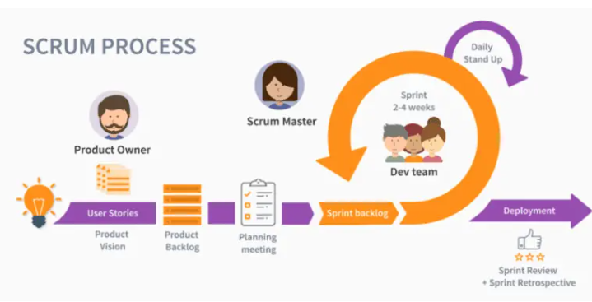

Figure 29: Scrum processes simplified ( Juillet, 2022).

Sprints: Sprints are fixed-length iterations, typically lasting between one and four weeks, during which the team works on a specific set of tasks. Each sprint has a defined goal, and at the end of the sprint, the team delivers a potentially shippable increment of the product (Scrum, What is a Sprint?, 2023).

Product Backlog: The Product Backlog is a prioritized list of features, enhancements, and bug fixes required for the product. The Product Owner is responsible for maintaining and refining the backlog, ensuring that the most valuable items are addressed first (Scrum, What is a Product Backlog?, 2023).

Sprint Planning: At the beginning of each sprint, the team gathers for a Sprint Planning meeting. During this session, the team selects the highest-priority items from the Product Backlog and plans how they will work on them during the sprint (Scrum, What is Sprint Planning?, 2023) .

As mentioned earlier, there are several key meetings within the Scrum framework that facilitate communication and collaboration among team members. Daily Stand-ups, or Daily Scrums, are brief daily meetings where team members share their progress, discuss roadblocks, and coordinate efforts to work efficiently toward the sprint goal (Scrum, What is a Daily Scrum?, 2023). At the end of each sprint, the team holds a Sprint Review meeting to demonstrate completed work to stakeholders and gather feedback, allowing them to adjust plans and priorities for future sprints (Scrum, What is a Sprint Review?, 2023). Finally, the Sprint Retrospective provides an opportunity for the team to reflect on their performance, identify areas for improvement, and create a plan for enhancing their work process in the upcoming sprint (Scrum, What is a Sprint Retrospective?, 2023).

#### **Advantages Scrum Framework**

Scrum enhances collaboration among team members by fostering open communication, shared responsibility, and effective problem-solving, which leads to faster time-to-market as teams focus on delivering potentially releasable increments at the end of each sprint. The iterative nature of Scrum and its emphasis on continuous improvement allow teams to identify and fix issues early, resulting in higher quality products. Scrum's flexibility enables teams to quickly adapt to changing requirements, customer feedback, or market conditions, minimizing the risks associated with rigid development processes. Greater transparency is achieved through Scrum's ceremonies and artifacts, such as the product backlog, daily stand-ups, and sprint reviews, which provide visibility into the project's progress for both the team and stakeholders (Mahmood, Usmani, Ali, & Farooqui, 2020). Overall, Scrum promotes increased customer satisfaction by delivering regular increments of value and maintaining responsiveness to customer needs.

#### **Disadvantages of using Scrum**

Scrum's focus on short, iterative sprints can make long-term planning challenging due to frequently changing priorities and requirements, and implementing Scrum may require a significant cultural shift within an organization, as it involves changes in roles, responsibilities, and communication styles. The success of a Scrum project relies heavily on the self-organization and commitment of the development team; if team members lack the necessary skills, experience, or motivation, the project may be at risk. The emphasis on working software over comprehensive documentation can result in less detailed documentation, posing challenges when onboarding new team members or maintaining the product in the long run. Scrum's adaptability can sometimes lead to scope creep, as changing priorities and requirements might cause the project to deviate from its original goals. Additionally, Scrum is typically more effective for smaller teams, and scaling it to large organizations or complex projects can be challenging, potentially leading to inefficiencies and communication issues (Raza & Majeed, 2012).

### Rapid Methodology

Rapid Application Development (RAD) is an innovative software development methodology that prioritizes speed, adaptability, and user involvement to expedite the creation of high-quality applications. Developed as an alternative to traditional software development methodologies like the waterfall model, RAD addresses the issues of lengthy development cycles and rigid processes by emphasizing rapid prototyping, iterative development, and user feedback. By fostering an environment of continuous improvement and collaboration, RAD enables the efficient delivery of software products tailored to meet changing customer needs. Utilizing a combination of modern techniques such as iterative development, modular programming, and time-boxing, RAD enables developers to rapidly adapt to evolving requirements and incorporate user feedback throughout the development process (P Beynon-Davies, Carne, Mackay, & Tudhope, 1999). This agile approach to software development ensures that the final product is aligned with user expectations and can be quickly adjusted to accommodate new or changing requirements, ultimately improving overall system functionality and customer satisfaction. The RAD methodology is particularly well-suited for projects where requirements may be fluid or where time-to-market is a critical factor, making it an ideal choice for the System Development Methodology in fast-paced, customer-driven environments (KissFlow, 2022).

The RAD methodology is characterized by key concepts such as iterative development, where multiple versions of the software product are refined based on user feedback and testing, allowing for continuous improvement and adaptation to changing requirements. Timeboxing, another essential concept, enforces strict deadlines for each development iteration, ensuring rapid project progression, effective task prioritization, and prevention of scope creep. RAD encourages the use of reusable components, such as libraries, frameworks, and templates, to expedite development and reduce costs. Prototyping is crucial in RAD, with functional prototypes representing key aspects of the software product serving as a basis for user feedback, enabling developers to address potential issues and refine the product based on real-world input ( Smith, Colombi, & Wirthlin, 2013). Collaborative development emphasizes cross-functional cooperation among team members, including developers, testers, designers, and stakeholders, ensuring all perspectives are considered for a more comprehensive and effective software product. Risk management is essential in RAD, with an emphasis on identifying and mitigating risks throughout the development process using iterative development, timeboxing, and rapid prototyping to address potential issues early on. Lastly, RAD allows for greater flexibility in defining and refining requirements, enabling the development team to respond to changing needs and priorities and ensuring that the final product meets stakeholder and end-user expectations (Gorbachenko, 2023).

#### **Process of Rapid Methodology**

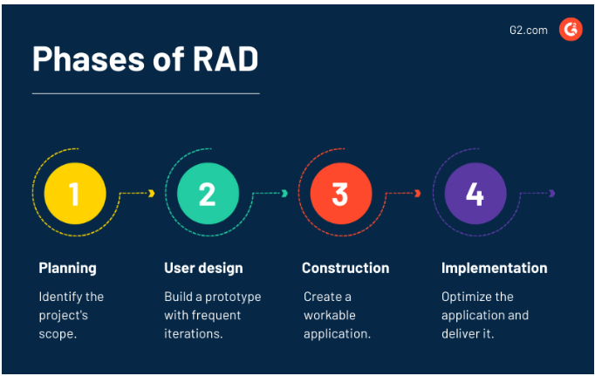

Figure 30: Rapid methodology phases ( Joshi, 2021).

Planning: In the planning phase, the project scope is identified, and stakeholder requirements (timeline, budget, expectations, and goals) are understood. This involves conducting meetings with developers, stakeholders, and the team to reach a consensus on the best way to meet the requirements quickly. The planning phase helps avoid confusion, minimize costly changes, and achieve a transparent understanding of stakeholder requirements. In RAD, planning is kept brief as requirements can change during development.

User Design: With a comprehensive understanding of client requirements, the user design phase focuses on building a prototype through rapid prototyping and iterative development. This involves working closely with clients to receive feedback and adjust as necessary. Creating prototypes enables developers to become aware of component complexities and facilitates the development of robust, structured, and less bug-prone applications.

Rapid Construction: In the rapid construction phase, a working model of the application is created based on the satisfactory prototype. As many issues, tweaks, and changes have already been addressed in the design phase, it takes less time to build workable applications. During this phase, developers, programmers, and testers stay connected with clients for feedback and accommodate any alterations and ideas. If clients find that some concepts do not function as expected, the prototype can be iterated to find a solution.

Implementation: The implementation phase involves making final changes to the application before launch. This includes data conversion, full-scale testing to detect bugs and issues, and optimizing the application for stability and maintainability. In addition, documentation, maintenance tasks, and user training are completed before handing over the final product to the client.

( Joshi, 2021) (TheAppSolutions, 2023)

#### **Advantages of RAD methodology**

The RAD methodology offers several advantages, including faster development, as its emphasis on iterative development, reusable components, and rapid prototyping enables quicker software development compared to traditional methodologies. Its adaptability allows teams to respond effectively to changing requirements and priorities, ensuring the final product meets stakeholders' and end-users' expectations. Improved communication is another significant benefit, as RAD's collaborative approach fosters cross-functional communication among team members, leading to a better understanding of project requirements and more effective problem-solving (Gorbachenko, 2023). Early risk detection is also a key advantage of RAD, as it identifies and mitigates risks throughout the development process, addressing potential issues before they escalate into significant problems. User-centric design is a core feature of RAD, with a focus on user feedback and prototyping to ensure that the software product is designed with the end-user in mind, ultimately leading to improved usability and user satisfaction. Finally, RAD is cost-effective, as the use of reusable components, rapid prototyping, and iterative development can result in reduced development costs and more efficient resource utilization ( Joshi, 2021).

#### **Disadvantages of RAD methodology**

RAD methodology, while advantageous in many aspects, also has its limitations. It may not be suitable for large-scale projects with complex requirements and dependencies, as its focus on rapid development can lead to oversights and difficulties in managing project scope. The success of RAD heavily depends on the expertise of development team members, who must be capable of adapting to changing requirements and quickly resolving issues. Furthermore, the emphasis on rapid development can sometimes result in inadequate documentation, making it challenging to maintain and scale the software product in the long run. Additionally, due to time constraints and the focus on rapid development, RAD projects may sometimes result in incomplete or suboptimal solutions that require further refinement and iteration. Insufficient planning, a consequence of the minimized planning and emphasis on adaptability in RAD, may lead to poor decision-making and inefficiencies in the development process. Lastly, implementing RAD may require a high initial resource investment, including significant upfront investments in training, software tools, and reusable components to ensure the development team can execute the methodology effectively. This investment may pose a challenge for organizations with limited resources or those that are hesitant to adopt a new development methodology (Agarwal, Prasad, Tanniru, & Lynch, 2000).

## Comparison of Proposed Methodologies

|  |  |  |
| --- | --- | --- |
| **Aspect** | **Scrum** | **Rapid Application Development (RAD)** |
| **Philosophy** | Agile framework focused on iterative and incremental development. | A methodology emphasizing rapid prototyping and user feedback for faster development. |
| **Planning** | Work is organized into fixed-length sprints with specific goals. | Planning is minimized, with an emphasis on iterative development and rapid prototyping. |
| **Team Structure** | Cross-functional teams with a Product Owner, Scrum Master, and Development Team members. | Smaller teams with multi-skilled members and a focus on collaborative work. |
| **User Involvement** | Regular stakeholder feedback through Sprint Reviews. | Extensive user involvement during prototyping and feedback phases. |
| **Development Cycle** | Work is organized into sprints, usually 1-4 weeks long. | Short, iterative cycles focused on developing and refining prototypes. |
| **Adaptability** | Highly adaptable due to iterative approach and regular feedback. | Highly adaptable due to minimal planning and emphasis on user feedback. |
| **Documentation** | Less emphasis on documentation, focusing on working software. | Flexible documentation, with a focus on working prototypes and user feedback. |
| **Product Type** | Suitable for various product types, especially those with evolving requirements. | Ideal for projects where quick delivery and adaptability are critical. |
| **Project Size** | Scalable for both small and large projects, depending on team and organization structure. | Better suited for small to medium-sized projects where speed and flexibility are essential. |
| **Suitability** | Best for projects with changing requirements and the need for close collaboration. | Best for projects requiring rapid delivery and the ability to quickly adapt to user needs. |

### Justification

In order to determine the most suitable methodology for the Small Enterprise Network Security Infrastructure (SENSI) project, both Scrum and Rapid Application Development (RAD) methodologies are compared across several criteria. While Scrum seems to be the preferred choice at first glance, a thorough analysis has been conducted for a conclusive decision.

Both Scrum and RAD are appropriate for small projects, with Scrum also being suitable for medium-sized projects due to its flexible team size of five to seven members. Both methodologies support software and application development, fitting the requirements of the SENSI project. However, there are differences in their workflow structure, adaptability to change, and approach to product delivery and documentation, which ultimately make Scrum the more suitable choice for this project.

Scrum is advantageous in its adaptability, as it employs an iterative approach and encourages regular feedback, making it more suited to address evolving requirements and security threats in the SENSI project. On the other hand, while RAD also involves user feedback, Scrum's structured approach to gathering feedback in each sprint ensures continuous alignment with stakeholder expectations.

In terms of team structure, Scrum utilizes cross-functional teams with clearly defined roles, facilitating effective collaboration and communication, leading to better project outcomes. Furthermore, Scrum's fixed-length sprints provide a structured and time-boxed approach to development, ensuring consistent progress and allowing the team to regularly reassess priorities and adapt the project scope as needed.

Scrum is scalable for both small and large projects, depending on team and organization structure, which ensures that the methodology can accommodate the potential growth of the SENSI project and any changes in its scope. As the SENSI project focuses on network security infrastructure and is likely to face continuous changes in requirements and security threats, Scrum's suitability for projects with changing requirements and the need for close collaboration between team members and stakeholders makes it a more suitable choice.

Lastly, Scrum can deliver results and product increments to customers more quickly than RAD, while also promoting efficiency with appropriate documentation that can lessen burdens and help to meet tight deadlines.

In conclusion, Scrum methodology is chosen for the SENSI project because it suits small web application development projects like this and works in flexible sprints that are adaptable to changes from clients, ensuring product quality. Its emphasis on collaboration, iterative development, and continuous feedback ensures that the project remains aligned with stakeholder needs and can quickly adapt to evolving security challenges.

## Implementation of Selected Methodology in SENSI

The chosen methodology for the SENSI project is a hybrid approach, combining elements from both Scrum and Rapid Application Development (RAD). This approach is deemed suitable for the project due to its flexibility, adaptability, and ability to incorporate user feedback throughout the development process.

Phase 1: Requirement Planning and Product Backlog Creation

In this phase, a combination of primary and secondary research methods is employed to gather information and define system requirements for SENSI. Literature reviews and analysis of similar systems provide insights into the domain and project scope. Additionally, feedback from target users is collected through questionnaires and interviews, enabling the developer to define initial requirements and user stories for SENSI's product backlog.

Phase 2: Prototyping and Sprint Planning

Using the requirements collected in the previous phase, the developer creates prototypes to demonstrate the features and functions of SENSI. Wireframe prototypes and UI designs are developed and presented to target users, allowing for the collection of functional feedback to enhance SENSI's system architecture and features. Concurrently, sprint planning takes place, with goals and durations determined based on the prioritized user stories in the product backlog.

Phase 3: Sprint and Construction

The developer works on the functional prototypes for SENSI and incorporates user feedback to create an improved User Experience (UX) design. During the sprint, the developer follows the sprint backlog, employing a task board to track progress on user stories and tasks. Unit Testing, Integrating Testing, and Usability Testing are conducted to ensure the functionality and usability of SENSI.

Phase 4: Daily Scrum and Testing

Daily Scrum meetings are held by the developer, allowing for continuous review of work progress on SENSI and identification of any underlying issues. The developer assumes the role of Scrum Master, brainstorming effective solutions and making necessary changes to user stories and tasks. The developer also performs testing on completed increments of SENSI and evaluates the results to ensure alignment with the listed requirements.

Phase 5: Sprint Review, Retrospective, and Cutover

At the end of each sprint, the developer reviews the work completed on SENSI and reflects on the successes and shortcomings. An improvement plan is conceived based on identified weaknesses and feedback from target users. Following the final sprint, the cutover phase commences, with the developer making any necessary adjustments and launching the completed SENSI product.

In summary, this hybrid methodology combines the strengths of both Scrum and RAD, allowing for a flexible, adaptable, and user-centric development process. By following this approach, the SENSI project aims to deliver a high-quality and user-friendly product within the specified timeframe."

# **RESEARCH METHODS**

## Introduction

In every research project, it is crucial to conduct a thorough investigation of the topic and the problem at hand. To address the research objectives effectively, selecting the appropriate research methodology is vital. Generally, research methods can be categorized into quantitative and qualitative approaches. Quantitative research focuses on testing theories and assumptions using numerical data, often represented in graphs and charts. Examples of quantitative methods include surveys, observations, and experiments. On the other hand, qualitative research aims to understand participants' opinions, thoughts, and experiences on specific topics or concepts. Examples of qualitative research methods are interviews, case studies, and focus groups (University of Newcastle, 2023).

For the SENSI project, a qualitative research method has been chosen to collect data from the target users, with interviews being the primary means of data collection. This approach was selected to gain a deeper understanding of the users' experiences, opinions, and thoughts relating to the project. Interviews allow for an in-depth exploration of the participants' perspectives, ensuring that the research conducted is highly relevant to the objectives and scope of the project. The data collected through these interviews will provide valuable insights into the potential issues that need to be addressed and will help in the development and enhancement of the SENSI system to cater to the users' needs and expectations accurately.

## Design

*Interview Questions Design:*

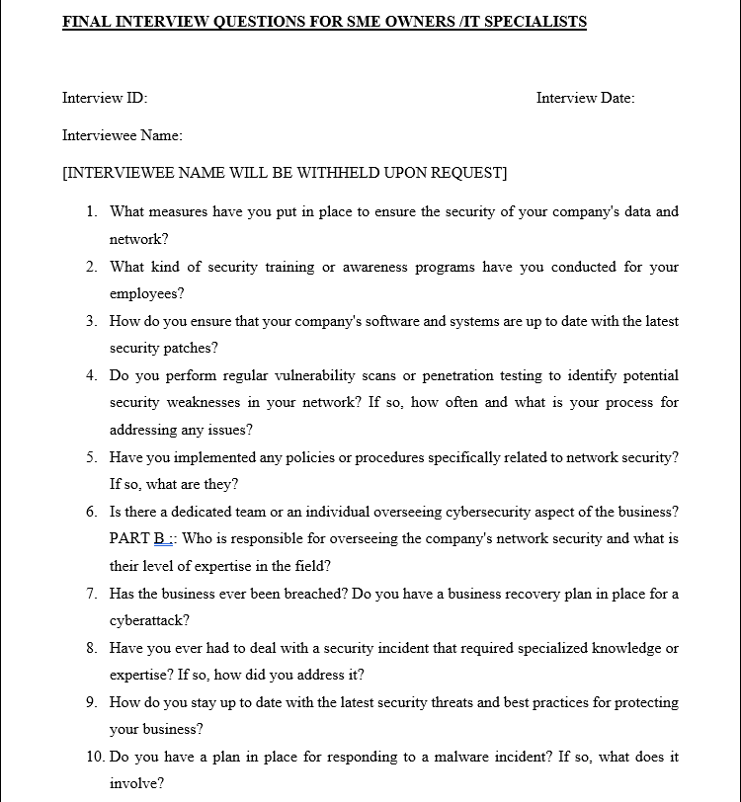

Figure 31: Finalized Interview Questions.

*Interview Consent Form Design:*

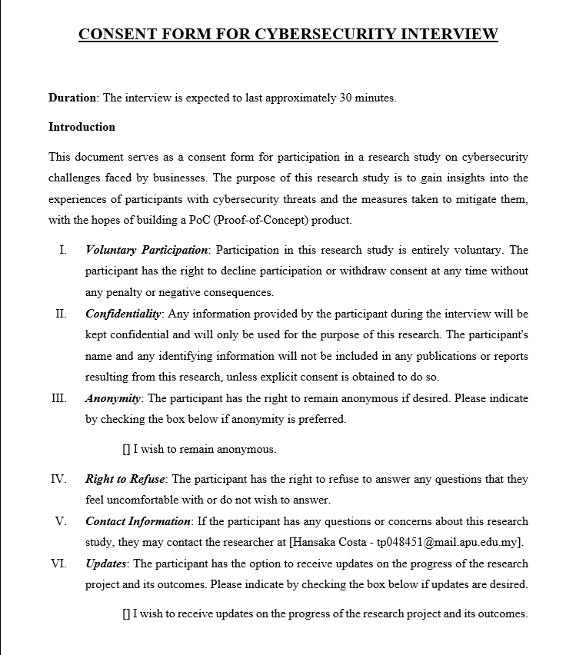

Figure 32: Consent Form for the Interview (A).

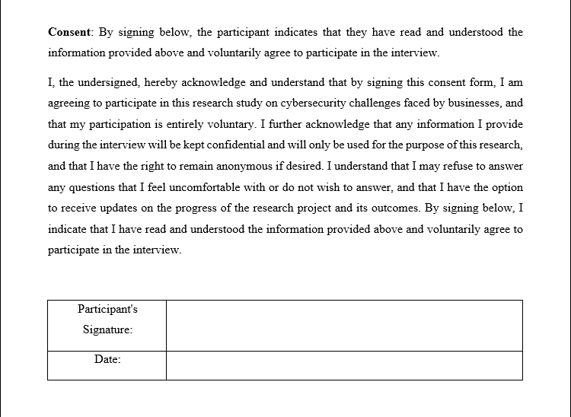

Figure 33: Consent Form for the Interview (B).

**Deeper Look at the Interview Questions**

1. *What measures have you put in place to ensure the security of your company's data and network?*

**Objective:** Gather insights into the security measures and practices implemented by the interviewee's company to protect their data and network.

1. *What kind of security training or awareness programs have you conducted for your employees?*

**Objective:** To understand the company's efforts in educating employees on cybersecurity practices and enhancing their security awareness.

1. *How do you ensure that your company's software and systems are up to date with the latest security patches?*

**Objective:** To assess the company's approach to maintaining updated software and systems for optimal security.

1. *Do you perform regular vulnerability scans or penetration testing to identify potential security weaknesses in your network? If so, how often and what is your process for addressing any issues?*

**Objective:** To determine the frequency and effectiveness of vulnerability assessments and the company's process for addressing identified security weaknesses.

1. *Have you implemented any policies or procedures specifically related to network security? If so, what are they?*

**Objective:** To identify the presence and nature of network security policies or procedures in the company.

1. *Is there a dedicated team or an individual overseeing cybersecurity aspect of the business?* ***PART B:*** *Who is responsible for overseeing the company's network security and what is their level of expertise in the field?*

**Objective:** To determine the organizational structure for cybersecurity oversight and the expertise of those responsible for network security.

1. *Has the business ever been breached? Do you have a business recovery plan in place for a cyberattack?*

**Objective:** To identify past security breaches and evaluate the existence and effectiveness of a cyberattack recovery plan.

1. *Have you ever had to deal with a security incident that required specialized knowledge or expertise? If so, how did you address it?*

**Objective:** To understand the organization's experience in handling security incidents requiring specialized knowledge and their approach to resolving such issues.

1. *How do you stay up to date with the latest security threats and best practices for protecting your business?*

**Objective:** To assess the organization's commitment to staying informed about evolving security threats and their approach to adopting best practices for safeguarding the business.

1. *Do you have a plan in place for responding to a malware incident? If so, what does it involve?*

**Objective:** To understand the organization's preparedness for handling a malware incident and gain insight into their response strategy.

## Summary

In this project, the interview method was chosen as the most appropriate approach for gathering data and insights on the topic, specifically from owners of SMEs and IT specialists working within these organizations. This method enabled the researcher to obtain in-depth opinions, experiences, and perspectives from the participants, focusing on aspects related to network security and company practices. Interviews were particularly useful in this context, as they allowed for a detailed exploration of the subject matter, beyond what could have been achieved through questionnaires alone.

By engaging with owners of SMEs and IT specialists in these organizations, the research was able to gather valuable information that contributed to the overall understanding of the problem at hand and the potential solutions to be implemented in the proposed system. This approach ensured that the project was grounded in real-world experiences and perspectives, ultimately enhancing its relevance and applicability to the target users, and addressing the unique challenges faced by SMEs in terms of network security and cybersecurity practices.

# **REQUIREMENTS VALIDATION**

In the Requirements Validation section, the primary focus is on verifying and refining the system requirements based on the insights gathered from interviews with five key stakeholders, who chose to remain anonymous. These stakeholders included owners of SMEs and IT specialists with a deep understanding of the unique challenges and needs of these organizations concerning network security and cybersecurity practices. To ensure the reliability and authenticity of the data collected, voice recordings were made during the interviews, which can be provided if needed for future reference. The interview questions, as mentioned earlier, were carefully designed to address various aspects of network security, employee training, incident response, and overall cybersecurity measures in place within the SMEs.

By analyzing the responses from these five interviewees, this section aims to validate and further refine the proposed system's requirements, ensuring that the final product is both relevant and effective in addressing the challenges faced by SMEs in maintaining a secure and resilient digital environment.

|  |  |  |  |  |  |
| --- | --- | --- | --- | --- | --- |
| **ID** | **Interview**  **1** | **Interview**  **2** | **Interview**  **3** | **Interview**  **4** | **Interview**  **5** |
| **Name** | *[ANONYMOUS]* | *[ANONYMOUS]* | *[ANONYMOUS]* | *[ANONYMOUS]* | *[ANONYMOUS]* |
| **Title** | *[ANONYMOUS]* | *[ANONYMOUS]* | *[ANONYMOUS]* | *[ANONYMOUS]* | *[ANONYMOUS]* |
| **Company** | *[ANONYMOUS]* | *[ANONYMOUS]* | *[ANONYMOUS]*  **Department:**  IT | *[ANONYMOUS]*  **Department:**  IT | *[ANONYMOUS]* |
| **Date of Interview** | 10/03/2023 | 10/03/2023 | 10/03/2023 | 11/03/2023 | 11/03/2023 |
| **Mode of Interview** | Face-to-face | Face-to-face | Face-to-face | Face-to-face | Face-to-face |

## Analysis of Interviews

1. *What measures have you put in place to ensure the security of your company's data and network?*

|  |  |
| --- | --- |
| Interview 1 | “Retail and therefore do not have advanced tech in place. Furthermore, staff scope does not include anything IT related.” |
| Interview 2 | “Nothing specific as we are a startup. But we do have VPNs for remote connectivity.” |
| Interview 3 | “We have various ACLs in place for end-point devices. We are struggling to match government compliance but hopeful.” |
| Interview 4 | “Outsourced database security. For the network, software-based firewalls along with Microsoft Defender on the cloud as a IPS.” |
| Interview 5 | Customer database is on the cloud and secured with the packaged security services. |

Analysis:

Interview 1 highlights that the retail nature of the company may not require advanced security measures, and their staff is not focused on IT-related tasks. This may leave the company vulnerable to cyber threats due to insufficient security measures and lack of specialized IT personnel.

Interview 2 points out that the company is a startup and has implemented VPNs for remote connectivity. While VPNs are a good starting point, relying solely on this security measure might not be enough to protect the company's data and network comprehensively.

Interview 3 mentions the use of Access Control Lists (ACLs) for endpoint devices and efforts towards meeting government compliance. This suggests that the company is aware of the importance of network security but may still be struggling to meet all the necessary standards.

Interview 4 indicates that the company has outsourced database security and uses a combination of software-based firewalls and Microsoft Defender on the cloud as an Intrusion Prevention System (IPS). This approach demonstrates a more comprehensive strategy for securing their data and network.

Interview 5 reveals that the company's customer database is stored on the cloud and secured using the packaged security services provided by the cloud provider. This suggests a reliance on the cloud provider's security measures, which might not cover all potential threats specific to the company.

In summary, the answers reveal that SMEs implement different security measures based on their size, industry, and available resources. However, some companies may not have adequate protection in place, indicating a need for a more comprehensive and tailored approach to cybersecurity for SMEs.

1. *What kind of security training or awareness programs have you conducted for your employees?*

|  |  |
| --- | --- |
| Interview 1 | “None.” |
| Interview 2 | “None.” |
| Interview 3 | “Nothing yet – planning in the future for compliance purposes.” |
| Interview 4 | “We have awareness program once every 6 months.” |
| Interview 5 | “Hoping to conduct one soon” |

Analysis:

Interviews 1 and 2 reveal that these companies have not conducted any security training or awareness programs, which may leave them more vulnerable to cyber threats due to a lack of employee knowledge and awareness.

Interview 3 mentions that they have not yet implemented any security training, but they are planning to do so in the future for compliance purposes. This indicates that the company recognizes the importance of employee training in maintaining security, but has not yet taken action.

Interview 4 demonstrates a more proactive approach, with the company holding a security awareness program once every six months. This can help ensure that employees are informed about potential threats and can contribute to maintaining a secure environment.

Interview 5 indicates that the company is hoping to conduct a security training program soon. Although they have not yet implemented a program, the intention to do so shows a level of awareness and commitment to improving their security posture.

In summary, the majority of the interviewed SMEs have not yet implemented employee security training or awareness programs. This suggests a potential vulnerability and highlights the importance of investing in employee training to reduce the risk of cyber threats and improve overall security.

1. *How do you ensure that your company's software and systems are up to date with the latest security patches?*

|  |  |
| --- | --- |
| Interview 1 | “Regular updates from notifications in Microsoft or antivirus.” |
| Interview 2 | “Wait for notifications from specific software.” |
| Interview 3 | “I keep up with the latest software releases on behalf of the company.” |
| Interview 4 | “We have specific software that keeps up to date with software version releases for critical systems.” |
| Interview 5 | “Mostly notifications from the specific source unless I get to know a newer version exists from external sources.” |

Analysis:

Interview 1 indicates that the company relies on notifications from Microsoft or antivirus software for updates. This approach may be sufficient for basic security but might not be comprehensive in addressing all potential vulnerabilities.

Interview 2 also depends on notifications from specific software for updates. This approach is similar to Interview 1 and may leave the company vulnerable to threats that are not covered by the software's update notifications.

Interview 3 demonstrates a more proactive approach, with the interviewee taking personal responsibility for keeping up with the latest software releases on behalf of the company. This method can be more effective in ensuring up-to-date security patches, but it relies heavily on the individual's vigilance and knowledge.

Interview 4 reveals that the company uses specific software to keep their critical systems updated with the latest security patches. This approach can be more efficient and effective in maintaining up-to-date security measures.

Interview 5 combines both notification-based updates and external sources for information on newer software versions. This approach can help the company stay updated with security patches but may still be limited by the timeliness and comprehensiveness of the notifications and external sources.

In summary, the interviewed SMEs have varying methods for ensuring their software and systems are up to date with the latest security patches. Some rely on notifications, while others take a more proactive approach. Companies should consider adopting a more comprehensive and proactive approach to updating their software and systems to minimize vulnerabilities and maintain strong security measures.

1. *Do you perform regular vulnerability scans or penetration testing to identify potential security weaknesses in your network? If so, how often and what is your process for addressing any issues?*

|  |  |
| --- | --- |
| Interview 1 | “No.” |
| Interview 2 | “We have done 1 testing since starting the company in 2019. We are hoping to do more.” |
| Interview 3 | “Once a year for compliance. The vulnerability testing company provides details on how to address the security concerns.” |
| Interview 4 | “We have one black box testing every year. 1 white box testing every 6 months. We have in-house specialists to address security holes found.” |
| Interview 5 | “None.” |

Analysis:

Interview 1 and Interview 5 indicate that their companies do not perform vulnerability scans or penetration testing, which leaves them potentially exposed to unknown security risks.

Interview 2 mentions having conducted only one testing since starting the company in 2019 and plans to do more. This infrequent testing might not be sufficient to identify and address new vulnerabilities that may emerge over time.

Interview 3 performs vulnerability scans once a year for compliance purposes and relies on the vulnerability testing company to provide guidance on addressing security concerns. Although this approach is better than not conducting any tests, annual testing might still not be frequent enough to keep up with the rapidly evolving threat landscape.

Interview 4 seems to have a more robust approach, with one black box testing every year and one white box testing every six months. Additionally, they have in-house specialists to address security issues identified during the tests. This approach is more comprehensive and proactive compared to the other respondents.

In summary, the interviewed SMEs demonstrate varying levels of commitment to vulnerability scanning and penetration testing. Companies should consider conducting regular and more frequent tests and have a process in place to address identified vulnerabilities in order to strengthen their network security.

1. *Have you implemented any policies or procedures specifically related to network security? If so, what are they?*

|  |  |
| --- | --- |
| Interview 1 | “We have WPA2 encryption for WiFi network.” |
| Interview 2 | “No. Except for the VPN we spoke about earlier.” |
| Interview 3 | “Mostly ACL for network security purposes.” |
| Interview 4 | “Nothing specific to network security. As a cloud start up, we depend on the security provided by the hosting company.” |
| Interview 5 | “Encryption for WiFi networks using a pre-set password.” |

Analysis:

Interview 1 and Interview 5 have implemented WPA2 encryption for their WiFi networks, which is a basic yet essential measure to secure wireless connections. However, this might not be enough to fully protect their networks from advanced threats.

Interview 2 has not implemented specific network security policies, but they do use VPNs for remote connectivity. While VPNs can improve security and privacy, they are not a comprehensive solution for network security.

Interview 3 employs ACLs (Access Control Lists) for network security purposes. ACLs help control access to network resources, but they should be complemented by other security measures to provide a more robust defense.

Interview 4 relies on the security provided by their cloud hosting company, which may offer some protection but might not be tailored to the specific needs of the business. It is essential to implement additional security measures that cater to the unique requirements of the company.

In summary, the interviewed SMEs have implemented some basic network security measures, but they may not be sufficient to protect against advanced threats. Companies should consider adopting a more comprehensive approach to network security, including implementing tailored security policies and procedures, to better safeguard their networks.

1. *Is there a dedicated team or an individual overseeing cybersecurity aspect of the business?* ***PART B:*** *Who is responsible for overseeing the company's network security and what is their level of expertise in the field?*

|  |  |
| --- | --- |
| Interview 1 | “Admin.” |
| Interview 2 | “The owner – don’t have the budget to hire a dedicated security guy.” |
| Interview 3 | “As the IT Manager, it falls under me. I have a master’s in information systems management.” |
| Interview 4 | “Yes, as we import and export data around the globe, we are required by law to have a qualified CISO.” |
| Interview 5 | “It is done by the owner. He has a Degree in Computer Science.” |

Analysis:

Analyzing the responses to the question "Is there a dedicated team or an individual overseeing cybersecurity aspect of the business? Who is responsible for overseeing the company's network security and what is their level of expertise in the field?", the following insights can be derived:

Interview 1 indicates that the admin is responsible for overseeing cybersecurity, which might not be the most suitable role for handling such critical tasks, as they may lack the necessary expertise.

Interview 2 reveals that the owner oversees cybersecurity due to budget constraints, which might not be the best option since they may not have the required skills or the time to effectively manage network security.

Interview 3 has an IT Manager with a master’s in information systems management, which suggests a higher level of expertise and a more appropriate person to oversee network security.

Interview 4 has a legally mandated CISO (Chief Information Security Officer) to oversee cybersecurity, which indicates a higher level of commitment to network security and likely more advanced security measures in place.

Interview 5 has the owner overseeing cybersecurity, who holds a Degree in Computer Science. While this suggests some level of expertise, it might still be insufficient to fully address the complexities of network security.

In summary, the interviewed SMEs have varying levels of expertise and dedication to cybersecurity. Companies with limited resources or expertise should consider investing in specialized personnel or seeking external guidance to enhance their network security and better protect their business.

1. *Has the business ever been breached? Do you have a business recovery plan in place for a cyberattack?*

|  |  |
| --- | --- |
| Interview 1 | “We have been in business for 15 years and no breach. And we do not have a recovery plan.” |
| Interview 2 | “Yes, breached twice in the past. So we have a recovery plan for this in case it happens in the future again.” |
| Interview 3 | “Yes, we were attacked by ransomware last year. Our recovery plan requires timely back-ups of all important systems.” |
| Interview 4 | “Definitely exposed to many attempts but we were protected by our security services provided by the cloud provider.” |
| Interview 5 | “No, we were never hacked and we do not have a recovery plan in place.” |

Analysis:

Interview 1 states that there has been no breach in their 15 years of business, but they lack a recovery plan. This reveals a potential vulnerability, as they may not be prepared to respond effectively if a breach were to occur.

Interview 2 has experienced two breaches in the past and now has a recovery plan in place. This demonstrates an increased awareness of the importance of cybersecurity and preparedness for future incidents.

Interview 3 experienced a ransomware attack and has implemented a recovery plan involving timely backups of critical systems. This indicates a proactive approach to minimizing potential damage from future cyberattacks.

Interview 4 mentions no successful breaches due to the security services provided by their cloud provider. However, it's unclear whether they have a recovery plan in place, which could be a point of concern.

Interview 5 has not experienced any breaches and does not have a recovery plan in place. This exposes the business to significant risk in the event of a cyberattack.

In summary, while some of the interviewed SMEs have experienced breaches and implemented recovery plans, others have not. It is crucial for all businesses, regardless of past incidents, to have a well-defined recovery plan in place to minimize potential damage and ensure business continuity in the event of a cyberattack.

1. *Have you ever had to deal with a security incident that required specialized knowledge or expertise? If so, how did you address it?*

|  |  |
| --- | --- |
| Interview 1 | “No no such event.” |
| Interview 2 | “Yes – we had to hire outside help.” |
| Interview 3 | “Yes, multiple times. Many were taken care of by us. Some required outside assistance.” |
| Interview 4 | “Yes – vast number of DDoS attacks were attempted. We had outsourced to resolve the issue.” |
| Interview 5 | “No nothing specific.” |

Analysis:

Interview 1 and Interview 5 both report that they have not experienced any security incidents that required specialized knowledge or expertise. This could suggest either a relatively secure environment or a lack of awareness of potential security threats.

Interview 2 and Interview 4 have faced security incidents that required external assistance to resolve. This indicates that their in-house resources may not be sufficient to handle certain types of cybersecurity threats and that they recognize the need for specialized expertise in those cases.

Interview 3 has dealt with multiple security incidents, some of which were addressed internally, while others required external assistance. This demonstrates a combination of internal expertise and the recognition of when to seek help from outside sources.

In summary, the responses show varying degrees of experience in dealing with security incidents requiring specialized expertise. Businesses must remain vigilant and be prepared to seek external assistance when necessary to handle complex cybersecurity threats.

1. *How do you stay up to date with the latest security threats and best practices for protecting your business?*

|  |  |
| --- | --- |
| Interview 1 | “Mostly news and social media and government notices.” |
| Interview 2 | “Mostly government notices and news.” |
| Interview 3 | “We follow through with the security directives provided by our software and hardware suppliers.” |
| Interview 4 | “We have a very passionate IT team – they take care of everything. They are part of many security circles among the government as well our cloud provider.” |
| Interview 5 | “Social media and news” |

Analysis:

Interview 1, Interview 2, and Interview 5 mostly rely on news, social media, and government notices to stay informed about the latest security threats and best practices. This suggests that they may be reactive to threats and depend on external sources for information.

Interview 3 focuses on following security directives provided by their software and hardware suppliers. This approach may help them to stay updated on specific threats related to their technology stack but may not provide comprehensive coverage of all potential threats.

Interview 4 has a dedicated IT team that stays up to date through various security circles, including the government and their cloud provider. This proactive approach demonstrates a strong commitment to maintaining a secure environment and being informed about the latest threats and best practices.

In summary, the responses show varying degrees of reliance on external sources for staying informed about security threats and best practices. It is important for businesses to be proactive in their approach to cybersecurity, using a combination of external sources and in-house expertise to stay updated on the latest threats and best practices.

1. *Do you have a plan in place for responding to a malware incident? If so, what does it involve?*

|  |  |
| --- | --- |
| Interview 1 | “I don’t think we are in any serious danger so no we do not have any response plan for this.” |
| Interview 2 | “Yes, we take back-ups once every 2 weeks.” |
| Interview 3 | “Yes we have a special response plan for malware.” |
| Interview 4 | “We have a series of plans for all types of cybersecurity related incidents and malware infections is one of them.” |
| Interview 5 | “We are in the process of making one – it is taking a bit longer than expected as we do not have the proper budget to implement such plans right away.” |

Analysis:

Interview 1 does not have a plan in place for responding to a malware incident, as they do not perceive any serious threat to their business. This attitude may leave them vulnerable to malware attacks and unprepared to handle them efficiently.

Interview 2 has a plan that involves taking backups every two weeks. While this is a good practice to ensure data recovery, it may not be sufficient for preventing or mitigating the impact of a malware attack.

Interview 3 has a special response plan specifically designed for malware incidents. This demonstrates a proactive approach to managing potential cybersecurity risks related to malware.

Interview 4 has a comprehensive set of plans for various cybersecurity incidents, including malware infections. This approach shows a strong commitment to addressing cybersecurity risks and being prepared for different scenarios.

Interview 5 is in the process of developing a response plan for malware incidents but faces budget constraints that are delaying its implementation. This highlights the challenges faced by some businesses in allocating resources to cybersecurity initiatives.

In summary, the responses show varying levels of preparedness for handling malware incidents. Businesses should prioritize developing and implementing comprehensive response plans to minimize the potential impact of malware attacks and enhance their overall cybersecurity posture.

## Summary

In this section, the researcher has analyzed the responses gathered from the questionnaire and interview with SME owners and IT specialists. The aim was to gain insights into their cybersecurity practices and to understand the potential requirements for a proposed cybersecurity system. The analysis provides valuable data about the current state of cybersecurity awareness, measures in place, and the need for improved security strategies. The findings indicate that many SMEs lack dedicated cybersecurity personnel or sufficient training programs for their employees. Furthermore, the majority of the respondents do not have regular vulnerability assessments or malware response plans in place. These insights have helped to identify gaps in cybersecurity practices and will inform the development of the proposed system, ensuring it addresses the real needs of SMEs.

Some key requirements that have emerged from this analysis include the need for accessible cybersecurity training, automated vulnerability assessments, and streamlined incident response plans. Additionally, the findings suggest the potential for integrating these features into a comprehensive cybersecurity solution tailored for SMEs.

# **SYSTEM ARCHITECTURE**

## Introduction

As outlined earlier, SENSI is an innovative Small Enterprise Network Security Infrastructure that integrates several powerful features to meet the security needs of small business networks. This section meticulously explains all of SENSI's core features and functionalities, promoting a thorough understanding for the reader.

At its essence, SENSI is designed to operate as a comprehensive security infrastructure. It is built primarily on Raspberry Pi, utilizing Suricata as the primary intrusion detection and prevention system (IDS/IPS). The user-friendly Sensi-menu bash script serves as the main control panel, giving users access to a wide range of options and features within the system. The system continuously monitors network traffic, detecting any suspicious activities or anomalies. Suricata then logs these alerts into a fast.log file. This choice of logging mechanism was made after careful comparison and analysis of various logging options offered by Suricata, with fast.log proving to be the most efficient and effective.

For an immediate response to threats and network anomalies, SENSI integrates a Telegram Notification Service, where a bot promptly pushes all alerts to a designated Telegram group. This allows multiple users or stakeholders to be informed in real-time, adding a layer of collaborative response to the network security. Users can invite other stakeholders to this group, providing everyone involved with a comprehensive view of network security alerts. The system also incorporates a feature to update the Raspberry Pi firmware, ensuring the device is always running the latest secure version. The 'Configurator.py' script, a part of the system, helps efficiently manage Suricata rules, and the testing option allows for system integrity checks whenever needed.

SENSI combines a broad spectrum of features to provide small businesses with a comprehensive network security solution. Given its vital role in protecting sensitive data, the system prioritizes simplicity, efficiency, and robust security measures to instill user confidence.

## Abstract Architecture

### System Design

System design is an organized process of designing the integral components of a system, including the interfaces, architecture, modules, and entities. It sheds light on how these elements work together to make a system function as intended. Here is an overview of each of these components as they relate to SENSI:

* **Architecture** – This underlines SENSI's relationship, structure, and general functionalities. The architecture centres on a Raspberry Pi device running Suricata as its main IDS/IPS and utilizes a bash script as a primary interface for managing the system. Alerts detected by Suricata are logged as a fast.log file, offering an efficient way to record and track network anomalies. A Telegram bot is also integrated into the architecture to send real-time notifications of these alerts to a dedicated Telegram group.
* **Modules** – These represent the tasks and activities executed within SENSI. The Sensi-menu bash script, for example, allows users to navigate various options, from updating Raspberry Pi firmware to managing Suricata rules via the 'Configurator.py' script and testing the system's integrity. Each module contributes to the system's overall functionality and efficiency.
* **Interfaces** – This aspect focuses on how information exchange occurs and how details are displayed. The Sensi-menu bash script is the primary user interface to interact with the system. Moreover, the Telegram group allows users to receive real-time notifications on potential security threats.
* **Entities** – These spotlight specific attributes and their corresponding behaviour within the system - for example, in SENSI, the Raspberry Pi device, the Suricata IDS/IPS, and the Telegram Bot can be viewed as primary entities, each having specific attributes and roles to play within the system.

The system design also enables understanding how well the components communicate to fulfil predefined requirements. Therefore, in this chapter, all design representations of SENSI, such as the system architecture diagram and sequence and activity diagrams for the system's various features, are included to present a comprehensive system view.

#### **System Architecture Diagram**

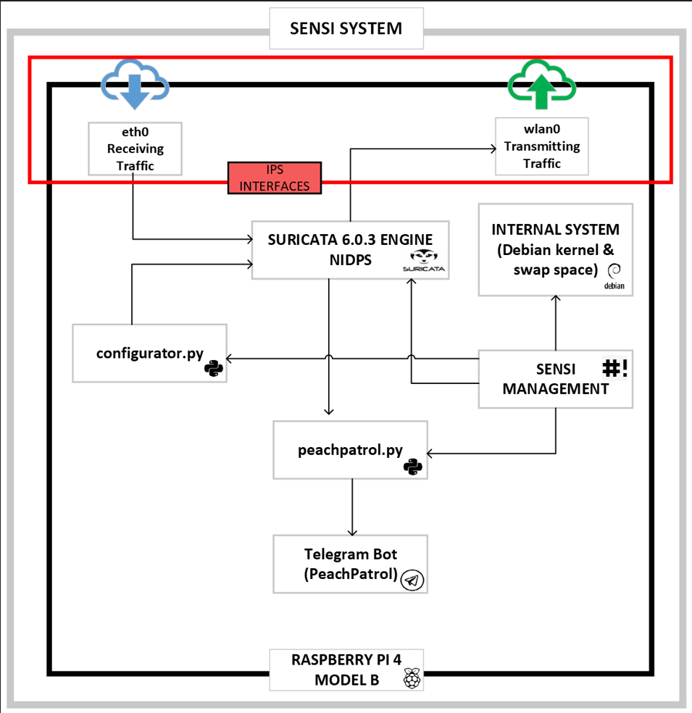

Figure 34: SENSI System Architecture.

The illustration above (figure 34) provides a detailed overview of the system architecture for the SENSI system. The SENSI system encapsulates all components within two broad layers represented as two outer boxes. The outer-most box denotes the SENSI system, and within this resides the more specified outer box that signifies the Raspberry Pi Model B in all other components are housed. In the Raspberry Pi component, at the top, are two interfaces labelled "eth0 Receiving Traffic" (ethernet) and "wlan0 Transmitting Traffic" (wireless LAN). These represent the interfaces that receive and transmit incoming and outgoing network traffic. All Intrusion Prevention Systems require two interfaces to create choke points to manipulate network traffic - these interfaces in the SENSI system are highlighted within the encapsulating red box marked "IPS INTERFACES".

Below the IPS Interfaces, the architecture houses six other key components vital for operating the SENSI system. At the top middle resides the "Suricata 6.0.3 Engine NIDPS" component, serving as the heart of the intrusion detection and prevention functionality. Adjacent to this is the "Internal System" component, which signifies the internal system management and kernel operations, underlining the inherent dependency of the SENSI on Debian.

Beneath the Suricata Engine are two interconnected boxes: "configurator.py" python3 script and "Sensi Management" bash script. The former is a dedicated configuration script connecting to the Suricata engine and ensuring the network intrusion prevention system functions effectively. The latter is a central managing module interacting with the internal system, Suricata Engine, configurator.py, and another python3 script named "peachpatrol.py". The "peachpatrol.py", located centrally below the previous layer, acts as a bridge between the Suricata Engine and the final box at the bottom, labelled "Telegram Bot (PeachPatrol)". The script processes alerts from the NIDPS and forwards them to the Telegram bot, ensuring stakeholders receive timely notifications.

The SENSI system's architecture clearly illustrates how each component connects and interacts, portraying an efficient model for a lightweight, low-resource-consuming NIDPS. The ethernet interface feeds traffic to the Suricata Engine, which analyses the data, and in the case of any detected threats, sends alerts to the PeachPatrol script. This script, managed by SENSI management, pushes the alerts to the PeachPatrol Telegram Bot. The clean network traffic is passed to the wlan interface, where the traffic is egressed to the internal network.

### Suricata as NIDPS

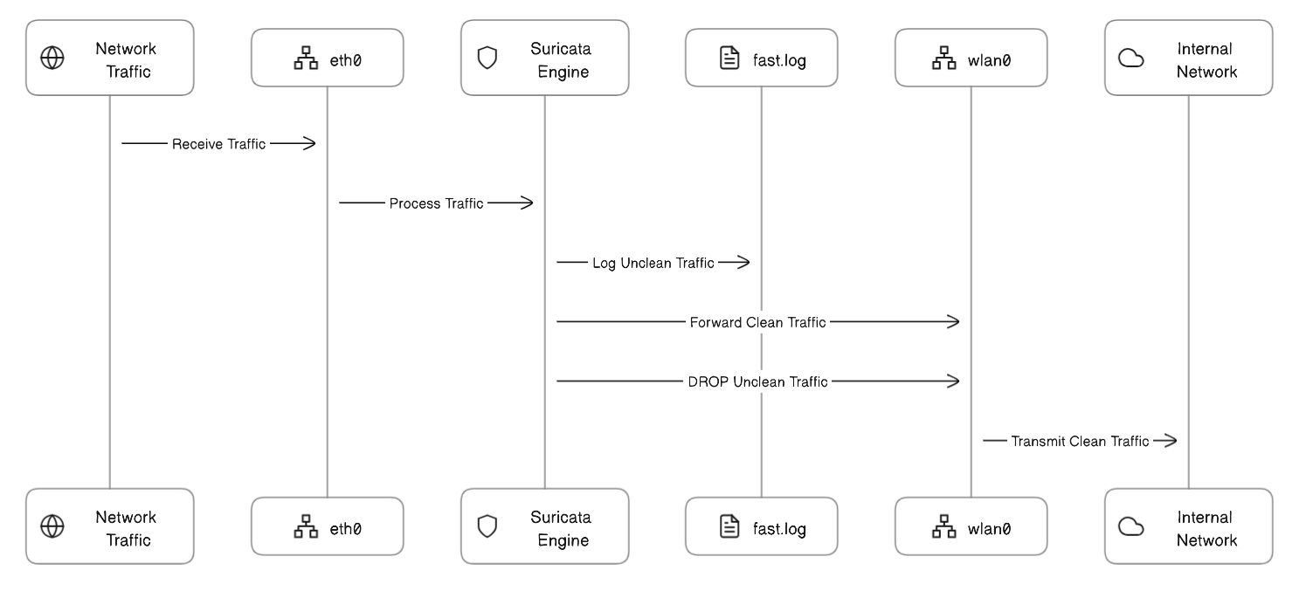

Figure 35: Suricata IPS Sequence Diagram.

The Suricata Network Intrusion Detection & Prevention System (NIDPS) is at the SENSI system’s core. Its principal function within the SENSI system is to monitor network traffic, identify potential threats, and interact with the Telegram Bot to ensure real-time alerting in the case of any detected anomalies.

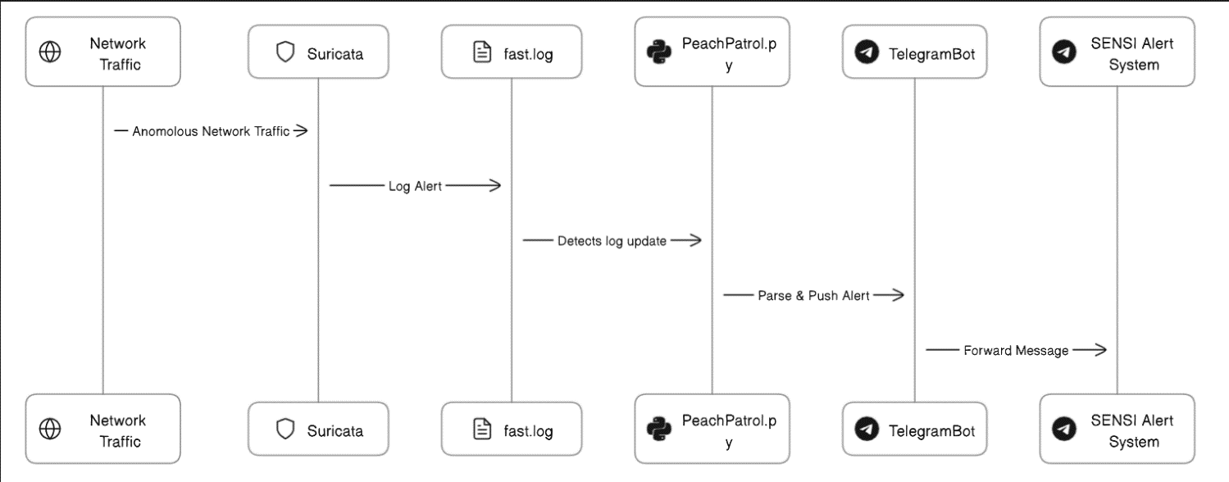

Figure 36: Suricata's interaction with Telegram Bot upon anomaly detection.

Suricata is a social mammal found in Africa and known for its sharp observation skills and ability to detect threats quickly. This is a fitting name for this particular IPS system as Suricata is always on guard and serves as the first line of defense against potential threats by continuously analyzing network traffic. Its rule-based engine enables it to effectively differentiate between clean and unclean traffic, meaning that it can identify many threats, including malware, exploits, and other malicious activities. In the system, this role is visually represented in the above sequence diagram (figure 36), showing how Suricata handles incoming traffic and deals with clean and unclean traffic.

However, identifying threats is just the first step in the process. Upon detection of any anomalous activity, Suricata interacts with the Telegram Bot, a unique feature of the SENSI system. The integration with Telegram Bot allows SENSI to notify administrators and other involved stakeholders immediately whenever an anomaly is detected via Telegram messages. This provides real-time awareness of any threats. This interaction is represented in the above sequence diagram (figure 36) showcasing the events unfolding once Suricata detects an anomaly.

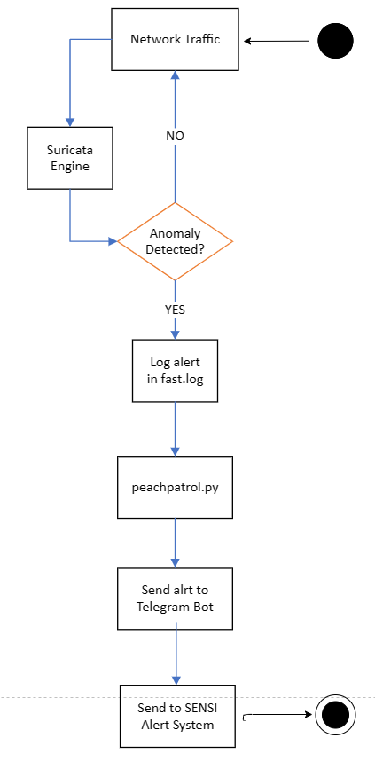

Figure 37: Suricata's interaction with Telegram Bot.

Moreover, the activity diagram above (figure 37) complements the sequence diagram by providing a more detailed view of how Suricata engages peachpatrol.py script and the Telegram Bot.

In summary, Suricata plays an essential role in maintaining the security and integrity of the SENSI system. Its capabilities of detecting and handling threats, coupled with the real-time alerting mechanism through the Telegram Bot, make it a critical component in the SENSI system.

### SENSI Management Bash Script

The SENSI Management aspect of the system serves as the control centre for Small Enterprise Network Security Infrastructure (SENSI). It provides an easy-to-use interface that allows the user to maintain, update, and configure various aspects of the system via a well-designed bash script includes eight main options that each manage a specific task, enhancing the system’s functionality and ensuring optimal performance.

#### **Update OS**

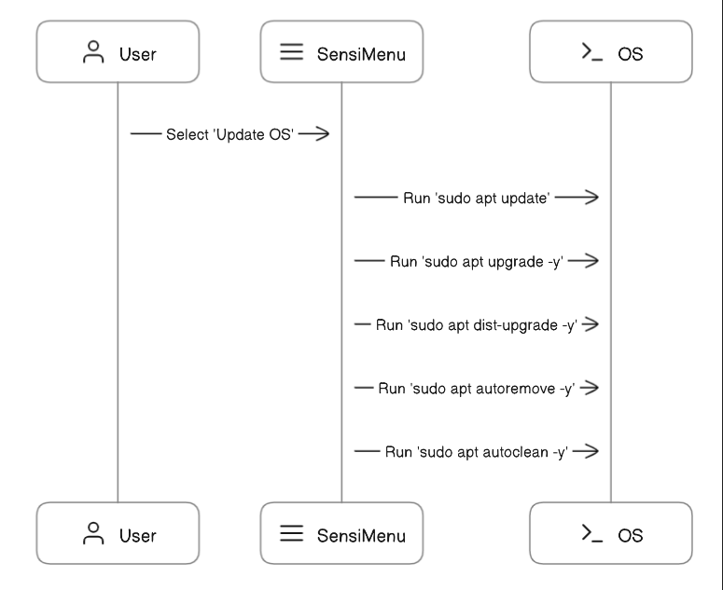

Figure 38: Update OS sequence diagram.

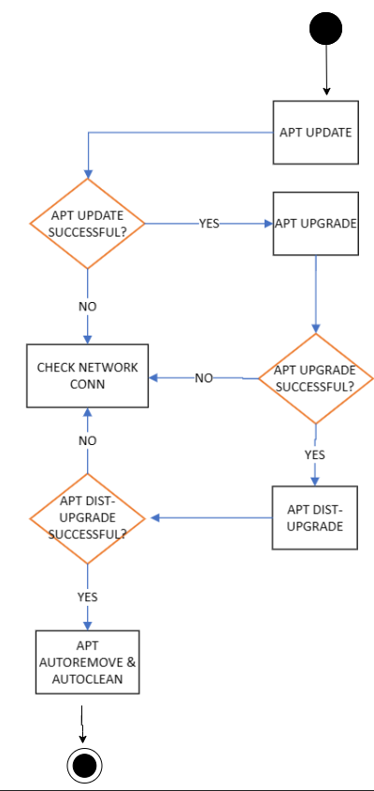

Figure 39: Update OS activity diagram.

The first option in the bash script handles updating the Debian-based operating system. It uses the apt package manager to perform a distribution upgrade, autoremove, and autoclean operations. The sequence diagram (figure 38) and the activity diagram (figure 39) visually represent this process.

#### **See Available Updates**

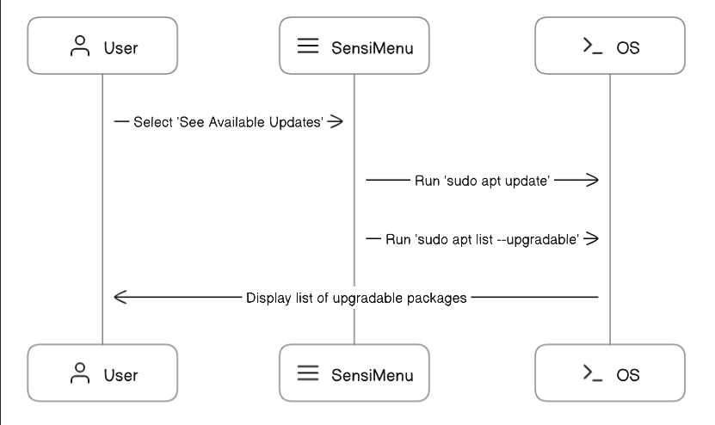

Figure 40: See Available Updates sequence diagram.

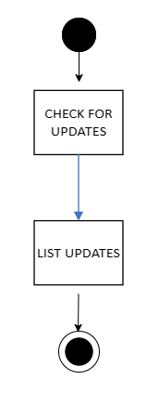

Figure 41: See Available Updates activity diagram.

This option checks for available updates for the system from the configured sources via the apt package manager and provides a list of all upgradable packages. Its sequence and flow diagrams (figure 40 & figure 41) provide an overview of how this operation works.

#### **Update Raspberry Pi Firmware**

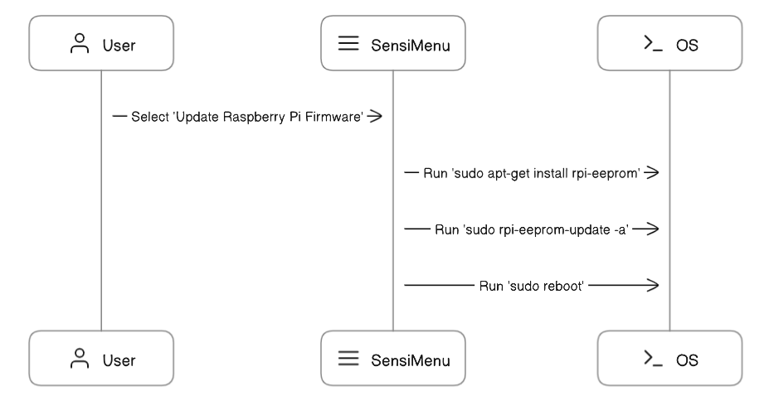

Figure 42: Update Raspberry Pi Firmware sequence diagram.

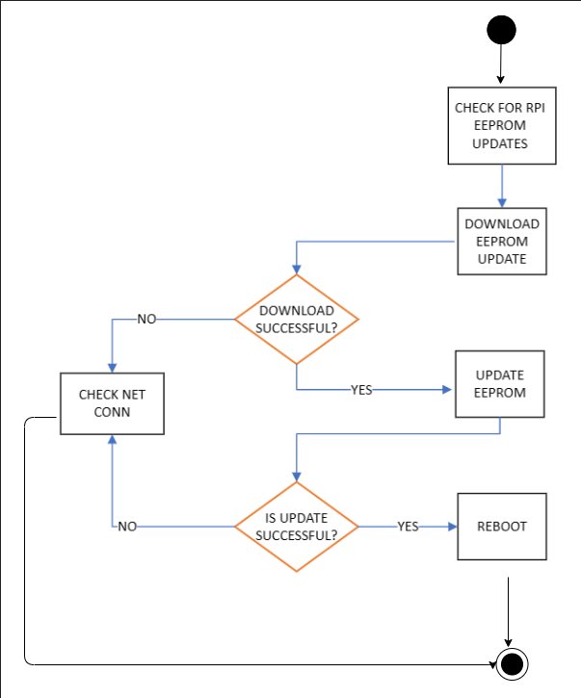

Figure 43: Update Raspberry Pi Firmware activity diagram.

This option installs the RPI-EEPROM package and performs an EEPROM update to ensure the Raspberry Pi is up to date. The above sequence and activity diagrams (figure 42 & figure 43) showcase its processes.

#### **View Latest Logs**

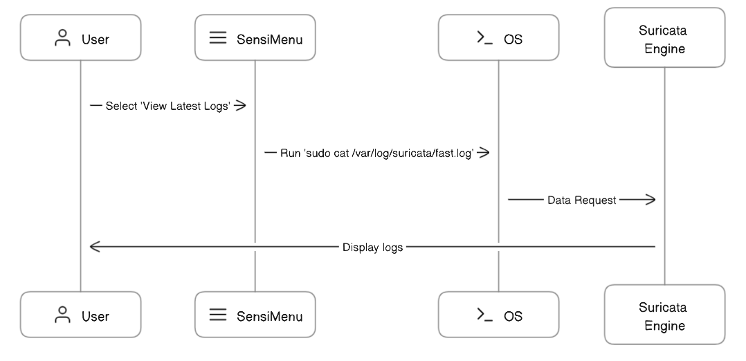

Figure 44: View Latest Logs sequence diagram.

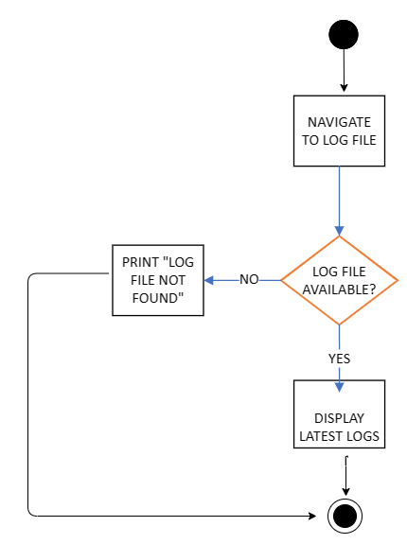

Figure 45: View Latest Logs activity diagram.

This option is designed to provide the user with the Suricata fast.log file’s output. It is critical for monitoring the system’s activity and detecting potential issues early. The above sequence diagram (figure 44) and activity diagram (figure 45) visualize how this operation takes place.

#### **Run Configurator**

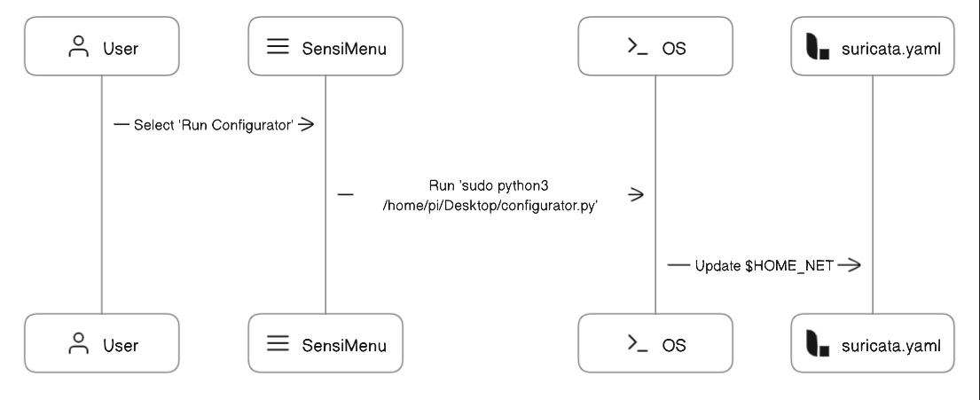

Figure 46: Run Configurator sequence diagram.

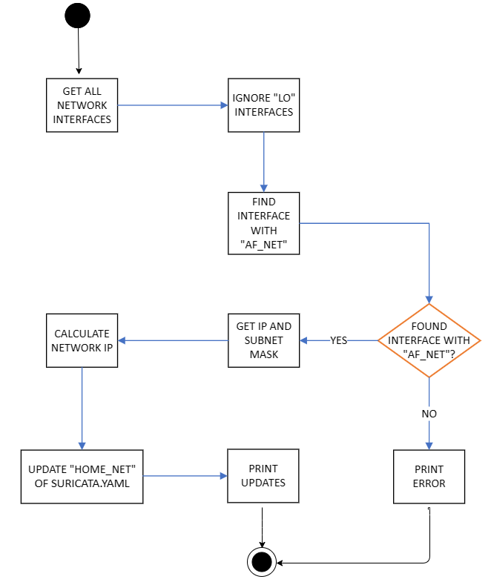

Figure 47: Run Configurator activity diagram.

This option runs the configurator.py python3 script which is designed to configure Suricata to function optimally with the network SENSI is connected to. The sequence diagram (figure 46) shows the operational steps, and the activity diagram (figure 47) shows the logic it follows.

#### **Activate Telegram Notification Service**

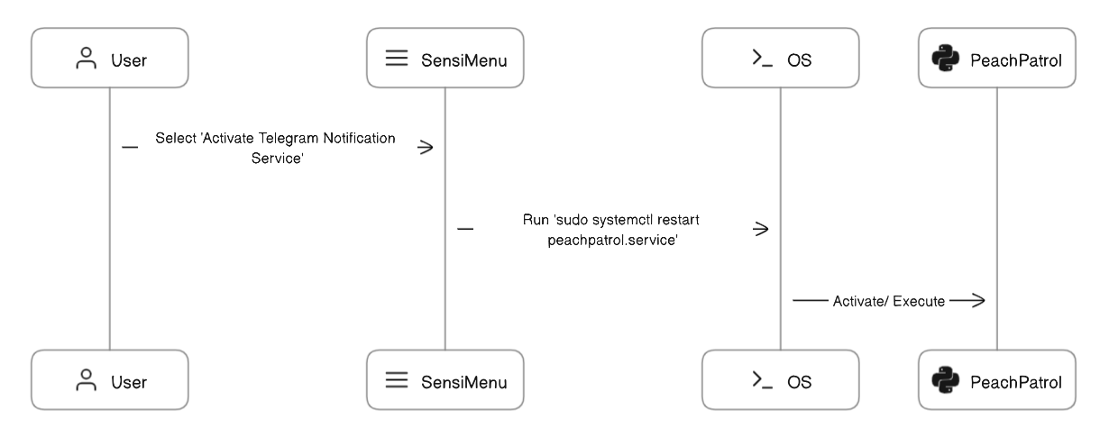

Figure 48: Activate Telegram Notification Service sequence diagram.

The activation of the Telegram Notification Service happens via this option. It force starts the peachpatrol service to run in the background (daemon). This service is responsible for the peachpatrol python3 script which handles Suricata alerts and sends them to a designated Telegram chat for prompt notification and action. The above sequence diagram (figure 48) visualizes the processes accompanied with this selection.

#### **Test Suricata Configuration**

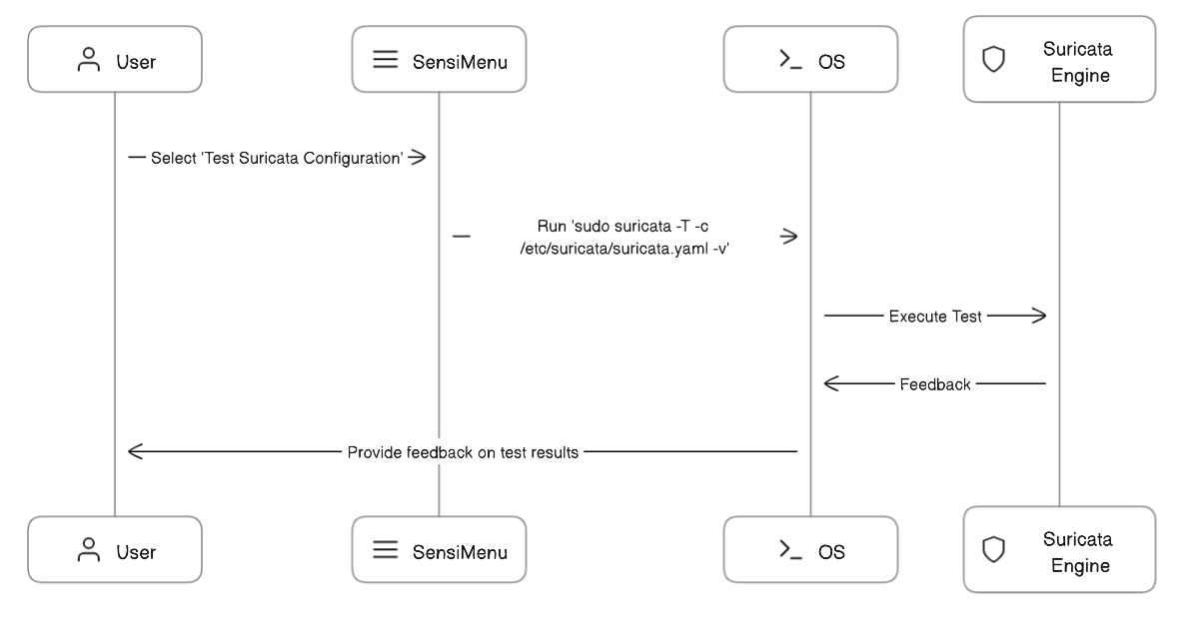

Figure 49: Test Suricata Configuration sequence diagram.

The script also offers an option to run Suricata in test mode to verify that the configuration is correct. This is crucial for preventing system failure due to incorrect configuration settings. The above sequence diagram (figure 49) visualizes this option.

#### **Exit**

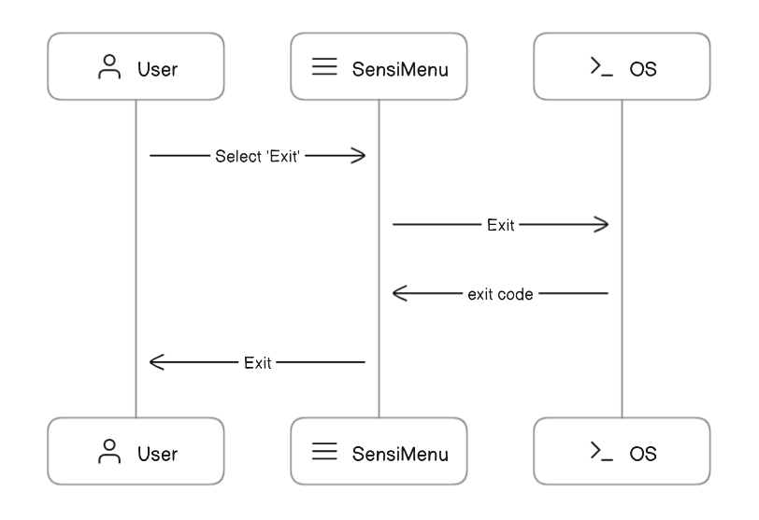

Figure 50: Exit sequence diagram.

Finally, an option to exit the script is provided (figure 50).

This detailed exploration of the SENSI Management bash script showcases its intricate design, interactions with other system components, and overall functionality. It underlines the integral role of SENSI Management in operating the SENSI system, making it an essential component of the Small Enterprise Network Security Infrastructure.

### configurator.py

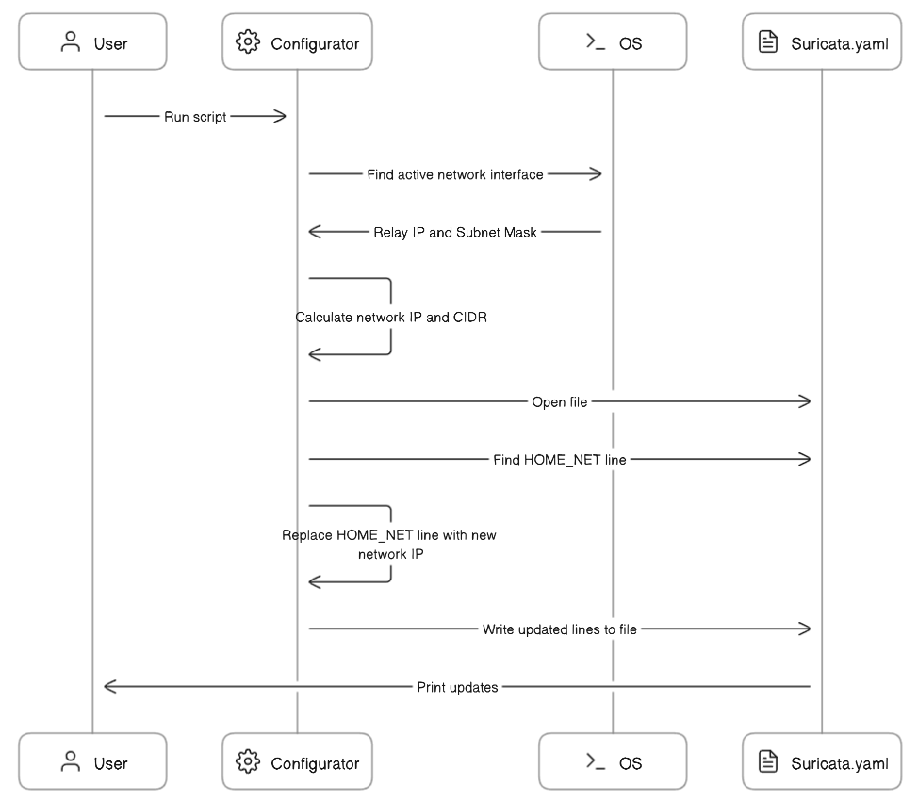

Figure 51: configurator script sequence diagram.

In the SENSI system, the configurator.py python3 script performs a critical function. This script is designed to seamlessly configure Suricata without any technical knowledge on the user’s part.

The script’s design is efficient and straightforward. Upon execution, it identifies the active network interface on the Raspberry Pi device. Post identification, it extracts the IP address and the subnet mask and calculates the IP address and the CIDR notation of the host network. The script then updates the Suricata configuration file (suricata.yaml).

The sequence diagram (figure 51) associated with the configuration.py script visually represents these operations and interactions. It outlines how the script interacts with the operating system to identify the network interfaces to printing the updated lines as feedback to the user. This diagram serves as an aid in understanding the step-by-step process that the script follows to achieve its purpose, demonstrating its efficiency and the vital role it plays within the SENSI system.

### peachpatrol.py

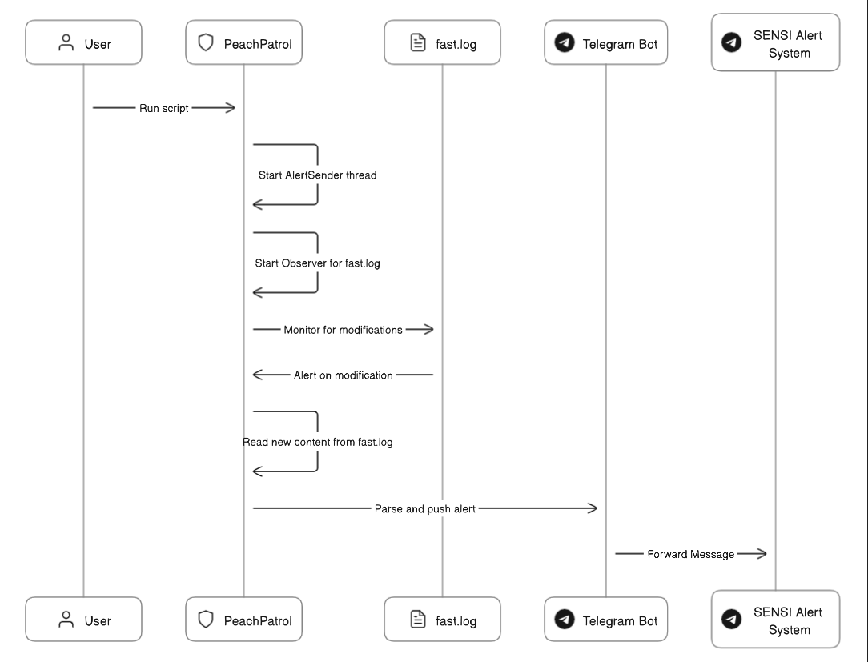

Figure 52: peachpatrol.py sequence diagram.

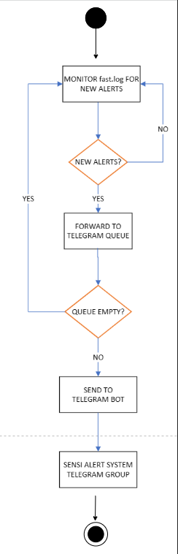

Figure 53: peachpatrol.py activity diagram.

### Network Architecture for SENSI

#### **Introduction**

The design and the layout of a network can significantly impact the efficacy and utility of a security solution. Therefore, in the context of deploying the SENSI system, choosing the exemplary network architecture is of paramount importance.

This section of the document offers comprehensive insights into SENSI’s recommended and alternative architectures. Each of these are designed to optimize the system’s performance and offer maximum protection against potential threats.

The best recommended architecture does not assume the availability of more sophisticated network devices such as network taps or managed switches as these devices are generally expensive and most SMEs tend to stay away. This approach ensures to broaden the audience that could benefit from the project.

As some organizations do employee more complex architectures via hardware, such as network taps or managed switches, two alternative architectures are provided. These architectures demonstrate how SENSI can integrate and work with these devices to enhance network security.

The below mentioned architectures can be combined to create a spectrum of other architectures. Through adaptability and versatility, SENSI is capable of providing robust network security in various network architectures. This is proof that SENSI can be tailored to fit any network.

#### **Recommended Network Architecture for SENSI Deployment**

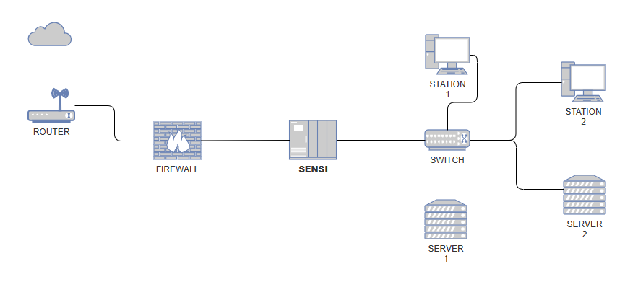

Figure 54: Recommended network architecture for the deployment of SENSI.

The above network architecture (figure 54) ensures that all inbound and outbound network traffic interacts with SENSI, providing a thorough and constant monitoring system for potential threats.

The architecture begins with the router, primary source, and the gateway to all incoming and outgoing network traffic. The router’s role in this architecture is to direct the data flow between the local network and the Internet.

Following the router, the traffic moves to a firewall – which is the first line of defense against potential threats. The firewall performs an essential security function, filtering and blocking unwanted traffic based on predefined security rules. This ensures that only safe, necessary traffic enters the internal network. In the absence of a network firewall, SENSI will sit between the router and the switch. However, it is crucial to note that firewalls are fundamental components of network architecture, significantly enhancing a network’s security. Thus, including a firewall in any network is a matter of grave importance.

SENSI sits behind the firewall (or behind the router at its absence). Being the central component of this architecture, SENSI inspects every piece of network traffic. Using the capabilities of Suricata IPS, SENSI detects any anomalies or potential threats based on the enabled rules. This provides a more sophisticated later of security that elevates the network’s overall protection.

After passing through SENSI, the traffic is directed to a switch (managed or unmanaged). This switch connects the internal network, routing all incoming traffic to its appropriate destinations and handles the outgoing traffic.

This recommended architecture demonstrates the comprehensive nature of SENSI’s security monitoring. Placing SENSI after the firewall and before the local network devices ensures that all network traffic is reviewed by SENSI, offering an industrial-grade security solution.

#### **Alternative Network Architecture - SENSI Deployment via Managed Switch**

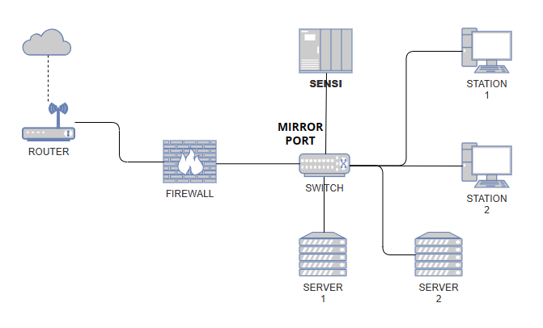

Figure 55: Mirror Port via Managed Switch network architecture for SENSI deployment.

A mirror port, also known as a SPAN (Switched Port Analyzer) port, is a designated port on a network switch configured to receive a copy of every packet the switch processes. The advantage of this setup is that the mirror port can provide an in-depth view of all network traffic without disrupting the data flow. It essentially creates a mirror of the network’s activity and provides a rich data source for analysis and monitoring.

In the context of SENSI, the mirror port approach (figure 55) represents an alternative network architecture that allows for comprehensive network traffic monitoring. In this architecture, the internet connection first enters through the router, which then forwards it to a firewall. Much like the previous architecture, the firewall acts as the first layer of defense and its absence will not affect the SENSI system; however, firewalls are highly recommended.

The managed switch plays a crucial role in this architecture as the switch’s mirror port is connected to the SENSI system. The mirror port replicates all the network traffic from the switch and sends it to SENSI for analysis. The remaining ports connect the devices to the network creating the internal network. This setup enables SENSI to analyse the entirety of the organisations’ network traffic, which in turn provides comprehensive insight into potential security threats.

However, it is important to note that this architecture requires a managed switch that supports port mirroring.

#### **Alternative Network Architecture - SENSI Deployment via Network Tap**

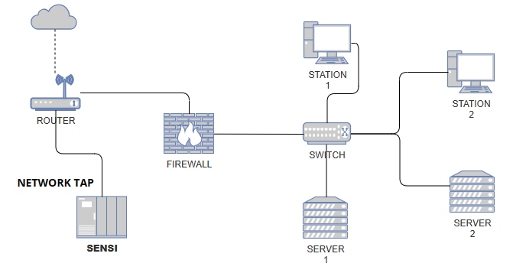

Figure 56: Deployment of SENSI via Network Tap

A network tap (Test Access Point) is a hardware device that allows access to the data flowing across a computer network. It works by making a copy of the data without distrupting or delaying traffic flow. A network tap can be handy for monitoring and troubleshooting as it allows the “tapping” into the network without intruding on the original data stream.

The internet connection comes in through the router and passes through the network tap (figure 56). At this point, the network tap creates a copy of the network data and forwards it to the SENSI system for monitoring and analysis. The original data stream continues from the tap to the firewall and then onto the rest of the network. This architecture ensures that the SENSI system receives an exact copy of all network traffic for analysis, providing a detailed and comprehensive view of potential security threats. At the same time, the original network operations are not interrupted or delayed, ensuring optimal network performance.

However, much like the previous alternative, this architecture requires a network tap.

### Interface Design

SENSI combines the power of Suricata, Telegram API, and custom Python3 scripts into a robust, open-source security system running on a Linux-based operating system. Automating internal processes by Python3 scripts eliminates the need for complex interfaces for the most part. Furthermore, Suricata and Telegram API are designed to run in the back-end.

However, the user is presented with a bash script-based interface (figure 57), allowing straightforward system control over a privileged Linux terminal.

#### **SENSI Management Menu (Bash Script)**

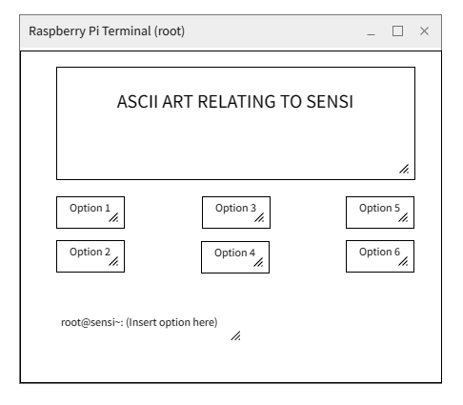

Figure 57: Proposed design for the SENSI Management Menu (bash script).

# **PROJECT PLAN**

## Details of the Release Plan

The development of SENSI, the Network Intrusion Detection System, is an intricate process that involves the tight integration of numerous components. Given the highly intertwined nature of these components, they must be released as a coherent, singular system instead of a series of incremental releases. This approach is necessitated by the project's structure and architecture3, where each element is closely interdependent on others, creating a synergistic ecosystem that operates together.

In a conventional software development scenario, adopting a step-by-step release plan is possible, where each feature or component is developed and deployed separately, typically in the order of their dependencies. This approach provides several advantages, such as obtaining early feedback from users and adjusting based on that feedback. It also allows for the gradual implementation of a project over time, which can help manage resources more effectively and reduce the overall project risk. In the case of SENSI, this approach is not viable. Each component, from the customised Raspberry Pi and Raspbian OS to the Suricata integration, the Telegram API, and the Python3 and Bash scripts, is crucial to the system's operation. The success of SENSI relies on the proper functioning and seamless integration of all these components, making it impossible to segregate them into separate, phased releases.

For instance, customising the Raspberry Pi and Raspbian OS is essential to hosting Suricata effectively. Similarly, the integration of the Telegram API for alert notifications and the development of Python3 scripts for automating processes all contribute to the functionality of SENSI. Finally, the user-friendly Bash script interface forms a crucial part of the system configuration and setup, without which the user would have to rely on technical knowledge to operate.

Therefore, SENSI will be released in a single phase, ensuring all components are thoroughly integrated, tested, and functional. This approach aligns with the project's requirements and allows for a comprehensive review and testing process before making the system available to users.

## Features

### Customizing Raspberry Pi and Raspberry Pi OS to better host Suricata.

One of the primary customisations involves a change in the booting process of the Raspberry Pi. Normally, Raspberry Pi boots from an SD card. However, this approach comes with limited storage space and slower read/write speeds, which can be a bottleneck for high-performance applications like Suricata. To overcome these constraints and to enhance the system's capacity to process and store a substantial volume of network data, the Raspberry Pi used for SENSI has been configured to boot from an SSD with 240GB of storage. This dramatically boosts storage capacity and significantly improves the speed and efficiency of the system's operations.

Another crucial customization pertains to the swap space of the Raspbian OS. Swap space is an extension of the system's physical memory, allowing the system to manage more data and processes simultaneously than the physical memory (RAM) alone can handle. The Raspberry Pi used for SENSI comes with 8GB of RAM, which, while substantial for a device of its class, might still be limiting for a high-performance application like Suricata. To address this, the swap space of the Raspbian OS has been increased to a total of 12GB, effectively giving the system an extension of up to 18GB of memory. This generous swap space allocation allows Suricata's smooth and efficient operation, even under heavy load conditions.

In conclusion, the above mentioned can be broken down into the following:

* Manipulation of Raspberry Pi boot order.
* Replacing SD card with a 2.5 SATA III SSD.
* Increase of swap space from 256MB to 12288MB (12GB).

The customisations mentioned above have tailored the Raspberry Pi and Raspbian OS environment to better host Suricata, thereby enhancing the overall performance of the SENSI system.

### Integration of Suricata as NIDPS (Network Intrusion Detection & Prevention System)

Suricata is the backbone of the SENSI system's threat detection capability. Its role within the SENSI system is to monitor the network traffic, identify and alert malicious activities, and ensure its integrity and security.

The integration of Suricata within SENSI involves its deployment on the customised Raspberry Pi system described earlier. Upon initial installation, Suricata is configured to operate in Network Intrusion Detection System (NIDS) mode, analysing the network traffic that passes through the Raspberry Pi. To operate as a NIDPS (Network Intrusion Detection & Prevention System), several modifications must be made to the Suricata configuration (suricata.yaml). When operating as a NIDPS, once Suricata detects a potential threat, it sends an alert to the system's logging engine. From there, the alert is forwarded to the appropriate channels for further action, including "DROPPING" the network traffic.

Proper integration of Suricata into the SENSI system is vital for effectively detecting and protecting against network threats. This high-performance engine adds robustness and reliability to SENSI, enhancing its value as a network security solution.

### Integration of Telegram API for Alert System

In order to promptly notify system administrators of any potential threats detected by Suricata, the SENSI system integrates with the Telegram API to send alert notifications. This feature is crucial in ensuring that immediate action can be taken in response to potential security issues, minimising the damage that malicious entities could inflict. This was achieved by creating a dedicated Telegram Bot. A Telegram Bot is a remarkable account operated by software, not people, and it interacts with users by responding to messages, commands, inline requests, and more. Once the bot was created - PeachPatrolbot- a dedicated Telegram group, was established for the SENSI system, serving as the central hub for alert notifications. By obtaining and utilising the chat ID of the Telegram group and the Bot token (a unique identifier assigned to each bot by Telegram), we could program the SENSI system to automate the delivery of notifications.

The integration of the Telegram API for alert notification allows for real-time, mobile-friendly alerts, providing system administrators with an efficient and convenient method for monitoring the security status of their network. The alerts are received directly on the administrator's mobile device, enabling immediate awareness and action. It thus greatly enhances the responsiveness of the SENSI system to network threats.

### Python3 Scripts for Automation

In the SENSI system, Python3 scripts are utilised to automate two vital processes, greatly enhancing the system's efficiency and usability, and reducing the need for manual intervention. These scripts are crucial for sending Suricata alerts to Telegram and updating system configurations.

This script automates updating this value, significantly reducing the complexity of Suricata configuration updates, and making the SENSI system more user-friendly, especially for users needing advanced technical knowledge. Through these Python3 scripts, the SENSI system can automate essential tasks that are key to its function as an effective network threat detection system, enhancing its user-friendliness and efficiency.

### Bash Script Interface for System Configuration

A vital aspect of the SENSI system design is its emphasis on usability, particularly in system configuration. Recognising that not all system users may have an in-depth understanding of technical processes, the SENSI system employs Bash scripts to facilitate a user-friendly interface for system configuration. Bash, or the Bourne Again SHell, is a widely used command processor. It is frequently employed for its ability to handle simple scripts, automating repetitive tasks and sequencing complex ones. Within the SENSI system, Bash scripts streamline its configuration process, making it accessible for users regardless of their technical expertise. The Bash script interface within SENSI is designed to guide the user step-by-step through the system configuration process. Furthermore, using Bash scripts allows seamless configuration of updates and adaptations as the system evolves without requiring significant user input.

This system configuration approach significantly simplifies the overall setup process, allowing users to deploy the SENSI system efficiently and effectively, regardless of their expert background and technical familiarity with systems like Raspberry Pi or Suricata. Through its user-friendly Bash script interface, SENSI aims to make network threat detection and management more accessible to a broader user base.

## Test Plan

### Unit Testing

#### **Raspberry Pi and Raspbian OS Configuration Test Plan**

|  |  |  |  |
| --- | --- | --- | --- |
| TEST CASE ID | DESCRIPTION | TEST CONDITION | EXPECTED RESULT |
| 1.1 | Boot Raspberry Pi from SSD | Raspberry Pi powered on | Raspberry Pi boots from SSD |
| 1.2 | Check Swap Space size | Run ‘free-h’ in terminal | Display of 12GB swap space |

#### **Suricata Integration Test Plan**

|  |  |  |  |
| --- | --- | --- | --- |
| TEST CASE ID | DESCRIPTION | TEST CONDITION | EXPECTED RESULT |
| 2.1 | Run Suricata | Execute Suricata in terminal | Suricata starts without any errors |
| 2.2 | Check Suricata logs | Inspect Suricata log files | Logs show detected network threats |

#### **Telegram API Integration Test Plan**

|  |  |  |  |
| --- | --- | --- | --- |
| TEST CASE ID | DESCRIPTION | TEST CONDITION | EXPECTED RESULT |
| 3.1 | Send alert via Telegram API | Trigger a rule in SENSI system | Alert is received in the Telegram group |

#### **Configurator.py**

|  |  |  |  |
| --- | --- | --- | --- |
| TEST CASE ID | DESCRIPTION | TEST CONDITION | EXPECTED RESULT |
| 4.1 | Run the configurator script to update HOME_NET value in suricata.yaml | Execute python script in terminal | HOME_NET value in suricata.yaml is updated |
| 4.2 | Print update | Upon successful execution | Print old and new updates |

#### **Peachpatrol.py**

|  |  |  |  |
| --- | --- | --- | --- |
| TEST CASE ID | DESCRIPTION | TEST CONDITION | EXPECTED RESULT |
| 5.1 | Run log monitoring and alerting script | Execute python script in terminal | Script runs without errors and pushes alerts to Telegram. |

#### **Bash Script Test Plan**

|  |  |  |  |
| --- | --- | --- | --- |
| TEST CASE ID | DESCRIPTION | TEST CONDITION | EXPECTED RESULT |
| 5.1 | Run bash script for system design | Execute bash script in terminal | Bash script executed in terminal |
| 5.2 | Test update function | Execute update function | Successful apt update, apt upgrade, apt dist-upgrade, apt autoremove & apt autoclean |
| 5.3 | Test display update functions | Execute display updates function | Successfully display available updates |
| 5.4 | Test update raspberry pi firmware option | Execute RPi firmware update option | Successfully determine if the RPi Firmware is up to date, offer updates if available |
| 5.5 | Test view log option | Execute view log option | Successfully display the most recent logged alerts |
| 5.6 | Test run configuration option | Execute configurator.py via bash script | Successfully update the suricata.yaml and print updates |
| 5.7 | Test activation of telegram service | Execute peachpatrol.py via bash script | Successfully execute the daemon related to python3 script without error |
| 5.8 | Test Suricata configuration option | Execute Suricata configuration test option | Successfully execute Suricata configuration test in verbose mode. |
| 5.9 | Test exit function | Execute exit option | Successfully exit out of the bash script without errors |

### Functional Test Plan

#### **Network Threat Detection**

|  |  |  |  |
| --- | --- | --- | --- |
| TEST CASE ID | DESCRIPTION | TEST CONDITION | EXPECTED RESULT |
| 1.1 | Introduce a known **threat** **within** the network | SENSI is active | SENSI detects the threat & Suricata logs it – corrective actions taken |
| 1.2 | **Incoming** attack from **external** network | SENSI is active | SENSI detects the attack, Suricata logs it – corrective actions taken |

#### **Alert Notification Test Plan**

|  |  |  |  |
| --- | --- | --- | --- |
| TEST CASE ID | DESCRIPTION | TEST CONDITION | EXPECTED RESULT |
| 2.1 | Trigger an alert in SENSI | Telegram API script is running | Alert notification is sent to dedicated Telegram group |
| 2.2 | Trigger multiple alerts in quick succession | Telegram API script is running | All messages are sent to the Telegram group |

### User Acceptance Testing

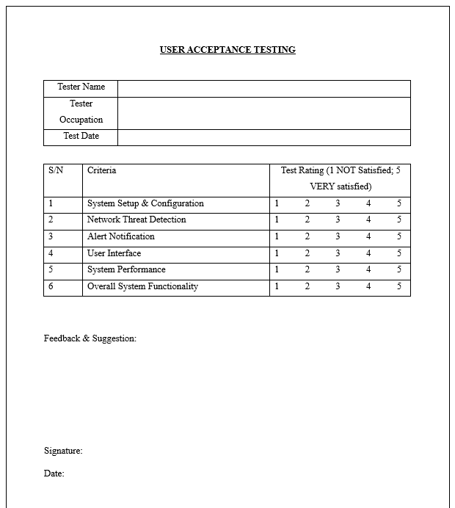

Figure 58: User Acceptance Testing form template.

# **IMPLEMENTATION**

## RPi & Raspbian OS Customization

The optimal operational capabilities of SENSI rely on customisations done at the kernel and operating system level. These can be referred to as RPi and Raspbian OS customizations.

### Raspberry Pi Boot Order & SSD File System Configuration

#### **Raspberry Pi Boot Order**

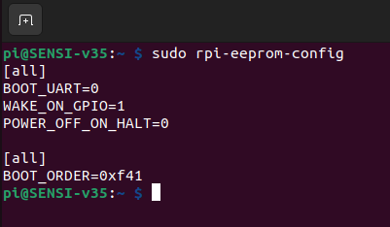

Figure 59: Boot order of RPi.

In the above figure 59, the boot order is printed in hexadecimal as “BOOT_ORDER=0xf41”. This can be decrypted using the below table:

|  |  |  |
| --- | --- | --- |
| VALUE | MODE | DESCRIPTION |
| 0x0 | SD Card detected. | Try SD then wait for card-detect to indicate that the card has changed. |
| 0x1 | SD Card | SD card boot. |
| 0x2 | Network | Boot over Network. |
| 0x3 | RPi Boot | RPi Boot configuration. |
| 0x4 | USB Mass Storage | Boot via USB Mass Storage |
| 0x5 | BCM-USB-MSD | USB 2.0 boot from USB Type C socket. |
| 0x6 | NVME | Boot from an NVMe SSD from PCIe interface. |
| 0x7 | HTTP | Boot over HTTP Ethernet. |
| 0xe | STOP | Stop and display error pattern. |
| 0xf | RESTART | Restart from the first boot option. |

By utilizing the above table, the “BOOT_ORDER=0xf41” can be decrypted as boot from ***USB Mass Storage.*** This is the correct boot order as SENSI indeed is designed to be booted via 2.5 SATA III SSD.

#### **SSD File System Configuration**

The below figure (figure 60) shows the configuration of the Kingston A400 SSD.

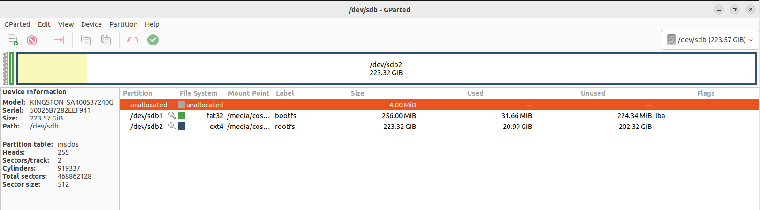

Figure 60: GParted information for SENSI SSD.

The SSD has a capacity of 240GB and consists of two primary partitions, /dev/sdb1 and /dev/sdb2. The first partition, /dev/sdb1, has a FAT32 file system labelled "bootfs" and occupies a size of 256MB on the SSD. The second partition, /dev/sdb2, uses the ext4 file system and is labelled as "rootfs". It is significantly bigger with a size of 223GB to allow for the prolonged accumulation of log files without the need to swap storage. The partition table for the drive uses the MSDOS format. These configurations ensure optimal performance of the SENSI project.

Furthermore, this configuration allows for the cloning of individual partitions to entire disk via the Linux utility command “dd” effectively and easily. This is vital for forensics and further enhancement, research and development purposes.

#### **SWAP SPACE Configuration**

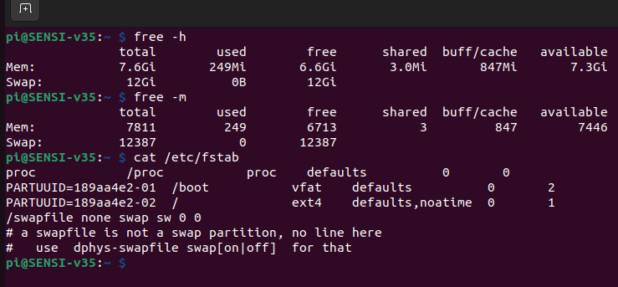

Figure 61: SWAP SPACE configuration of SENSI.

In computer systems, the swap space is a buffer that supports system operations when the physical memory (RAM) is fully utilised. By default, the Raspberry Pi OS allocates 256MB for swap space, which can sometimes be insufficient, especially when running resource-intensive applications such as Suricata or Python scripts. For the SENSI project, the swap space was substantially increased to 12GB to improve system performance. This setup is illustrated in the terminal output shown in Figure 61.

The command **“*free -h*”** provides a human-readable output of the system's memory usage. In this case, the total physical memory (RAM) is approximately 7.6GB, with 249MB in use and about 6.6GB free. Notably, the total swap space is 12GB, which is currently accessible.

The command ***“free -m”*** displays the same information but with memory amounts in megabytes. This shows that the total swap space is approximately 12387MB, equivalent to the 12GB.

The command ***“cat /etc/fstab”*** provides details of the file systems that the system mounts automatically at startup. The output shows a swap file entry at the end ***(/swapfile none swap sw 0 0***), which indicates the system is utilising a swap file for additional memory.

Increasing the swap space significantly enhances the SENSI system's ability to manage memory. Suricata can process large amounts of data, and Python scripts can be memory-intensive, especially when handling large data structures or performing complex computations. By allowing a larger swap space, the system can better handle such scenarios, ensuring smoother operation and better performance of SENSI. This setup reflects a practical understanding of resource management in the context of the requirements of cybersecurity solutions.

## Suricata NIDPS Implementation

### suricata.yaml

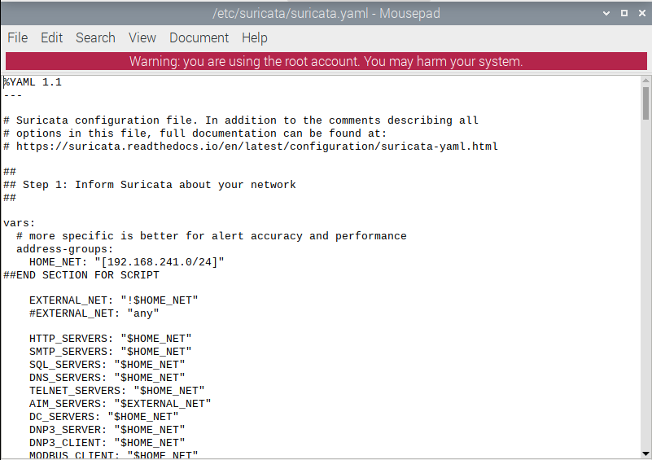

Figure 62: Suricata configuration .yaml file.

The ***“HOME_NET”*** (figure 62) represents the network that the NIDPS considers to be the internal network. The value set for the HOME_NET in this example is ***“192.168.241.0/24”.*** The ***“#END SECTION FOR SCRIPT”*** comment serves as a marker for the configurator.py script to locate and update the HOME_NET value. All servers in addition to these, including a variety of network servers typically found in SME infrastructures are also tagged to be part of the HOME_NET.

The ***“EXTERNAL_NET”*** (figure 62) on the other hand, represents all networks considered foreign to the internal network. This value is set as ***“!$HOME_NET”*** which means all IP addresses not part of the HOME_NET value is considered foreign. For example, as the HOME_NET value for this specific network is updated as 192.168.241.0/24, all IP addresses from 192.168.241.1 – 192.168.241.254 are identified to be part of the internal network. All other IP addresses outside of this range are considered foreign.

These variables are critical for the effective operation of Suricata. Suricata will thoroughly examine any traffic originating from or directed towards the HOME_NET based on its rule sets. The precise definition of HOME_NET and EXTERNAL_NET enhances the accuracy of alerts and overall system performance, ensuring SENSI can provide robust cybersecurity solutions.

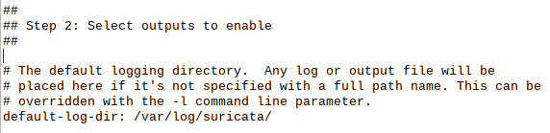

Figure 63: Suricata log directory.

The above section (figure 63) of the configuration represents another vital area of the suricata.yaml. It configures where the default log directory is. Suricata in SENSI is configured to log alerts to a default directory at ***“/var/log/suricata”***.

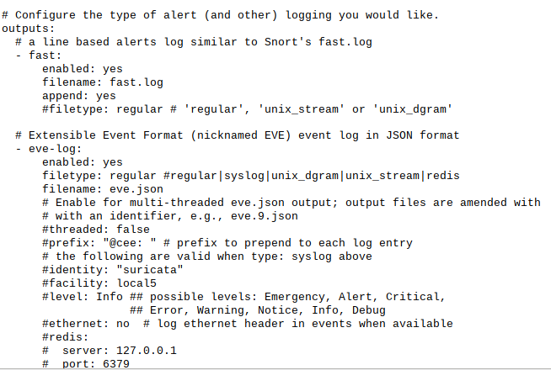

Figure 64: Configured output plugins for Suricata alerts (A).

There are a wide variety of output plugins available for Suricata. The output plugins define how the format of the alerts are logged to the earlier mentioned default logging directory. The output plugins configured for SENSI system are as follows (figure 64):

* fast.log

The fast.log plugin generates a minimal alert log. The advantage of fast.log is its simplicity and straightforward format which is easily readable. In SENSI, fast.log is monitored by the peachpatrol.py script which sends any new alerts to the user via the Telegram Bot.

* eve-log

The eve-log is a more comprehensive JSON formatted log. The advantage of eve-log is that it gives a complete picture of network traffic for advanced forensic investigations.

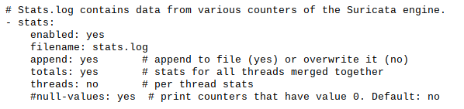

Figure 65: Configured output plugins for Suricata alerts (B).

Suricata's stats.log (figure 65) collects statistical data from various counters in the Suricata engine. This statistical data can provide a glimpse into Suricata's performance and behaviour. These stats include packet processing rate, the number of alerts generated, and the number of sessions open. For the SENSI project, stats.log is configured as follows:

1. ***“filename”***: The filename: stats.log specifies the filename where the statistical data is stored.
2. ***“append”***: configured to yes, the statistical data is not overwritten each time Suricata restarts. Instead, new data is appended to the existing stats.log file, preserving historical data.
3. ***“totals”***: The configuration merges stats from all threads. This is important when running Suricata on multi-core systems.
4. ***“threads”***: This being set to "no" means that separate statistics for each thread are not kept. This declutters the stats.log by not breaking down statistics on a per-thread basis.

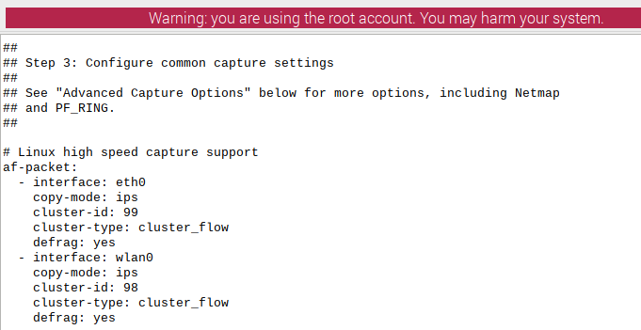

Figure 66: Suricata interfaces configured to IPS.

The IPS interface configuration in Suricata (figure 66) plays an essential role in detecting and mitigating potential threats in real-time. For the SENSI, the IPS interface configuration is as follows:

1. ***“af-packet”***: This section refers to the use of AF_PACKET for packet capture. AF_PACKET is a Linux-specific feature that allows applications to hook directly into the networking stack. It provides efficient packet capture and transmission, thus being the recommended packet capture method for Linux systems running Suricata.
2. ***“interface”***: Two interfaces are specified here: eth0 and wlan0. The eth0 interface is the wired Ethernet connection, while the wlan0 is the wireless network interface. This configuration ensures traffic ingress is via eth0 and traffic egress is via wlan0.
3. ***“copy-mode: ips”***: configures Suricata to function in an Intrusion Prevention System (IPS) mode. This mode allows Suricata to detect threats and prevent them by altering or dropping malicious packets.
4. ***“cluster-id”***: cluster-id is a unique identifier for each interface used for load balancing when multiple instances of Suricata are running. Here 99 and 98 are the unique identifiers for the eth0 and wlan0 interfaces, respectively.
5. ***“cluster-type: cluster_flow”***: ensures that all packets of a single flow (a flow is a stream of related packets between a source and destination) are sent to the same Suricata instance. This is crucial for proper threat detection and analysis.
6. ***“defrag: yes***”: enables the defragmentation of fragmented packets. This is particularly important when dealing with attacks that use fragmentation to evade detection.

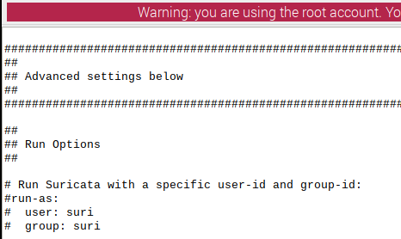

Figure 67: Suricata least privileged account principal.

The above configuration setup (figure 67) runs Suricata in a dedicated user and group. This implements the cybersecurity practice of running applications on the least needed privileges. This segments Suricata and protects the system if in case Suricata is compromised by an attacker. However, SENSI does not come with these pre-configured as the system requires unrestricted access to certain systems and network operations. If the user chooses to, the above settings could be implemented by simply uncommenting the lines ***“# user: suri”*** and ***“# group: suri”***.

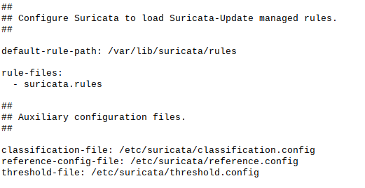

Figure 68: Suricata Rule and Auxiliary configurations.

The above configuration section (figure 68) sets the default path to Suricata rules, classification configurations and threshold configurations. These are crucial for Suricata to function as an effective NIDPS.

### Suricata Rules

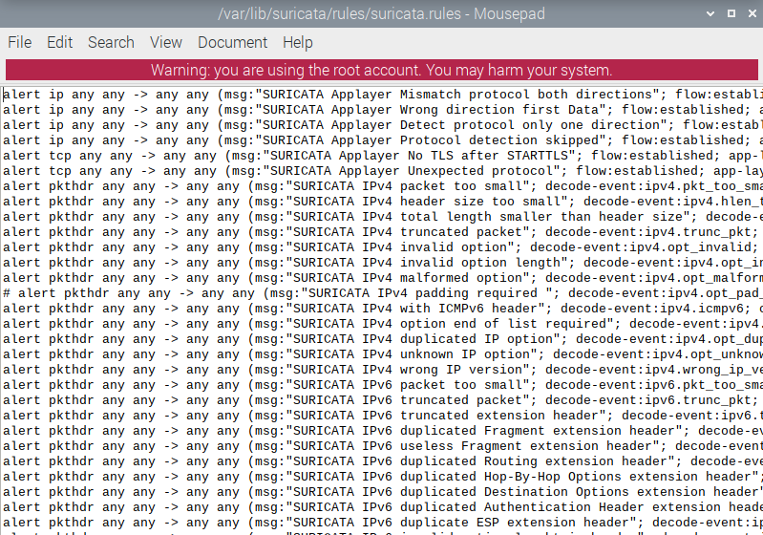

Figure 69: Suricata Rules saved as suricata.rules.

Suricata rules (figure 69) are the basis for detecting network threats in Suricata. They provide the framework Suricata uses to identify malicious or suspicious activities on a network. Each rule is a definition of what constitutes an "alert-worthy" activity. Suricata processes network traffic according to many rulesets (a tiny sample is shown in figure 69), comparing the traffic against these rules. If the traffic matches the conditions specified in a rule, Suricata takes the action specified in that rule. In an IDS configuration, this typically involves generating an alert; in an IPS configuration, it could also involve dropping or rejecting the offending packets.

The above-mentioned ruleset is stored in the directory *“/var/lib/suricata/rules/suricata.rules”.*

### Suricata Threshold Configuration

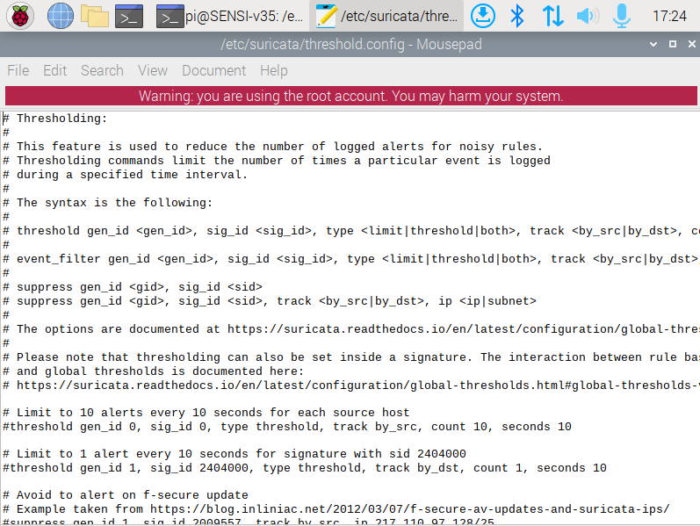

Figure 70: Suricata Threshold configuration.

The threshold.config file in Suricata (figure 70) is used for fine-tuning the sensitivity of the NIDPS. This is an essential aspect of managing the signal-to-noise ratio in Suricata, meaning it helps reduce the number of false positives and general noise generated and increase the system's ability to correctly identify real threats.

### Suricata Configuration Test

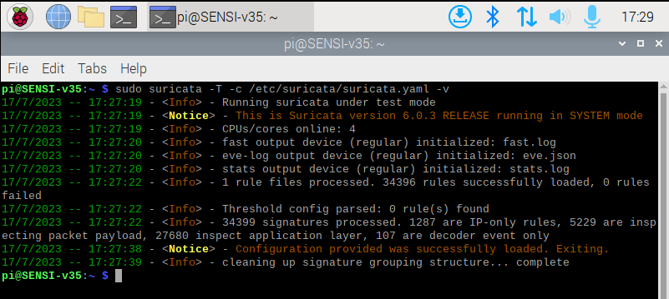

Figure 71: Suricata configuration test.

The command ***"sudo suricata -T -c /etc/suricata/suricata.yaml -v"*** runs Suricata in test mode, and the ***"-v"*** parameter is for verbose mode - which prints detailed feedback on the processes (figure 71). This crucial tool validates the configuration and rule files without activating the Suricata service. This process ensures that errors or misconfigurations do not interfere with live IDS/IPS operations. The output indicates Suricata's version (6.0.3 RELEASE) and the mode (SYSTEM mode, indicating Suricata is functioning as a system-level service), which aids performance tuning.

Further, the output reveals the successful initialisation of the Fast.log, Eve-log, and stats.log output plugins - which, as explained earlier, is vital for logging alerts and events. The successful processing of one rule file and the effective loading of all 34396 rules from the file are also indicated. The output also states that no rules were found during threshold configuration parsing, hinting that threshold tuning has yet to be applied. The type of rules loaded is further broken down: 1287 are IP-only rules, 5229 inspect packet payloads, 27680 study the application layer, and 107 are decoder events only. The successful test confirms the configuration file and rule files' successful load, implying that the SENSI system's Suricata configuration is ready for deployment in a live network environment.

### Suricata as a daemon (suricata.service)

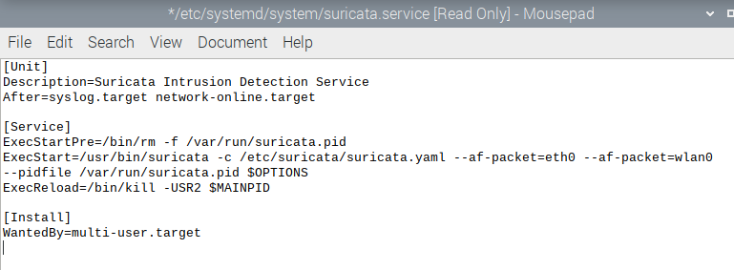

Figure 72: Suricata service daemon file (A).

For Suricata to run uninterrupted at startup without having to depend on user input, the best way to implement Suricata is as a service daemon – or simply as a background process. To do so, a file needs to be created for Suricata. Figure 72 represents the file created for this process – ***suricata.service***. This Suricata daemon file is saved in the directory for all services ***“/etc/system/system/suricata.service”***. This daemon is configured to run the command ***“/etc/suricata/suricata.yaml –af-packet=eth0 –af-packet=wlan0”*** using ***“suricata -c”*** in ***“/usr/bin/suricata”***, automatically at startup.

Furthermore, there is general operating system error handling implemented to the above daemon, such as if the system detects another Suricata child process, it is killed before the birthing a new Suricata child process.

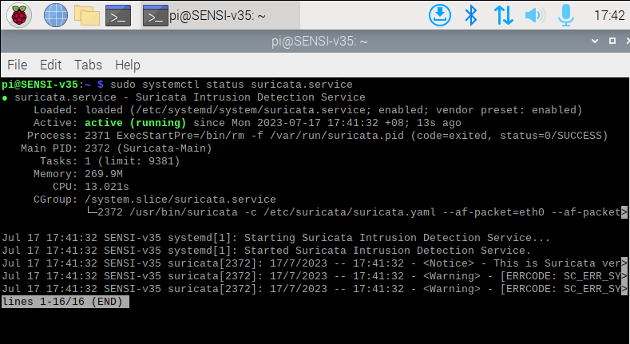

Figure 73: Suricata running as a service daemon (B).

The ***“sudo systemctl status suricata.service”*** prints details (figure 73) regarding the previously implemented suricata.service. As the figure above shows, the suricata.service is ***“enabled”*** which means that it is loaded at startup. It goes on to show the main PID of the daemon, number of tasks and memory used.

## PeachPatrol

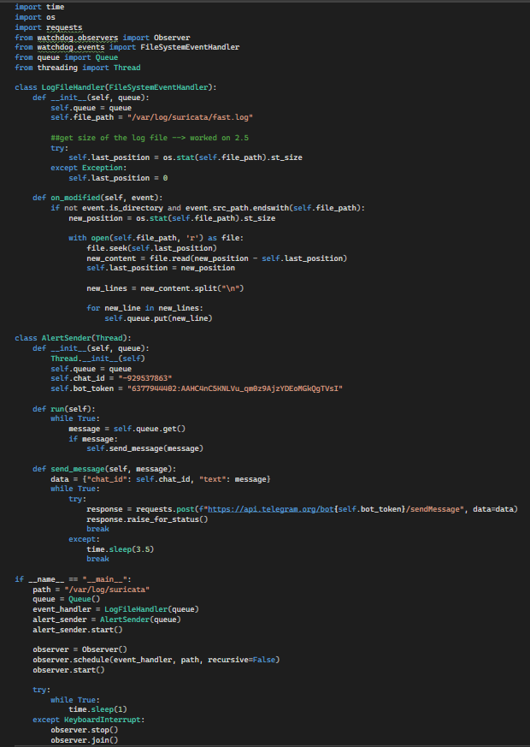

Figure 74: PeachPatrol source code.

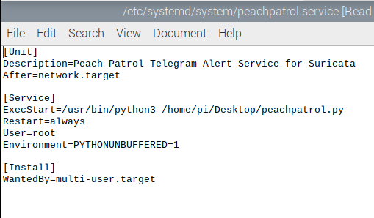

Figure 75: PeachPatrol service daemon file (A).

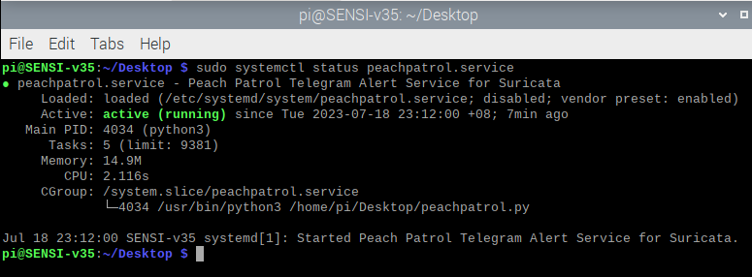

Figure 76: PeachPatrol python script running as a service daemon (B).

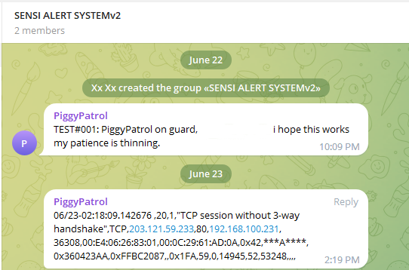

Figure 77: First successful Telegram notifications via python script and Telegram bot (PiggyPatrol – version 1). Please note that the implemented notification system has since evolved.

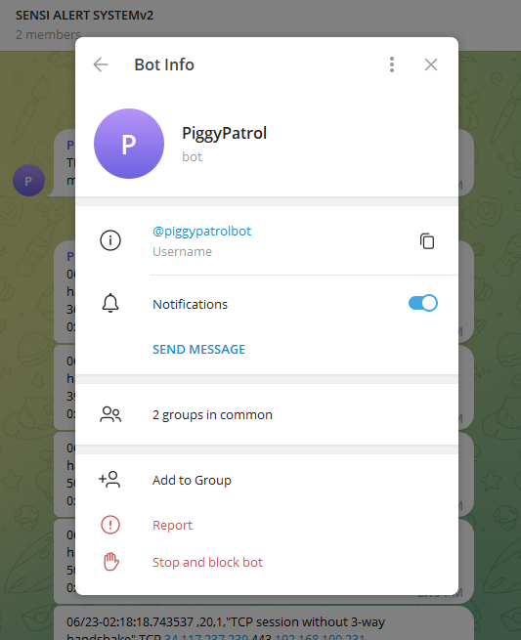

Figure 78: First Telegram bot (PiggyPatrol – version 1) created for notification system.

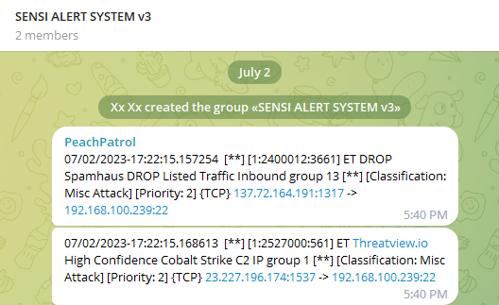

Figure 79: Finalized notification system for SENSI.

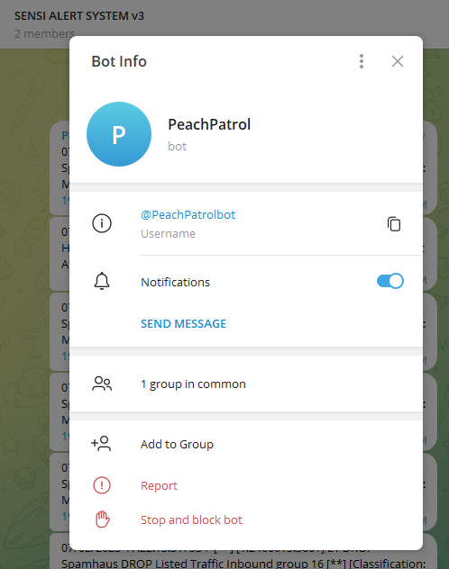

Figure 80: Implemented Telegram bot (PeachPatrol – version 4) for SENSI notification system.

The peachpatrol.py script is fashioned for the single purpose of monitoring fast.log and upon detecting an update to the log file, push the new line to Telegram via a Telegram bot. This allows for a simple yet efficient notification system that alerts the user of new developments via Telegram notifications. Figure 74 demonstrates the peachpatrol.py python script implemented to forward Suricata alerts as Telegram notifications to a dedicated Telegram group.

Figures 75 and 76 show the configurations for systemd daemon created for peachpatrol.py – named ***peachpatrol.service***. The daemon file is configured so that the service is run after local network services are running. Moreover, the script is run in privileged environment with the command ***“/home/pi/Desktop/peachpatrol.py”*** via ***“/usr/bin/python3”***.

Figures 77 demonstrates the first ever successful Telegram notification pushed via the python script and the figure 78 shows the Telegram bot created to achieve this event. However, due to other evolutions made over time to the python script and the notification system as a whole, a Telegram bot and a new Telegram alert group was created (figures 79 & 80).

## configurator.py

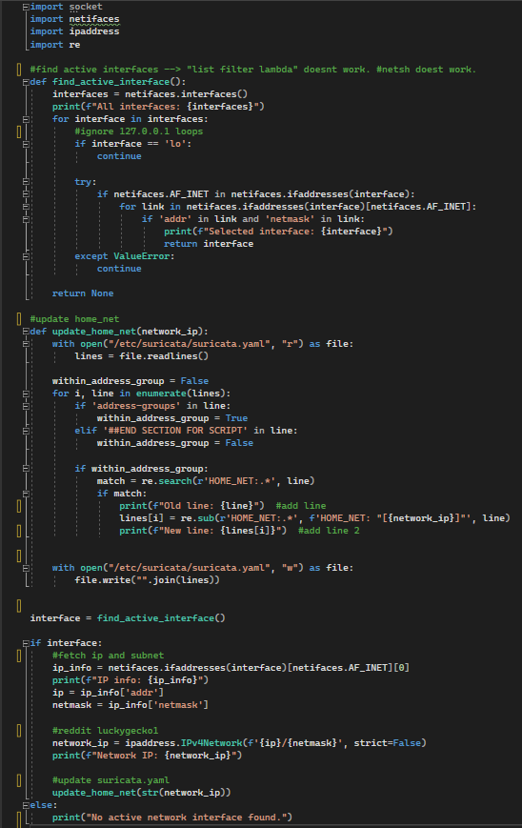

Figure 81: configurator.py source code.

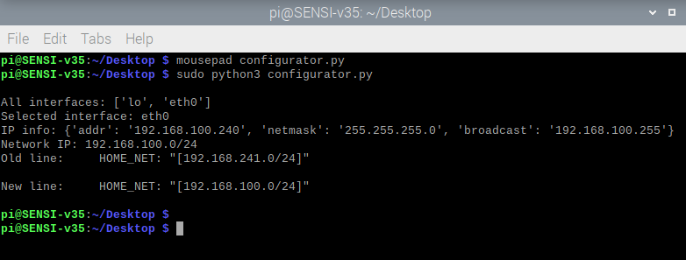

Figure 82: configurator.py print feedback.

The configurator python script (figure 81), like its sister script peachpatrol.py is designed for a single purpose. The configurator script aims to eliminate the need for user input in the event of a major network modification such as a public IP change or connecting SENSI to another network. The user would only need to execute the python script from a privileged terminal and the script calculates the network address from online interfaces and updates the ***“HOME_NET”*** value in the suricata.yaml.

Upon successfully updating the suricata.yaml, the configurator script will print the necessary details (figure 82) for the user to review.

## SENSI Management System

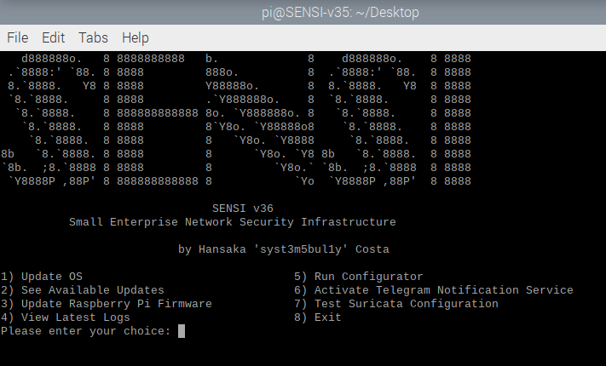

Figure 83: SENSI Management System.

The centrepiece of the SENSI Management System is a user-friendly command line interface developed as a bash script, which serves as the primary means of managing and interacting with the SENSI. The interface, when executed, provides an ASCII art banner, credits the author, and then presents a straightforward menu with various options for system management (figure 83). These options range from routine system update tasks, viewing the latest security logs, running automated system configurations, and activating a Telegram-based notification service to testing the Suricata configuration. As each option is selected, the script executes various commands or sequences of commands, providing feedback and error checking.

This management interface is designed to be comprehensive yet straightforward, catering to non-technical and advanced users. By abstracting complex commands and procedures into simple menu options, SENSI reduces the barriers to effective system management, making it easier for small enterprises to maintain network security.

### Update OS

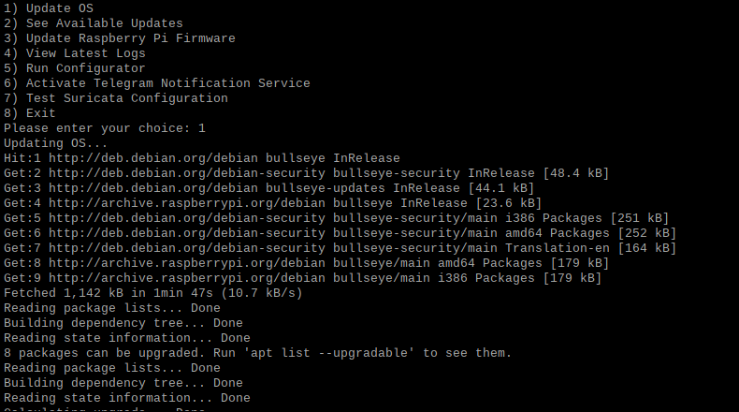

Figure 84: Update OS option in motion (A).

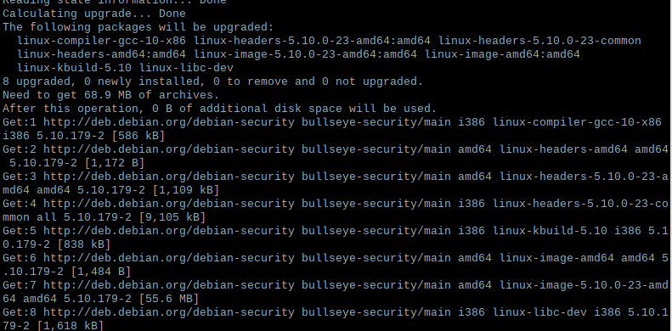

Figure 85: Update OS option in motion (B).

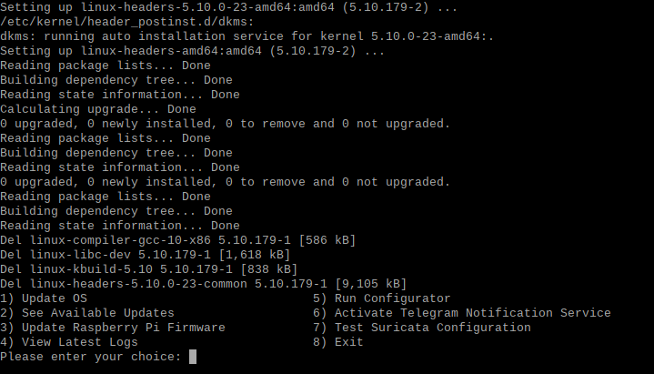

Figure 86: Update OS option in motion (C).

The first option is ***“Update OS”*** option (figure 84) – this bash script runs a sequence of Debian commands. These are:

* ***sudo apt update***

This command retrieves the latest information on installed software to update the local package index.

* ***sudo apt upgrade -y***

This command downloads and installs the available updates for the system including security updates for the OS to bug fixes on software. “-y” flag is to force automatic yes so that this process could function without user input.

* ***sudo apt dist-upgrade -y***

This is similar to the previous upgrade option. However, it also resolves package conflicts to force install updates.

* ***sudo apt autoremove -y***

This command will remove the dependencies of installed packages to free up the disk.

* ***sudo apt autoclean -y***

This command removes outdated packages from the cached package files.

As this bash script runs all options in the same terminal the main script was executed in, the user will see the progress of the entire process as it happens (figures 85 & 86). This is vital, as Debian commands also print errors on to the terminal if such event occurs.

### See Available Updates

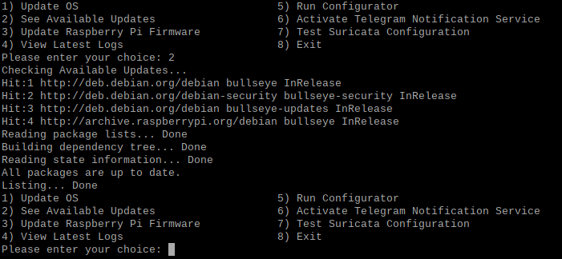

Figure 87: See Available Updates option.

If the user wishes to view updates without necessarily updating the system, it could be achieved by using the second option on the bash script (figure 87). This script works by running the following Debian commands:

* ***sudo apt update***

This is the same Debian command executed first when the user chooses the first option. It retrieves the latest updates and updates the local package index.

* ***sudo apt list –upgradable***

This Debian command lists the available updates for the local package index. This list is printed on the same terminal.

If the system is up to date, then a feedback message stating, **“All packages are up to date.”** is printed.

### Update Raspberry Pi Firmware

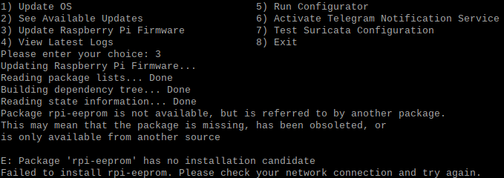

Figure 88: Update Raspberry Pi Firmware option.

The third option is intended to update the firmware of the Raspberry Pi 4 (figure 88). RPi acts as the backbone of the SENSI system and therefore, it is important that the system is maintained for optimal performance in the long run.

This option runs the following commands in the sequential order:

* ***sudo apt-get install rpi-eeprom***

This Debian command is used to install the rpi-eeprom package on Raspberry Pi systems. This package provides tools and firmware for updating the EEPROM (Electrically Erasable Programmable Read-Only Memory) on Raspberry Pi boards.

* ***sudo rpi-eeprom-update -a***

This Debian command updates the EEPROM firmware on a Raspberry Pi device. The ***“-a”*** flag stands for "auto," which means it will attempt to update all applicable components of the firmware.

* ***sudo reboot***

This command restarts the system to implement the update.

### View Latest Logs

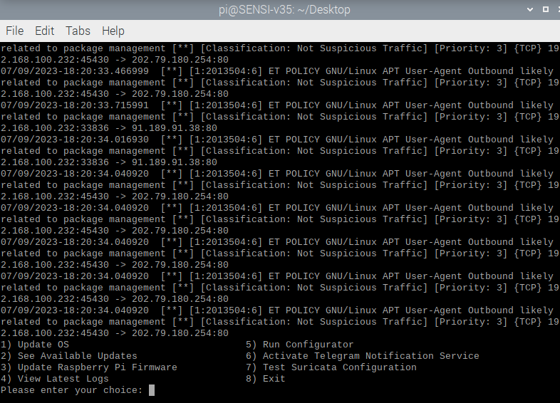

Figure 89: View Latest Logs (second half of output).

This option displays the most recent alerts logged by Suricata to fast.log for a quick glimpse (figure 89).

To achieve this, this option executes the following Debian command:

* ***sudo cat /var/log/suricata/fast.log***

This command uses the cat function to display the last few lines (most recent alerts) on the terminal.

### Run Configurator

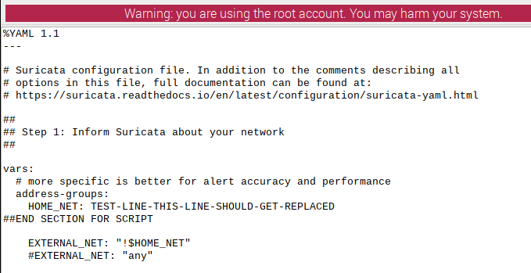

Figure 90: suricata.yaml with a test line next to 'HOME_NET' (A).

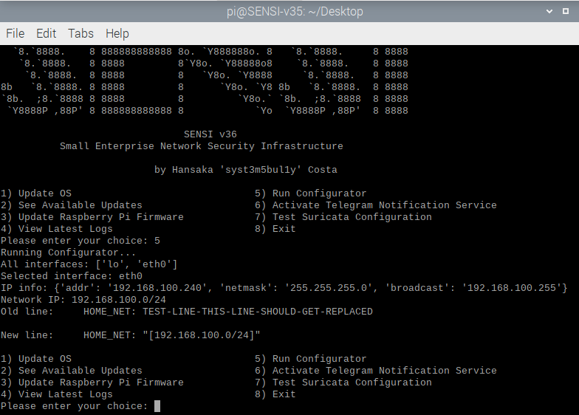

Figure 91: Option 5, executes configurator.py and displays updates on terminal (B).

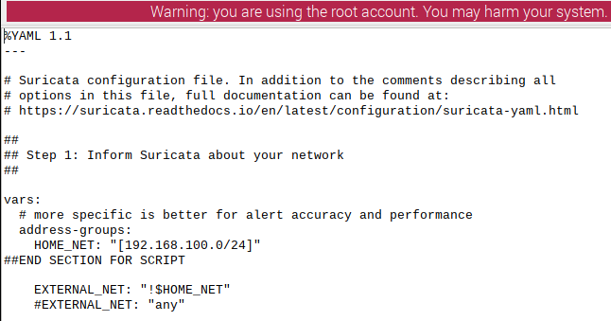

Figure 92: Updated suricata.yaml after execution of 'Option 5' via SENSI Management System (C).

Figure 91 shows the 5th option of SENSI Management System – the switch the execute the configurator.py python3 script. This integration of python3 script to the bash script makes it easier for the user to execute the python3 script simply by selecting **“5”** instead of resorting to complex technical steps to autoconfigure the HOME_NET value of the suricata.yaml to fit the host network.

The bash script achieves the above by executing the following Debian command:

* ***sudo python3 /home/pi/Desktop/configurator.py***

This command executes the python3 script stored in **“/Desktop/”** with elevated privileges.

The consequences of executing this option can be understood by figures 90 – 92. In figure 90, the suricata.yaml has a deliberate non-IP test line. Figure 91 shows that option 5 was executed, and successful update-feedback was given. Figure 92 shows that the suricata.yaml was indeed modified accurately to the previously generated feedback.

### Activate Telegram Notification Service

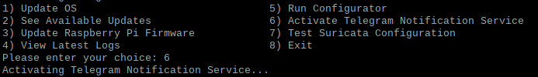

Figure 93: Activate Telegram Notification Service option.

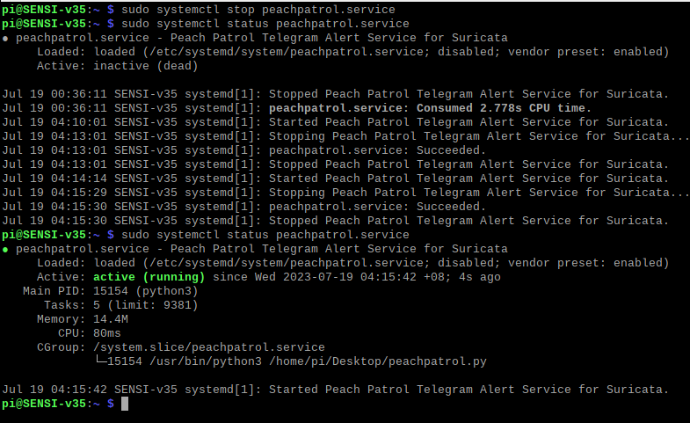

Figure 94: peachpatrol.service active daemon.

Option 6 in the SENSI Management System bash script is to activate the peachpatrol.service daemon for Telegram notification service (figure 93). This option achieves this by executing the following Debian command:

* ***sudo systemctl restart peachpatrol.service***

This command executes the peachpatrol.service with root privileges to ensure uninterrupted access and supply to necessary resources.

Upon executing option 6, the peachpatrol.service daemon is successfully loaded and activated (figure 94).

### Test Suricata Configuration

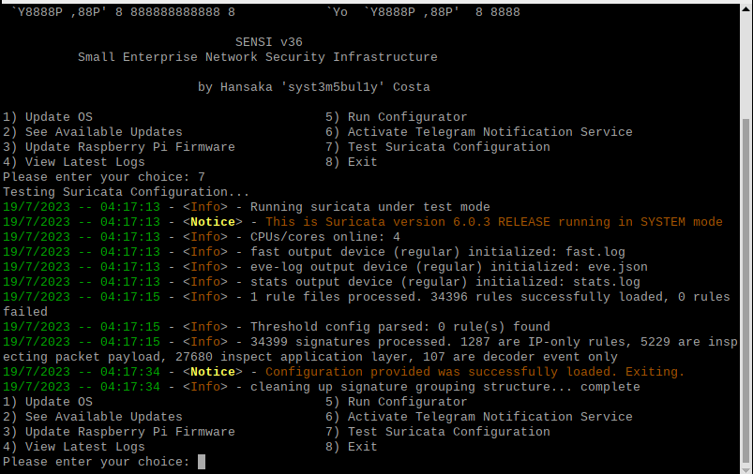

Figure 95: Test Suricata Configuration - option 7.

This option exists to help users conduct suricata configuration tests without having to depend on any technical experience. This option works by executing the following command:

* ***sudo suricata -T -c /etc/suricata/suricata.yaml -v***

The above command executes Suricata test feature in a root access environment for its configuration file in verbose mode – which displays more details regarding the test. All Suricata test results are printed on the same terminal (figure 95).

If the tests are successful, the results will reflect so. If the test process runs into an error, the specificizes of the occurred error would be printed as well.

### Exit

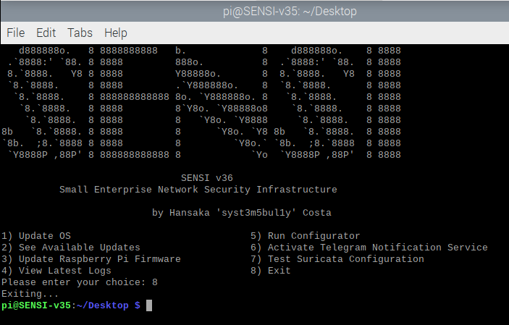

Figure 96: Exit option of SENSI Management System.

The final function of the SENSI Management System will use the exit logic to safely exit out of the bash script and give control of the terminal back to the user (figure 96).

## Overall Cost of Implementation

|  |  |  |  |  |
| --- | --- | --- | --- | --- |
| **ITEM** | **DESCRIPTION** | **REQUIRED** | **COST** | **REMARKS** |
| Raspberry Pi 4 Model B | Main unit for SENSI | **YES** | Board only: MYR 370.00  Basic Package: MYR 460.00 | Prices are from Cytron Marketplace Malaysia. |
| Kingston A400 SSD | Storage and boot media. | **YES** | 120GB: MYR 48.00  240GB: MYR 70.00 | Prices from Official Kingston store on Lazada. |
| UGREEN SATA to USB 3.0 adapter | High quality connector for SSD and Raspberry Pi. | **YES** | MYR 30.00 | Price from Official UGREEN store on Lazada. |
| Alfa AWUS036NHA Adapter | For external wireless NIC. | **NO** | MYR 165.00 | Not required. Used on this project development for debugging purposes. |
| CAT6 Cable | To connect SENSI to the network. | **YES** | MYR 7.00 – MYR 60.00 | An OEM CAT6 cable works great. |

The cost of developing customised, home-grown SENSI systems can vary significantly, largely contingent on the chosen hardware specifications. Estimated costs fall within a range of approximately MYR 460.00 to MYR 800arc.00. However, this spectrum is flexible and can undoubtedly deviate towards the lower and higher end based on the purchasing decisions and availability of discounts. For instance, substitutions with more affordable brands can lead to cost reductions. Replacing a Kingston A400 120GB SATA 3 SSD with an ADATA SU650 120GB SATA 3 SSD, a relatively less expensive brand, could decrease the overall expense by MYR 10.00 to MYR 12.00 at the sacrifice of performance.

Moreover, the costs of components like CAT6 cables fluctuate due to brand reputation, quality, and additional features. Although a consumer may opt for an OEM CAT6 5m cable of respectable quality within MYR 15.00 to MYR 20.00, the price could ascend to MYR 40.00 - MYR 60.00 for a branded, feature-rich alternative that essentially provides comparable functionality.

Given these considerations, the precise cost of SENSI's development and implementation inherently depends on the purchasing decisions made. Despite this variability, a reasonable estimate of the total expenditure typically falls between MYR 460.00 and MYR 800.00. This cost becomes particularly compelling when considering the absence of recurring expenses, such as monthly service payments or third-party subscription fees. Even at the upper end of the cost spectrum, SENSI is still a more cost-effective option than most hardware-based network security solutions in the current market.

## Sample Codes - Main Functions

### PeachPatrol Python3 Script

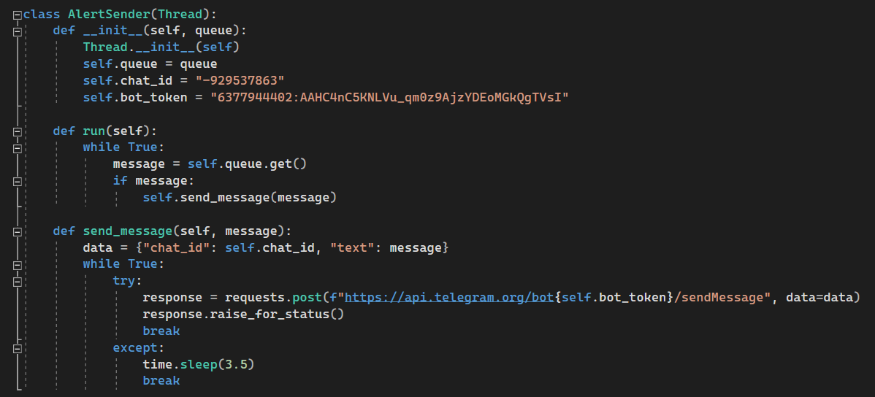

Figure 97: Portion of the PeachPatrol script that is responsible for queuing and sending Telegram messages via the Telegram bot.

The PeachPatrol.py script accomplishes its functions by utilizing the above method (figure 97). It is designed to create a new thread class named **“AlertSender”** by using the **“threadding”** library. The **“AlertSender”** receives new alerts to a queue and contains the **“chat_id”** and **“bot_token”** for Telegram. The **“chat_id”** is the ID of the Telegram chat where the alerts are sent; the **“bot_token”** is the token of the Telegram Bot (PeachPatrolbot) that will send the message.

The **“run”** method calls for an infinite loop that fetches messages from the queue. If the message is not none, it calls for the **“send_message”** method. If the message is none, it stays on loop until this event changes.

The **“send_message”** method is the part of the script responsible for sending the message. It achieves this by creating a dictionary called **“data”** which includes the message, chat id and the bot token. It then uses the **“request”** library’s **“POST”** function to send a POST request to the Telegram Bot API via the Telegram dedicated link.

**“response.raise_for_status()”** forces the script to break the loop if the POST request is successful. If an exception was raised, the script sleeps for 3.5 seconds before retrying. This was implemented as most of the exceptions that were raised during development and testing were due to Telegram Abuse detection – which temporarily deactivates Telegram Bots if a certain threshold is crossed (10 Telegram messages per second).

### Configurator Python3 Script

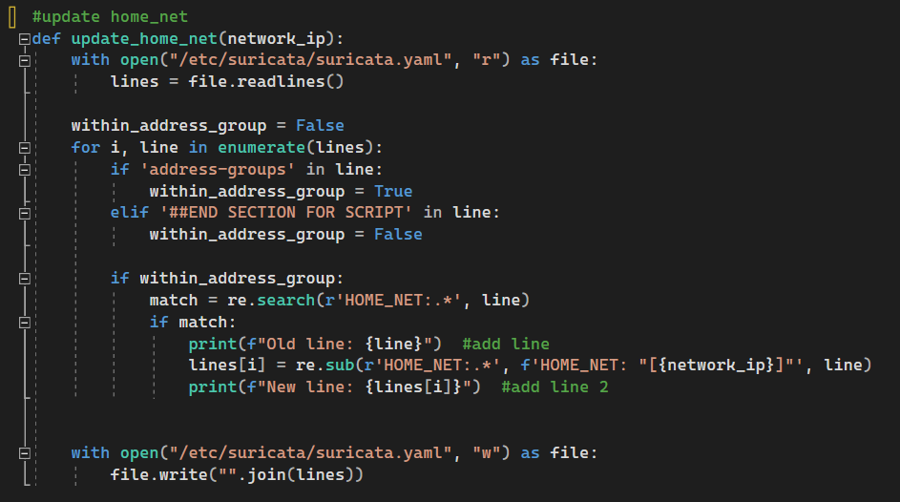

Figure 98: Portion of the configurator script that is responsible for reading the suricata.yaml and updating the HOME_NET value.

The primary purpose of configurator.py works with the help of the **“update_home_net(network_ip)”** function (figure 98). It reads the configuration file suricata.yaml line by line within the **“address-groups”** section. This is important as the **“HOME_NET”** value is in this section.

It achieves this by reading line by line till it finds **“address-groups”** string, at which point **“within_address_group”** variable is set to **“True”**. It continues to read lines until it reads the line **“##END SECTION FOR SCRIPT”**, at which point sets the variable **“within_address_group”** to **“False”**. This indicates that the script is indeed within the right section.

Then, the script uses **“match = re.search(r‘HOME_NET:.*’, line)”** function to search and match the line **“HOME_NET”**. Then it replaces the existing value with the new network IP **“network_ip”** using **“re.sub”** function. This effectively updates the HOME_NET value in suricata.yaml to reflect the new network IP.

Finally, the configurator.py script writes the updated lines into the suricata.yaml using the **“file.write”** function.

### SENSI Management System Bash Script

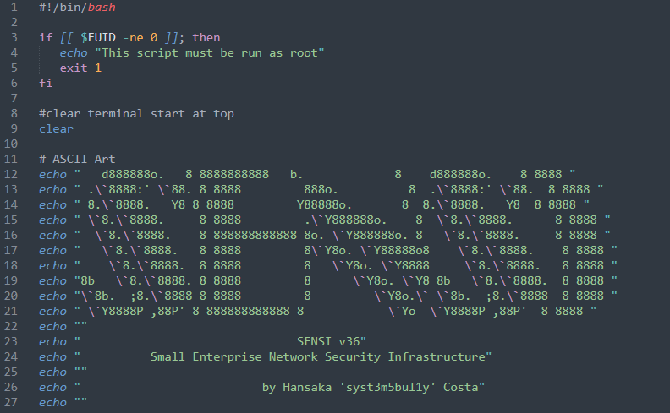

Figure 99: SENSI Management System Bash Script (A).

The script uses an **“if”** statement to examine the effective user ID via **“$EUID”** of the current user (figure 99) – if the script is not being executed by root user (root has user ID of 0), a message is printed to the console and the script terminates itself with **“exit 1”** (figure 100).

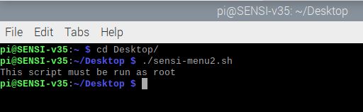

Figure 100: Failed attempt to run the script without root privileges.

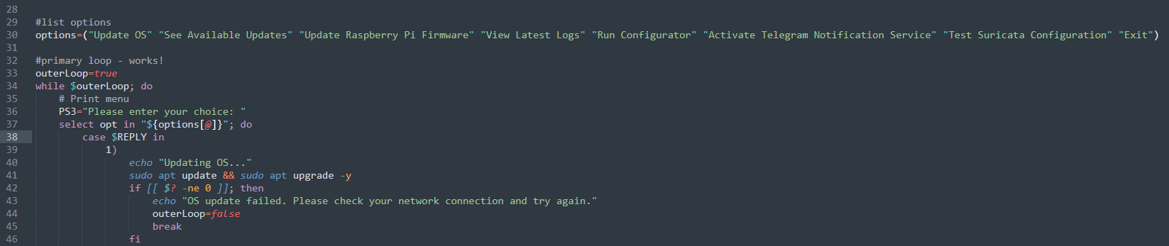

Figure 101: SENSI Management System Bash Script (B).

Figure 101 shows the options of the menu the user interacts with. The **“options”** array declared holds a set of string values which represent options. The **“outerLoop”**  variable is **“true”,** and a **“while”** loop is initiated. This loop stays alive as long as **“outerLoop”** remains true.

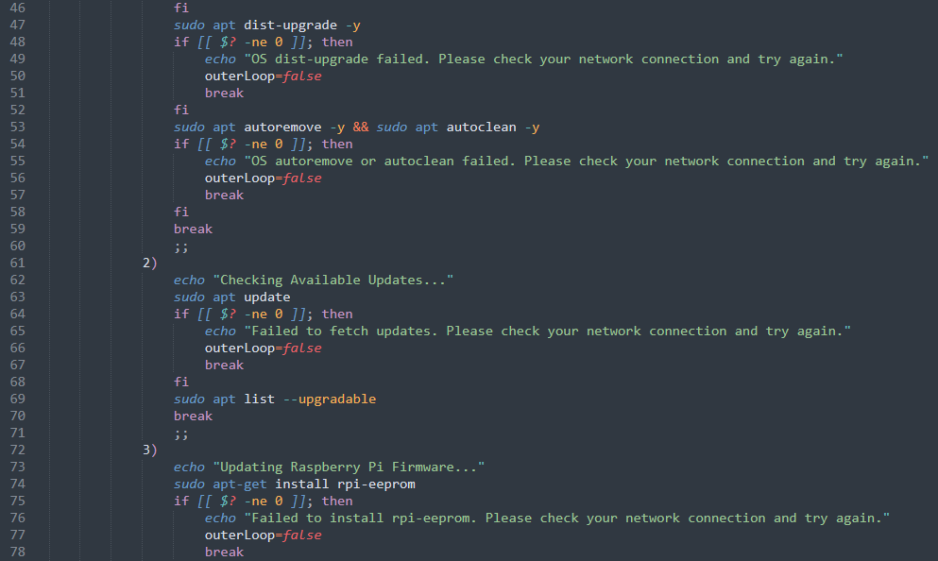

Figure 102: SENSI Management System Bash Script (C).

The error handling implemented is with great attention to good practice for scripts that update a system. By checking the exit status – **“$?”**, of each command, the script ensures that subsequent steps are not attempted if a previous step fails (figure 102). This is to make sure errors are caught and handled promptly, and to provide useful feedback to the user. It also ensures the script does not continue to execute potentially harmful commands when there is a known issue.

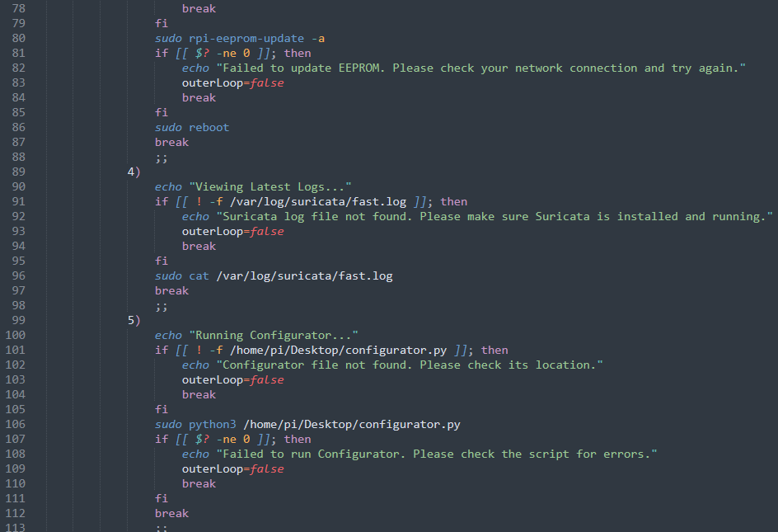

Figure 103: SENSI Management System Bash Script (D).

The above portion of the script, as shown in figure 103, uses different parameters. One parameter is to ensure that the configurator.py exists in the directory. To do so, it first checks for the file by **“[[ ! -f /home/pi/Desktop/configurator.py ]]”**, if the file does not exist, the script will print an error message and stop the loop. If the file is found, it is executed. Moreover, if the configurator.py breaks, and returns a non-zero exit, **“[[ $? -ne 0 ]]”,** the script will also break the loop.

Similar parameters are implemented for the fast.log file status to ensure that the file exists. If the file does not exist, the loop breaks and prints an error message.

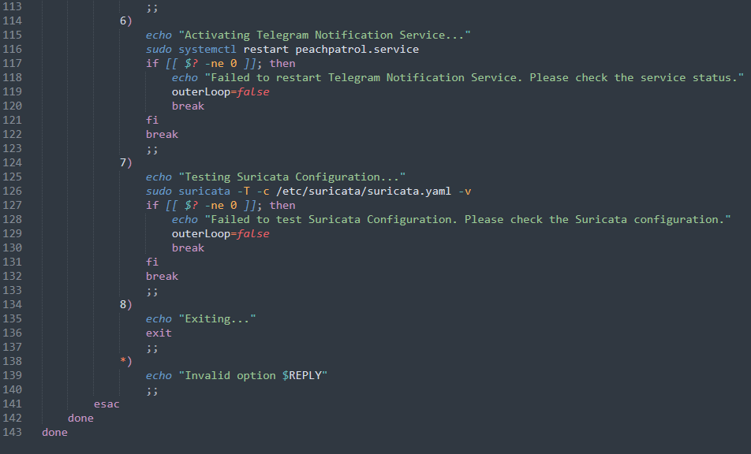

Figure 104: SENSI Management System Bash Script (E).

If the user enters a number that does not associate with any of the options presented in the bash script, it will print an error message with the chosen number – **“ *) echo “Invalid option $REPLY” ”** (figure 104).

# **SYSTEM VALIDATION**

## Unit Testing

### Raspberry Pi & Raspbian OS Configuration Test Plan

|  |  |  |  |  |  |
| --- | --- | --- | --- | --- | --- |
| TEST CASE ID | DESCRIPTION | TEST CONDITION | EXPECTED RESULT | ACTUAL RESULT | PASS /FAIL |
| 1.1 | Boot Raspberry Pi from SSD | Raspberry Pi powered on | Raspberry Pi boots from SSD | AS EXPECTED | PASS |
| 1.2 | Check Swap Space size | Run ‘free-h’ in terminal | Display of 12GB swap space | AS EXPECTED | PASS |

### Suricata Integration Test Plan

|  |  |  |  |  |  |
| --- | --- | --- | --- | --- | --- |
| TEST CASE ID | DESCRIPTION | TEST CONDITION | EXPECTED RESULT | ACTUAL RESULT | PASS /FAIL |
| 2.1 | Run Suricata | Execute Suricata in terminal | Suricata starts without any errors | AS EXPECTED | PASS |
| 2.2 | Check Suricata logs | Inspect Suricata log files | Logs show detected network threats | AS EXPECTED | PASS |

### Telegram API Integration Test Plan

|  |  |  |  |  |  |
| --- | --- | --- | --- | --- | --- |
| TEST CASE ID | DESCRIPTION | TEST CONDITION | EXPECTED RESULT | ACTUAL RESULTS | PASS /FAIL |
| 3.1 | Send alert via Telegram API | Trigger a rule in SENSI system | Alert is received in the Telegram group | AS EXPECTED | PASS |

### Configurator.py

|  |  |  |  |  |  |
| --- | --- | --- | --- | --- | --- |
| TEST CASE ID | DESCRIPTION | TEST CONDITION | EXPECTED RESULT | ACTUAL RESULT | PASS /FAIL |
| 4.1 | Run the configurator script to update HOME_NET value in suricata.yaml | Execute python script in terminal | HOME_NET value in suricata.yaml is updated | AS EXPECTED | PASS |
| 4.2 | Print update | Upon successful execution | Print old and new updates | AS EXPECTED | PASS |

### Peachpatrol.py

|  |  |  |  |  |  |
| --- | --- | --- | --- | --- | --- |
| TEST CASE ID | DESCRIPTION | TEST CONDITION | EXPECTED RESULT | ACTUAL RESULT | PASS /FAIL |
| 5.1 | Run log monitoring and alerting script | Execute python script in terminal | Script runs without errors and pushes alerts to Telegram. | AS EXPECTED | PASS |

### Bash Script Test Plan

|  |  |  |  |  |  |
| --- | --- | --- | --- | --- | --- |
| TEST CASE ID | DESCRIPTION | TEST CONDITION | EXPECTED RESULT | ACTUAL RESULT | PASS /FAIL |
| 5.1 | Run bash script for system design | Execute bash script in terminal | Bash script executed in terminal | AS EXPECTED | PASS |
| 5.2 | Test update function | Execute update function | Successful apt update, apt upgrade, apt dist-upgrade, apt autoremove & apt autoclean | AS EXPECTED | PASS |
| 5.3 | Test display update functions | Execute display updates function | Successfully display available updates | AS EXPECTED | PASS |
| 5.4 | Test update raspberry pi firmware option | Execute RPi firmware update option | Successfully determine if the RPi Firmware is up to date, offer updates if available | AS EXPECTED | PASS |
| 5.5 | Test view log option | Execute view log option | Successfully display the most recent logged alerts | AS EXPECTED | PASS |
| 5.6 | Test run configuration option | Execute configurator.py via bash script | Successfully update the suricata.yaml and print updates | AS EXPECTED | PASS |
| 5.7 | Test activation of telegram service | Execute peachpatrol.py via bash script | Successfully execute the daemon related to python3 script without error | AS EXPECTED | PASS |
| 5.8 | Test Suricata configuration option | Execute Suricata configuration test option | Successfully execute Suricata configuration test in verbose mode. | AS EXPECTED | PASS |
| 5.9 | Test exit function | Execute exit option | Successfully exit out of the bash script without errors | AS EXPECTED | PASS |

## Functional Test Plan

### Network Threat Detection

|  |  |  |  |  |  |
| --- | --- | --- | --- | --- | --- |
| TEST CASE ID | DESCRIPTION | TEST CONDITION | EXPECTED RESULT | ACTUAL RESULT | PASS /FAIL |
| 1.1 | Introduce a known **threat** **within** the network | SENSI is active | SENSI detects the threat & Suricata logs it – corrective actions taken | AS EXPECTED | PASS |
| 1.2 | **Incoming** attack from **external** network | SENSI is active | SENSI detects the attack, Suricata logs it – corrective actions taken | AS EXPECTED | PASS |

### Alert Notification Test Plan

|  |  |  |  |  |  |
| --- | --- | --- | --- | --- | --- |
| TEST CASE ID | DESCRIPTION | TEST CONDITION | EXPECTED RESULT | ACTUAL RESULT | PASS /FAIL |
| 2.1 | Trigger an alert in SENSI | Telegram API script is running | Alert notification is sent to dedicated Telegram group | AS EXPECTED | PASS |
| 2.2 | Trigger multiple alerts in quick succession | Telegram API script is running | All messages are sent to the Telegram group | AS EXPECTED | PASS |

## User Acceptance Testing

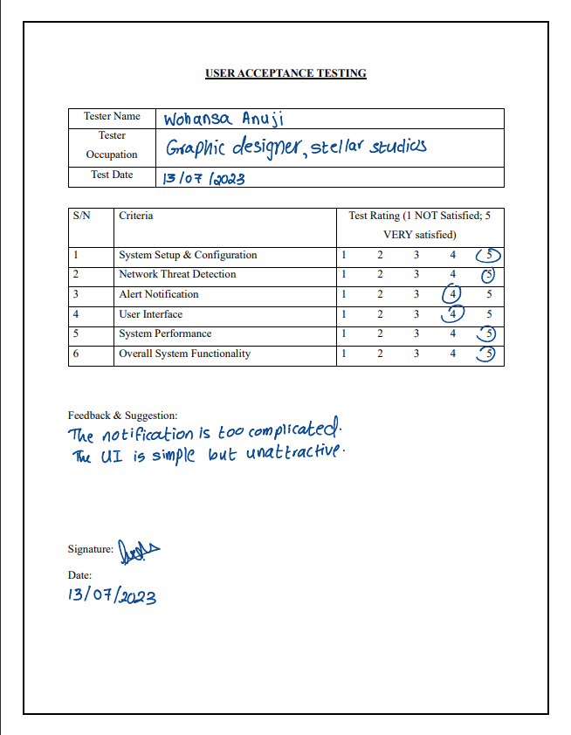

Figure 105: Tester 1 Feedback (non-technical user).



Figure 106: Tester 2 Feedback (non-technical user).

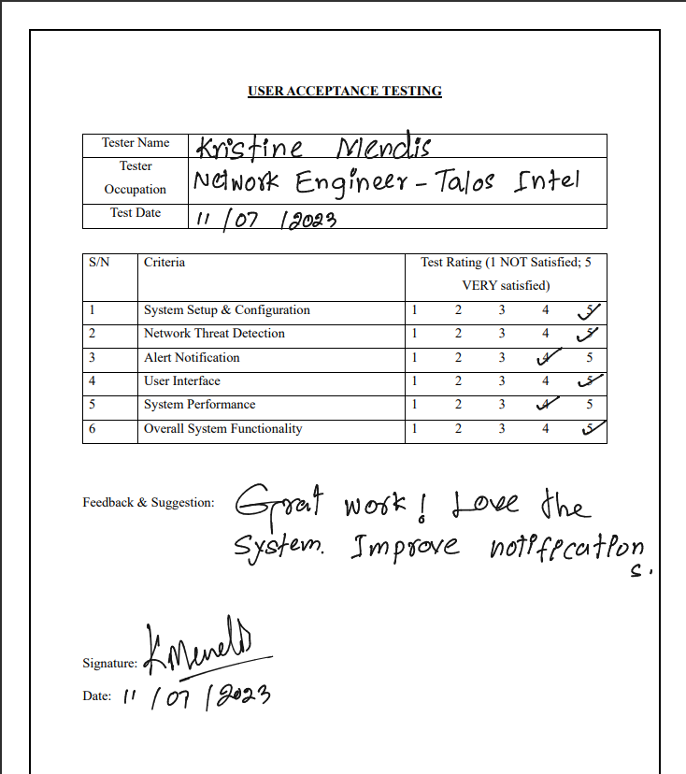

Figure 107: Tester 3 Feedback (Technical User – Network Engineer).

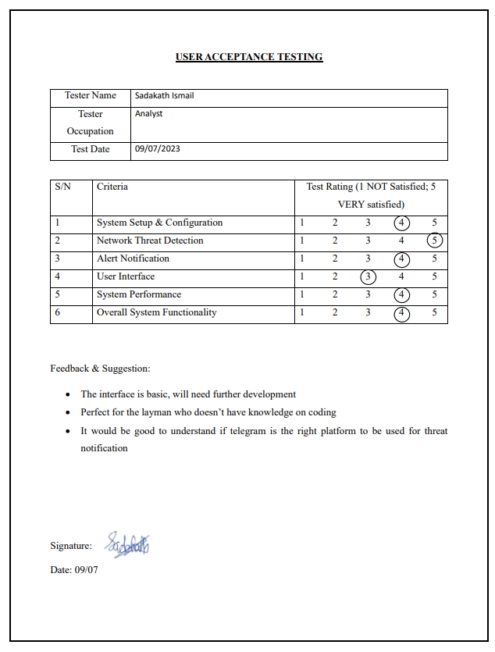

Figure 108: Tester 4 Feedback (Technical User – Intelligence Analyst)

### Summary of User Acceptance Testing

The results from the UAT of SENSI system provided critical insights. Users particularly were appreciative of the system’s setup, configuration ease, and network threat detection capabilities.

While the system performance was rated high, there were suggestions for improvements in two areas – the notification system and the user interface. Users reported that while functional, the alert system was complex. They suggested implementing a system that categorizes alerts based on their threat level, making the notifications more manageable.

The user interface also receives mixed responses. While the simplicity of the UI was appreciated, some users suggested a redesign stating it looks outdated. This could be largely due to terminal-run environment which does not compare to advanced UIs available in software today. This feedback underscores the importance of a user-friendly and attractive interface for user satisfaction.

In conclusion, the UAT results indicate that the SENSI system is an effective network security solution. The feedback and suggestions from users have also highlighted valuable areas for future enhancements that can significantly improve the user experience and the system’s overall efficiency.

# **Conclusion & Reflections**

## Critical Evaluation

The designing and development of the Small Enterprise Network Security Infrastructure was begun with the hopes that it would empower more Small and Medium Enterprises in Malaysia to go online and provide an affordable yet effective network security solution. By recognizing rise in cyberthreats and potential threats to SMEs in Malaysia in the digital age, SENSI was designed to serve as a reliable shield against security breaches.

SENSI was successfully developed to offer an easy-to-use, comprehensive network security system that considers the varying skill levels of potential users, from network administrators to less-tech savvy individuals. The simple user interface, paired with a robust set of functionalities, makes SENSI user-friendly and efficient. However, SENSI’s core strength is based on its cost-effectiveness and flexibility.

During the course of this project, various non-technical and technical knowledge domains have been thoroughly researched and critically examined. At the initial stages of the project, such as the literature review, provided valuable insights into the current state of network security in Malaysia, especially concerning the SME industry of Malaysia. In this phase, similar systems were evaluated to learn from their strengths and weaknesses and to understand how SENSI could be uniquely positioned to cater to its intended audience.

The technical research also played a crucial role in shaping the project. It informed about the selection of development tools and languages. The study on software development methodologies helped in choosing the appropriate approach that would ensure the smooth execution of SENSI.

In the end, to ascertain the validity and effectiveness of the project, SENSI was tested in real-world conditions by a mix of testers from different technical backgrounds and the feedback was collected. This process helped to confirm the assumptions made during the design and development phase and validate the functionalities. Moreover, this provided understanding on what areas that could be further enhanced.

## Limitations of SENSI

The SENSI system offers many benefits but also presents a few limitations that should be addressed in future evolutions.

Firstly, the system's reliance on Raspberry Pi introduces a constraint regarding computing power. While this platform is cost-effective, it may need to handle large-scale networks or heavy traffic loads more effectively. As such, in scenarios where network complexity or volume is high, SENSI might experience performance bottlenecks due to this inherent hardware limitation.

Secondly, early testers have pointed out that the notification system could sometimes be too complex for non-tech-savvy users. A complex notification system could lead to essential alerts being overlooked or misinterpreted, potentially compromising the network's security. Simplifying and prioritizing these alerts based on severity could improve the user experience and increase the system's threat-reporting effectiveness.

Lastly, SENSI's current design depends on Raspberry Pi, which may limit its compatibility with other systems or hardware platforms. Different businesses may use a diverse array of devices for their network infrastructure so this compatibility limitation could affect SENSI's broad applicability. Future evolutions should enhance system compatibility to make SENSI a more universally adaptable network security solution.

## Future Evolutions and Enhancements Suggestions

### Multiple Raspberry Pi 4s in a TCP Master-Slave Architecture

This proposed TCP Master-Slave architecture would allow for multiple Raspberry Pi boards to be integrated together to create a more powerful and better performing system. This would address scalability issues with growing networks. The enhancement of power would allow for SENSI to be integrated with various other heavy-duty tools such as BARNYARD2 and PulledPork which will also further enhance SENSI.

Moreover, a Master-Slave architecture would allow for Raspberry Pi boards to work independently. This means, that if one segment of SENSI breaks or goes offline, the other boards would still be capable of monitoring the network without interruptions.

### Integration of PulledPork and BARNYARD2

PulledPork is an open-source script developed to automate the management of Snort’s and Suricata’s rulesets.

BARNYARD2 is an open-source interpreter for Snort’s unified2 binary output files. However, it could also be integrated into Suricata to provide a web-based frontend for user interface for the user to interact with.

PulledPork would assist in the automated installation and management of rulesets for Suricata and BARNYARD2 would allow for clean visuals of threats to better understand the vast amounts of data processed by Suricata. This would make SENSI an easier system to use.

### NMAP-based Active Threat Hunting

NMAP is an industrial-grade network scanning tool used primarily for vulnerability assessment. This tool could be integrated into SENSI, so that if Suricata detects an internal threat, for example, an ICMP ping from an unknown device within the network to a known device, NMAP would be triggered to conduct a vulnerability scan (“-Sn” flag) of the device being scanned (victim device). The results of the vulnerability scan could then be sent as a notification to a dedicated Telegram group for Administrators to act on.

This implementation would allow for Administrators to cut-in during an attack and mitigate the threat by taking temporary defensive actions to impede access to the vulnerable machine.

### Cleaner Notifications

Feedback from users has indicated that the notifications can sometimes be complex and difficult to understand. This can be a serious impediment to the overall usability of SENSI.

To address the above concern, future evolutions should weigh more towards less clustered and easily understood formats of notifications. Clarity and simplicity should be at the forefront of this design. It could potentially achieve this by grouping notifications of similarity together. Similarly, a priority management system based on severity or relevance could potentially further unburden the user in this regard.

In summary, the proposed enhancements would significantly upgrade the SENSI system, transforming it into a more scalable and dynamic network security solution. This evolved version would not only accommodate expanding networks more effectively, but also facilitate initiative-taking threat detection with easy-to-understand notifications. These improvements would contribute to a more intuitive, efficient, and responsive security infrastructure for modern networks.

## Conclusion

In conclusion, SENSI is a testament that network security can be simple and inexpensive. It validates that even small enterprises with limited resources and technical expertise can effectively secure their network systems from potential threats.

SENSI's strength lies in its simplicity and comprehensiveness. Its user-friendly interface and robust functionality allow users, regardless of their technical prowess, to easily navigate and use the system. It effectively bridges the gap between advanced network security measures and affordability, making it a perfect fit for small businesses. However, like any system, SENSI has room for improvements and enhancements. Some limitations identified during its development and testing include a more streamlined notification system and a potential performance enhancement through a TCP master-slave architecture.

Despite these limitations, SENSI's future looks promising. As the demand for affordable and efficient network security solutions continues to grow, SENSI, with its potential enhancements, stands ready to meet and exceed these demands. With further development and refinement, SENSI is expected to evolve into an indispensable tool for network security within small enterprises.

# **REFERENCES**

A400 SATA SSD. (2023). Retrieved from Kingston: https://www.kingston.com/unitedkingdom/en/ssd/a400-solid-state-drive?partnum=sa400s37%2F240g

Abdel Hakee, S., Hussein, H., & Kim, H. (2022). Security Requirements and Challenges of 6G Technologies and Applications. MDPI SENSORS.

About. (2023). Retrieved from GNOME Partition Editor: https://gparted.org/

Agarwal, R., Prasad, J., Tanniru, M., & Lynch, J. (2000). Risks of Rapid Application Development. Communications of the ACM.

Aljawarneh, S. (2011). Cloud Security Engineering: Avoiding Security Threats the Right Way. International Journal of Cloud Applications and Computing.

Allan, A. (2019). Meet the New Raspberry Pi 4, Model B. Retrieved from Hackster.io: https://www.hackster.io/news/meet-the-new-raspberry-pi-4-model-b-9b4698c284

Allodi, L. (2019). On the Need for New Antphishing Measures Against Spear Phishing Attacks. IEEE Security & Privacy Mag.

Arora, S. (2023, March 10). Why Learn Python? Reasons and Benefits of Learning Python. Retrieved from Simpli Learn: https://www.simplilearn.com/why-learn-python-a-guide-to-unlock-your-python-career-article

Beegle, L. E. (2007). Rootkits and Their Effects on Information Security. Information Systems Security.

Barba, D. (2022, September 1). Python Concurrency — concurrent.futures. Retrieved from Towards Data Science: https://towardsdatascience.com/python-concurrency-concurrent-futures-15b56dc9a14d

Bash Reference Manual. (2023). Retrieved from GNU: https://www.gnu.org/software/bash/manual/bash.html

Bernama. (2022, August 5). DDoS attacks rose 100 times to reach 3,000 minutes in Q2 2022 -- Kaspersky. Retrieved from Bernama: https://bernama.com/en/business/news.php?id=2107914

Bot API. (2023). Retrieved from Telegram: https://core.telegram.org/api

Bourgeois, S. (2016, October 6). 11 Types of Networks Explained: VPN, LAN & More. Retrieved from BELDEN: https://www.belden.com/blogs/network-types

BRATHWAITE, S. (2021, July 8). The Importance Of Bash Scripting For Ethical Hacking. Retrieved from CYBRARY: https://www.cybrary.it/blog/the-importance-of-bash-scripting-for-ethical-hacking

Bruijn, H. d., & Janssen, M. (2017). Building Cybersecurity Awareness: The need for evidence-based framing strategies. ELSEVIER.

BusinessToday. (2021, May 08). NSFOCUS 2020 DDoS Attack Landscape Report Warns of New Threat Vectors. Retrieved from Business Today: https://www.businesstoday.com.my/2021/05/08/nsfocus-2020-ddos-attack-landscape-report-warns-of-new-threat-vectors/

BusinessToday. (2022, February 04). Cybersecurity Costs Hinders SME’s Digital Adoption. Retrieved from Business Today: https://www.businesstoday.com.my/2022/02/04/cybersecurity-costs-hinders-smes-digital-adoption/

BusinessToday. (2023, March 01). Changing the Conversation on the Cybersecurity Talent Shortage. Retrieved from Business Today: https://www.businesstoday.com.my/2023/03/01/changing-the-conversation-on-the-cybersecurity-talent-shortage/

Busch, Z. (2022, January 31). What Is a Network? Why It’s Important for Resource Sharing. Retrieved from G2: https://www.g2.com/articles/what-is-a-network

Camisso, J. (2021, November 24). Understanding Suricata Signatures. Retrieved from Digital Ocean: https://www.digitalocean.com/community/tutorials/understanding-suricata-signatures

CertNZ. (2023). Legacy systems. Retrieved from CertNZ - New Zealand Security Response: https://www.cert.govt.nz/it-specialists/guides/legacy-systems/

cisa.gov. (2019, June 04). DNS Amplification Attacks. Retrieved from Cybersecurity & Infrastructure Security Agency: https://www.cisa.gov/news-events/alerts/2013/03/29/dns-amplification-attacks

CISA.GOV. (2023). Stop Ransomware. Retrieved from CISA GOV: https://www.cisa.gov/stopransomware#:~:text=Ransomware%20is%20a%20form%20of,ransom%20in%20exchange%20for%20decryption.

Cisco. (2023). What Is a Worm? Retrieved from Cisco: https://www.cisco.com/c/en/us/products/security/what-is-a-worm.html

Cisco. (2023). What is malware? Retrieved from CISCO: https://www.cisco.com/site/us/en/products/security/what-is-malware.html

Clifton, L., & David, J. (2013). Security Risk Management. ScienceDirect.

CloudFlare. (2023). HTTP flood attack. Retrieved from CloudFlare: https://www.cloudflare.com/learning/ddos/http-flood-ddos-attack/

Cloudflare. (2023). What is a DDoS attack? Retrieved from CLOUDFLARE: https://www.cloudflare.com/learning/ddos/what-is-a-ddos-attack/

Cociorba, M. (2016, October 16). Top 5 Most Common Network Vulnerabilities: Lack of Network Segregation. Retrieved from Perspective Risk: https://perspectiverisk.com/top-5-common-network-vulnerabilities-lack-network-segregation/

Complete list of Suricata Features. (2023). Retrieved from Suricata: https://suricata.io/features/all-features/

Comptia. (2023). Network Security: What Is It, Why Does It Matter and What Can You Do to Make Networks More Secure? Retrieved from Comptia: https://www.comptia.org/content/guides/network-security-basics-definition-threats-and-solutions

ConditionZebra. (2022, March 2). Ransomware Attacks in 2022: Malaysia’s Ultimate Guide. Retrieved from Condition Zebra: https://condition-zebra.com/ransomware-attacks-in-2022/

Crawford, D. (2019, November 20). PiVPN Review. Retrieved from ProPrivacy: https://proprivacy.com/vpn/review/pivpn

Das, A. (2019, January 9). Bash 5.0 Released with New Features. Retrieved from ITS FLOSS: https://itsfoss.com/bash-5-release/

Debian 11 bullseye released. (2021, August 14). Retrieved from Debian: https://www.debian.org/News/2021/20210814

Deshmukh, R. V., & Devadkar, K. K. (2015). Understanding DDoS Attack & Its Effect In Cloud Environment. International Conference on Advances in Computing, Communication and Control (ICAC3’15).

Fadzline, P. (2019). The Challenges and Solutions of Cybersecurity Among Malaysian Companies. ResearchGate.

Farah, A. (2022, March 14). Business email compromise attacks scale up to 8000 in Q4, become more targeted. Retrieved from Malaysian Business: https://www.malaysian-business.com/index.php/wordpress/item/6010-business-email-compromise-attacks-scale-up-to-8000-in-q4-become-more-targeted

fbi.gov. (2019, March 25). The Melissa Virus. Retrieved from FBI: https://www.fbi.gov/news/stories/melissa-virus-20th-anniversary-032519

fbi.gov. (2023). Business Email Compromise. Retrieved from FBI.gov: https://www.fbi.gov/how-we-can-help-you/safety-resources/scams-and-safety/common-scams-and-crimes/business-email-compromise

FCC. (2023). Cybersecurity for Small Businesses. Retrieved from Federal Communications Commission: https://www.fcc.gov/communications-business-opportunities/cybersecurity-small-businesses

Features. (2023). Retrieved from GNOME Partition Editor: https://gparted.org/features.php

Firewalla. (2023). About Firewalla. Retrieved from Firewalla: https://firewalla.com/

Firewalla. (2023). Firewalla Purple. Retrieved from Firewalla: https://firewalla.com/products/firewalla-purple

Firewalla. (2023). User Manual. Retrieved from Firewalla: https://firewalla.com/pages/user-manual

F-Secure. (2023). Adware:W32/Gator. Retrieved from F-Secure: https://www.f-secure.com/sw-desc/adware_w32_gator.shtml

FS-Isac, & Akamai. (2023). The Evolution of DDoS: Return of the Hacktivists. FS-ISAC.

Firch, J. (2023, September 23). Common Types of Network Security Vulnerabilities. Retrieved from PurpleSec: https://purplesec.us/common-network-vulnerabilities/

Grammatikakis, K.-P., Koufos, I., Kolokotronis, N., & Vassilakis, C. (2021). Understanding and Mitigating Banking Trojans: From Zeus to Emotet.

GreatHorn. (2021, February 8). What Are the 3 Phases of the Phishing Attack Kill Chain? Retrieved from GreatHorn: https://www.greathorn.com/blog/what-are-the-3-phases-of-the-phishing-attack-kill-chain/

Gorbachenko, P. (2023). What is the Rapid Application Development Process? Retrieved from Enkonix: https://enkonix.com/blog/rapid-application-development/

Humayun, M., Zaman, N., Alsayat, A., & Ponnusamy, V. (2020). Internet of things and ransomware: Evolution, mitigation and prevention. Egyptian Informatics Journal. Retrieved from Internet of things and ransomware: Evolution, mitigation, and prevention

Hurera, N. S. (2021). SECURING NETWORK BY IMPLEMENTING A VPN. Universiti Sultan Zainal Abidin.

(ISC)2. (2022, October 24). (ISC)2 Cybersecurity Workforce Study 2022. Retrieved from HRM Asia: https://hrmasia.com/asia-pacifics-cybersecurity-workforce-gap-hits-2-14m/

IBM. (2017). OS Communications Server: IP Sockets Application Programming Interface Guide and Reference. Retrieved from IBM: https://www.ibm.com/docs/en/zos/2.1.0?topic=concepts-introducing-tcpip-socket-libraries

IBM. (2022). What is network security? Retrieved from IBM: https://www.ibm.com/my-en/topics/network-security

IBM. (2023). What is networking? Retrieved from IBM: https://www.ibm.com/topics/networking#:~:text=Computer%20networks%20connect%20nodes%20like,communications%20are%20sent%20and%20received.

Imperva. (2023). Phishing attacks. Retrieved from Imperva: https://www.imperva.com/learn/application-security/phishing-attack-scam/

Ignatius, C. (2022, November 1). Malaysia Remains Top Country In SEA When It Comes To Financial Phishing. Retrieved from BusinessToday: https://www.businesstoday.com.my/2022/11/01/malaysia-remains-top-country-in-sea-when-it-comes-to-financial-phishing/

JavaTPoint. (2023). What is DDoS Attack? Retrieved from JavaTPoint: https://www.javatpoint.com/what-is-ddos-attack

Jit, S. (2023). Bash Scripting – Introduction to Bash and Bash Scripting. Retrieved from GeeksforGeeks: https://www.geeksforgeeks.org/bash-scripting-introduction-to-bash-and-bash-scripting/

Joy, A. (2021, November 10). 5 Main Disadvantages of Python Programming Language. Retrieved from Pythonista Planet: https://pythonistaplanet.com/disadvantages-of-python/

JuniperNetworks. (2021). Simplifying Enterprise Network Architecture to Succeed in the Cloud Era. Juniper Networks.

Joshi, S. (2021, May 24). How Rapid Application Development Helps Teams Save Time. Retrieved from G2 Learn: https://learn.g2.com/rapid-application-development

Juillet, R. (2022, May 23). What is the Scrum method? Retrieved from Bocassay: The Scrum method and its benefits in web development.

Kali. (2023). What is Kali Linux & Kali's features. Retrieved from Kali: https://www.kali.org/docs/introduction/

Kali Linux. (2023, March 13). Documentation. Retrieved from Kali Linux: https://www.kali.org/blog/kali-linux-2023-1-release/

Kaspersky. (2022). Ransomware Attacks and Types – How Encryption Trojans Differ. Retrieved from Kaspersky: https://www.kaspersky.com/resource-center/threats/ransomware-attacks-and-types

Kaspersky. (2023). Malware & Computer Virus Facts & FAQs. Retrieved from Kaspersky: https://www.kaspersky.com/resource-center/threats/computer-viruses-and-malware-facts-and-faqs

Kaspersky. (2023). Ransomware Attacks and Types – How Encryption Trojans Differ. Retrieved from Kaspersky: https://www.kaspersky.com/resource-center/threats/ransomware-attacks-and-types

Kaspersky. (2023). What is Adware? – Definition and Explanation. Retrieved from Kaspersky: https://www.kaspersky.com/resource-center/threats/adware

Kaspersky. (2023). What is Rootkit – Definition and Explanation. Retrieved from Kaspersky: https://www.kaspersky.com/resource-center/definitions/what-is-rootkit

Kaspersky, D. (2023). The Human Factor in IT Security: How Employees are Making Businesses Vulnerable from Within. Retrieved from Kaspersky Daily: https://www.kaspersky.com/blog/the-human-factor-in-it-security/

KissFlow. (2022, January 23). Rapid Application Development (RAD) Model: An Ultimate Guide For App Developers in 2023. Retrieved from KissFlow: https://kissflow.com/application-development/rad/rapid-application-development/

Knapp, E. D., & Langill, J. T. (2014). Industrial Network Security - Securing Critical Infrastructure Networks for Smart Grid, SCADA, and Other Industrial Control Systems. SYNGRESS.

Landsberger, D. (2020, October 23). What Is Network Segmentation and Why It Matters? Retrieved from CompTIA: https://www.comptia.org/blog/security-awareness-training-network-segmentation

Leblond, E. (2022, January 18). Introducing Suricata Language Server: Real-time Rule Syntax Checking and Auto-completion. Retrieved from Stamus Networks: https://www.stamus-networks.com/blog/suricata-language-server-real-time-rule-syntax-checking-and-auto-completion

Liew, T. W., Gan, C. L., & Lee, Y. Y. (2023). Thwarting Instant Messaging Phishing Attacks: The Role of Self-Efficacy and the Mediating Effect of Attitude towards Online Sharing of Personal Information. Psycho-Criminology, Crime, and the Law (2nd Edition).

Loshin, P. (2023). bash (Bourne again shell). Retrieved from TechTarget: https://www.techtarget.com/searchdatacenter/definition/bash-Bourne-Again-Shell#:~:text=Bash%20can%20be%20used%20to,network%20performance%20on%20organizational%20networks.

Lohrmann, D. (2022, August 25). Opinion: Hacktivism and DDOS attacks rise dramatically in 2022. Retrieved from TheStar: https://www.thestar.com.my/tech/tech-news/2022/08/25/opinion-hacktivism-and-ddos-attacks-rise-dramatically-in-2022

Mahmood, W., Usmani, N., Ali, M., & Farooqui, S. (2020). Benefits to Organizations after migrating to Scrum. Sustainable Economic Growth, Education Excellence, and Innovation Management through Vision 2020.

Mccutchen, D. (2021, August 11). Ransomware: A Beginner’s Guide to Threat Detection. Retrieved from NETWITNESS: https://www.netwitness.com/blog/ransomware-faq/

Medium. (2022, October 05). Pros and Cons of Installing pfSense as Virtual vs Dedicated Server. Retrieved from Medium: https://netshopisp.medium.com/pros-and-cons-of-installing-pfsense-as-virtual-vs-dedicated-server-9e12d39c4cfd

Meikeng, Y. (2020, March 22). In need of cybersecurity experts. Retrieved from The Star: https://www.thestar.com.my/news/focus/2020/03/22/in-need-of-cybersecurity-experts

Microsoft. (2008, April 01). Spyware:Win32/Coolwebsearch.H. Retrieved from Microsoft Security Intelligence: https://www.microsoft.com/en-us/wdsi/threats/malware-encyclopedia-description?Name=Spyware%3AWin32%2FCoolwebsearch.H

Microsoft. (2023). It’s how you make software. Retrieved from Microsoft: https://visualstudio.microsoft.com/#:~:text=The%20Visual%20Studio%20IDE%20is,and%20then%20publish%20an%20app.

Microsoft. (2023, January 21). Measure memory usage in Visual Studio (C#, Visual Basic, C++, F#). Retrieved from Microsoft Learn: https://learn.microsoft.com/en-us/visualstudio/profiling/memory-usage?view=vs-2022

Microsoft Security Intelligence. (2008, April 01). Spyware:Win32/Coolwebsearch.H. Retrieved from Microsoft Security Intelligence: https://www.microsoft.com/en-us/wdsi/threats/malware-encyclopedia-description?Name=Spyware%3AWin32%2FCoolwebsearch.H

Morgan, S. (2020, November 13). Cybercrime To Cost The World $10.5 Trillion Annually By 2025. Retrieved from CyberCrime Magazine: https://cybersecurityventures.com/cybercrime-damages-6-trillion-by-2021/

Mousepad Developers. (2023, February 09). Mousepad. Retrieved from FlatHub: https://flathub.org/apps/details/org.xfce.mousepad

Nation Entrepreneur and SME Development Council (NESDC). (2021). MSME INSIGHTS 2021. Malaysia.

Mulligan, D., & Perzanowski, A. K. (2008). The Magnificence of the Disaster: Reconstructing the Sony Bmg Rootkit Incident. Law and Technology Scholarship, Berkeley Center for Law and Technology, UC Berkeley.

Murugiah, S. (2022, December 14). Cyber threat actors to ramp up attacks targeting security blind spots in coming year, warns Trend Micro. Retrieved from The Edge Market: https://www.theedgemarkets.com/article/cyber-threat-actors-ramp-attacks-targeting-security-blind-spots-coming-year-warns-trend

Murugiah, S. (2023, March 08). Ransomware attacks in Malaysia up 16% y-o-y in 2022, says Trend Micro. Retrieved from The Edge Market: https://www.theedgemarkets.com/node/658253#:~:text=KUALA%20LUMPUR%20(March%208)%3A,cybersecurity%20firm%20Trend%20Micro%20Inc.

MyCert. (2021). Malaysia Botnet Drones and Malware Infection 2021. Retrieved from MyCert: https://www.mycert.org.my/portal/statistics-content?menu=b75e037d-6ee3-4d11-8169-66677d694932&id=e7dbc6f4-01c3-408f-aa4d-b394272e3f25

MyCert. (2022). Malaysia Botnet Drones and Malware Infection 2022. Retrieved from MyCert: https://www.mycert.org.my/portal/statistics-content?menu=b75e037d-6ee3-4d11-8169-66677d694932&id=6d6ae450-74eb-4ee5-9490-859ac5653fed

MyCert. (2023). Incident Statistics. Retrieved from MyCERT: https://www.mycert.org.my/portal/statistics-content?menu=b75e037d-6ee3-4d11-8169-66677d694932&id=6d6ae450-74eb-4ee5-9490-859ac5653fed

MyCERT General Statistics 2021. (2021, November 05). Retrieved from MyCERT: https://mycert.org.my/portal/statistics-content?menu=b75e037d-6ee3-4d11-8169-66677d694932&id=77be547e-7a17-444b-9698-8c267427936c

nces.gov. (2023). Introduction to Security Management. Retrieved from National Centre for Educational Statistics: https://nces.ed.gov/pubs98/safetech/chapter1.asp

ncsc.gov. (2023). Whaling: how it works, and what your organisation can do about it. Retrieved from National Cybersecurity Centre: https://www.ncsc.gov.uk/guidance/whaling-how-it-works-and-what-your-organisation-can-do-about-it#:~:text=Whaling%20is%20a%20highly%20targeted,a%20wire%20transfer%20of%20funds.

Netgate. (2023). Get to Know pfSense Plus. Retrieved from Netgate: https://www.netgate.com/pfsense-features

Network diagram templates and examples. (2022). Retrieved from LucidChart: https://www.lucidchart.com/blog/network-diagram-templates

NewEgg. (2023). Pfsense Mini PC G30. Retrieved from NewEgg: https://www.newegg.com/p/2SW-003T-00267

NewStraitsTimes. (2022, June 20). #TECH: Every 1 in 2 phishing attempts in Malaysia finance-related. Retrieved from New Straits Times: https://www.nst.com.my/lifestyle/bots/2022/06/806623/tech-every-1-2-phishing-attempts-malaysia-finance-related

NewStraitsTimes. (2022, June 20). #TECH: Every 1 in 2 phishing attempts in Malaysia finance-related. Retrieved from NewStraitsTimes: https://www.nst.com.my/lifestyle/bots/2022/06/806623/tech-every-1-2-phishing-attempts-malaysia-finance-related

Nhat, A. (2019). Capstone Project Document PHISHING DETECTION IN EMAIL MINISTRY OF EDUCATION AND TRAINING. ResearchGate.

P Beynon-Davies, Carne, C., Mackay, H., & Tudhope, D. (1999). Rapid application development (RAD): an empirical review. European Journal of Information Systems.

(2019). Performance of SMEs. Malaysia: SME Corporation Malaysia.

PiVPN. (2023). About. Retrieved from PiVPN: https://pivpn.io/#about

PiVPN. (2023). PiVPN. Retrieved from PiVPN: https://pivpn.io/#

Preston, H. (2022, March 11). 5 Reasons a Raspberry Pi Belongs in Your Network Lab. Retrieved from Cisco Blog: https://blogs.cisco.com/learning/5-reasons-a-raspberry-pi-belongs-in-your-network-lab

Python. (2023). Applications for Python. Retrieved from Python: https://www.python.org/about/apps/

Python. (2023). About. Retrieved from Python: https://www.python.org/

Python. (2023). argparse — Parser for command-line options, arguments and sub-commands. Retrieved from Python Docs: https://docs.python.org/3/library/argparse.html#:~:text=The%20argparse%20module%20makes%20it,generates%20help%20and%20usage%20messages.

Python. (2023). What is Python? Executive Summary. Retrieved from Python: https://www.python.org/doc/essays/blurb/

PythonDocs. (2023). threading — Thread-based parallelism. Retrieved from Python: https://docs.python.org/3/library/threading.html

Ragent. (2023). Business Email Compromise Scams Are On The Rise. Retrieved from Regents: https://regentsriskadvisory.com/4374-2/

Rapid7. (2020, October 26). Understanding and Configuring Snort Rules. Retrieved from RAPID7: https://www.rapid7.com/blog/post/2016/12/09/understanding-and-configuring-snort-rules/#:~:text=Snort%20generates%20alerts%20according%20to,internet%20activities%20and%20malicious%20activities.

RAPID7. (2023). Patch Management Definition & Best Practices. Retrieved from RAPID7: https://www.rapid7.com/fundamentals/patch-management/

Raspberry Pi 4 Tech Specs. (2023). Retrieved from Raspberry Pi: https://www.raspberrypi.com/products/raspberry-pi-4-model-b/specifications/

Raspbian. (2023). About Raspbian. Retrieved from Raspbian: https://www.raspbian.org/RaspbianAbout

Raza, A., & Majeed, H. (2012). Issues and Challenges in Scrum Implementation. International Journal of Scientific & Engineering Research.

RiseMalaysia. (2022, June 14). Kaspersky Blocks 11 Million Malicious Emails In SEA 2021. Retrieved from RISE Malaysia: https://risemalaysia.com.my/13274/bec-attacks-kaspersky/

Root, E. (2022, August 8). ILOVEYOU: the virus that loved everyone. Retrieved from Kaspersky Daily: https://www.kaspersky.com/blog/cybersecurity-history-iloveyou/45001/

Rosenberg, J. (2017). Chapter E6 - Embedded security. In J. Rosenberg, Rugged Embedded Systems (pp. 1-74). 2017 Elsevier Inc.

Rubenking, N. J. (2022, May 25). Firewalla Purple Review. Retrieved from PCMag: https://www.pcmag.com/reviews/firewalla

Salgueiro, P. D. (2012). DECLARATIVE DOMAIN-SPECIFIC LANGUAGES AND APPLICATIONS TO NETWORK MONITORING. Universidade de Évora.

Shah, D., Shah, V., & Shah, H. (2017). Survey on Computer Worms. International Journal on Recent and Innovation Trends in Computing and Communication.

Smith, A. R., Colombi, J. M., & Wirthlin, J. R. (2013). Rapid Development: A Content Analysis Comparison of Literature and Purposive Sampling of Rapid Reaction Projects. Procedia Computer Science.

Scapy. (2023). What is Scapy? Retrieved from Scapy: https://scapy.net/

Scrum. (2023). What is a Daily Scrum? Retrieved from Scrum: https://www.scrum.org/learning-series/what-is-scrum/the-scrum-events/what-is-a-daily-scrum

Scrum. (2023). What is a Developer? Retrieved from Scrum: https://www.scrum.org/learning-series/what-is-scrum/the-scrum-team/what-is-a-developer

Scrum. (2023). What is a Product Backlog? Retrieved from Scrum: https://www.scrum.org/learning-series/what-is-scrum/the-scrum-artifacts/what-is-a-product-backlog

Scrum. (2023). What is a Product Owner? Retrieved from Scrum: https://www.scrum.org/learning-series/what-is-scrum/the-scrum-team/what-is-a-product-owner

Scrum. (2023). What is a Scrum Master? Retrieved from Scrum: https://www.scrum.org/learning-series/what-is-scrum/the-scrum-team/what-is-a-scrum-master

Scrum. (2023). What is a Sprint Retrospective? Retrieved from Scrum: https://www.scrum.org/learning-series/what-is-scrum/the-scrum-events/what-is-a-sprint-retrospective

Scrum. (2023). What is a Sprint? Retrieved from Scrum: https://www.scrum.org/learning-series/what-is-scrum/the-scrum-events/what-is-a-sprint

Scrum. (2023). What is a Sprint Planning? Retrieved from Scrum: https://www.scrum.org/learning-series/what-is-scrum/the-scrum-events/what-is-sprint-planning

Scrum. (2023). What is a Sprint Review? Retrieved from Scrum: https://www.scrum.org/learning-series/what-is-scrum/the-scrum-events/what-is-a-sprint-review

Scrum. (2023). What is Scrum? Retrieved from Scrum: https://www.scrum.org/learning-series/what-is-scrum

Scrum. (2023). What is Sprint Planning? Retrieved from Scrum: https://www.scrum.org/learning-series/what-is-scrum/the-scrum-events/what-is-sprint-planning

Security. (2023). Retrieved from Telegram: https://core.telegram.org/api

Seungjin, L., Abdullah, A., & Jhanjhi, N. (2020). A Review on Honeypot-based Botnet Detection Models for Smart Factory. (IJACSA) International Journal of Advanced Computer Science and Applications.

Seungwon, S., Guofei , G., Reddy, N., & Lee, C. (2012). A Large-Scale Empirical Study of Conficker. IEEE Transactions on Information Forensics and Security.

Sivalingam, J. (2016, November 15). As Malaysia's economy goes high tech, so do cyber threats. Retrieved from New Straits Times: https://www.nst.com.my/news/2016/11/188974/malaysias-economy-goes-high-tech-so-do-cyber-threats

sme.asia. (2022, June 23). Email Threats Spike 101%, Remains a Top Attack Vector. Retrieved from SME.Asia: https://sme.asia/email-threats-spike-101-remains-a-top-attack-vector/

Suricata Logo. (2023). Retrieved from Suricata: https://suricata.io/wp-content/uploads/2022/01/Logo-SuricataFinal-2-white-background.jpg

Tay, C. (2022, October 7). BNM orders iPay88 to strengthen cybersecurity controls after data breach incident. Retrieved from The Edge Market: https://www.theedgemarkets.com/article/bnm-orders-ipay88-strengthen-cybersecurity-controls-after-data-breach-incident

Telegram Applications. (2023). Retrieved from Telegram: https://telegram.org/apps

TheAppSolutions. (2023). UNDERSTANDING THE RAPID APPLICATION DEVELOPMENT MODEL. Retrieved from The App Solutions: https://theappsolutions.com/blog/development/rad-model/#:~:text=Stage%201%3A%20Business%20Modeling,Stage%204%3A%20Application%20Generation

TheEdgeMarkets. (2021, April 14). Bridging the cybersecurity skills gap in Malaysia. Retrieved from The Edge Markets: https://www.theedgemarkets.com/content/advertise/bridging-cybersecurity-skills-gap-malaysia

Todd, M., & M. Rahman, S. (2022). COMPLETE NETWORK SECURITY PROTECTION FOR SME’SWITHIN LIMITED RESOURCES. International Journal of Network Security & Its Applications (IJNSA). Retrieved from Solution Tech: https://solutiontech.com.au/cyber-security-for-small-businesses/

Trend Micro. (2021). Trend Micro Cloud App Security Threat Report 2021. Trend Micro.

TrendMicro. (2023). What Are the Different Types of Phishing? Retrieved from TREND MICRO: https://www.trendmicro.com/en_my/what-is/phishing/types-of-phishing.html

TrustRadius. (2023). pfSense. Retrieved from TrustRadius: https://www.trustradius.com/products/pfsense/reviews

Ubuntu 22.04.2 LTS. (2023). Retrieved from Ubuntu: https://ubuntu.com/download/desktop

UMBC. (2022, August 27). WHY USE PYTHON FOR CYBER SECURITY? Retrieved from University of Maryland: https://www.umbctraining.com/python-for-cyber-security/

University of Newcastle. (2023, March 14). Research Methods: What are research methods? Retrieved from University of Newcastle Library: https://libguides.newcastle.edu.au/researchmethods

Vidhya, D. (2018). Network Security using Python. IJSRSET.

w3schools. (2023). Python Introduction. Retrieved from W3 Schools: https://www.w3schools.com/python/python_intro.asp

Wan, Q. (2021). Defending wireless communication against eavesdropping attacks using secret spreading codes and artificial interference. COMPUTERS AND SECURITY 103.

What is Bash? (2023). Retrieved from OpenSource: https://opensource.com/resources/what-bash

Woods, E. (2023). The Three Stages Of a Phishing Attack - Bait, Hook And Catch. Retrieved from USECURE: https://blog.usecure.io/three-steps-of-phishing

Yeoh, A. (2022, June 02). Maybank warns of malicious SMSSpy campaign targeting Android users in Malaysia. Retrieved from I3investor: https://www.thestar.com.my/tech/tech-news/2022/06/02/maybank-warns-of-malicious-smsspy-campaign-targeting-android-users-in-malaysia

Zaboon, H. K., Alhammadi , N. A., & Abdullah, A. A. (2021). A Review of the Common DDoS Attack: Types and Protection Approaches Based on Artificial Intelligence. Fusion: Practice and Applications (FPA).

Zhang, C., Zhou, S., & Chain , B. M. (2015). Hybrid Epidemics—A Case Study on Computer Worm Conficker. PLOS ONE.

# **APPENDICES**

## **SENSI POSTER**

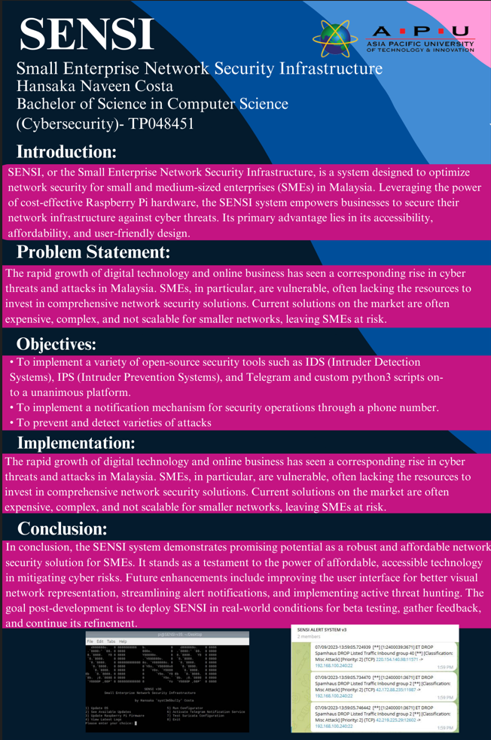

## **PPF**

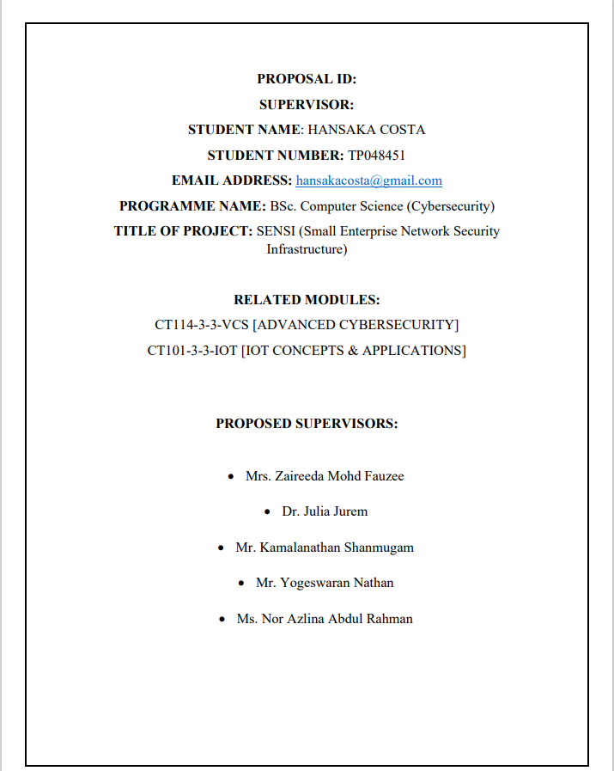

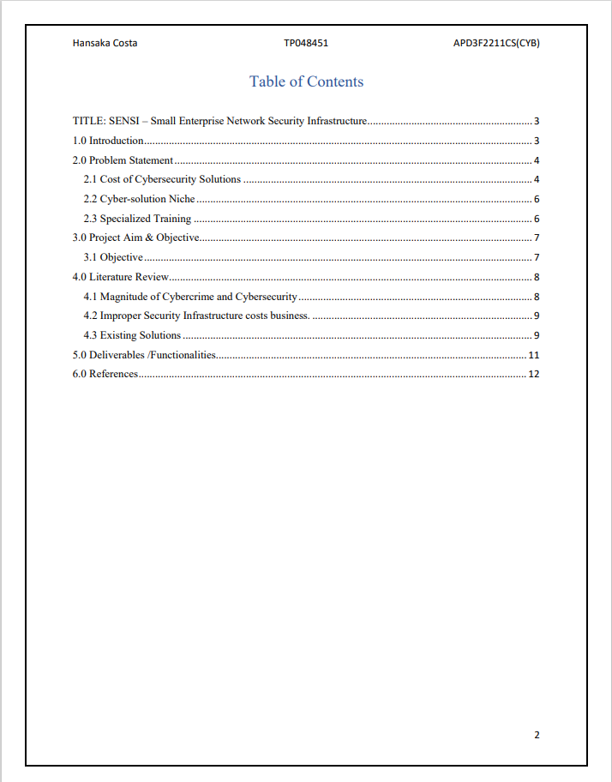

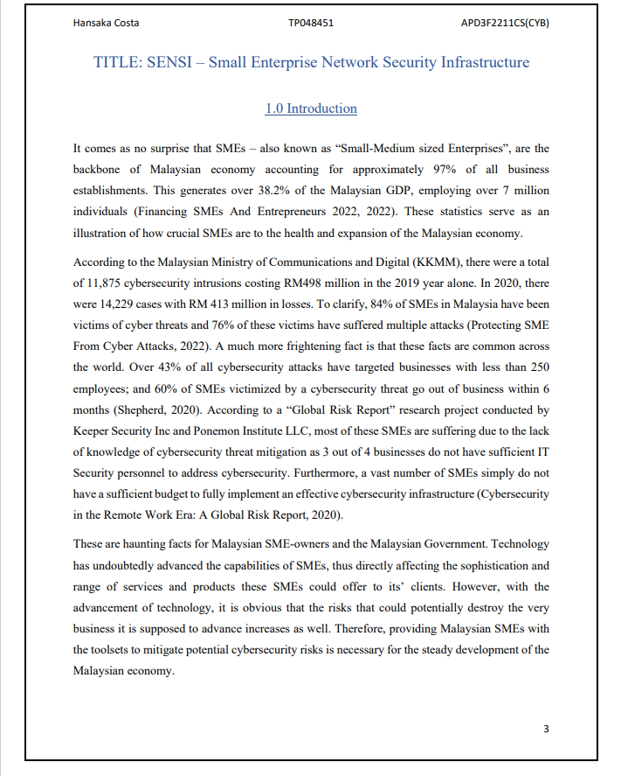

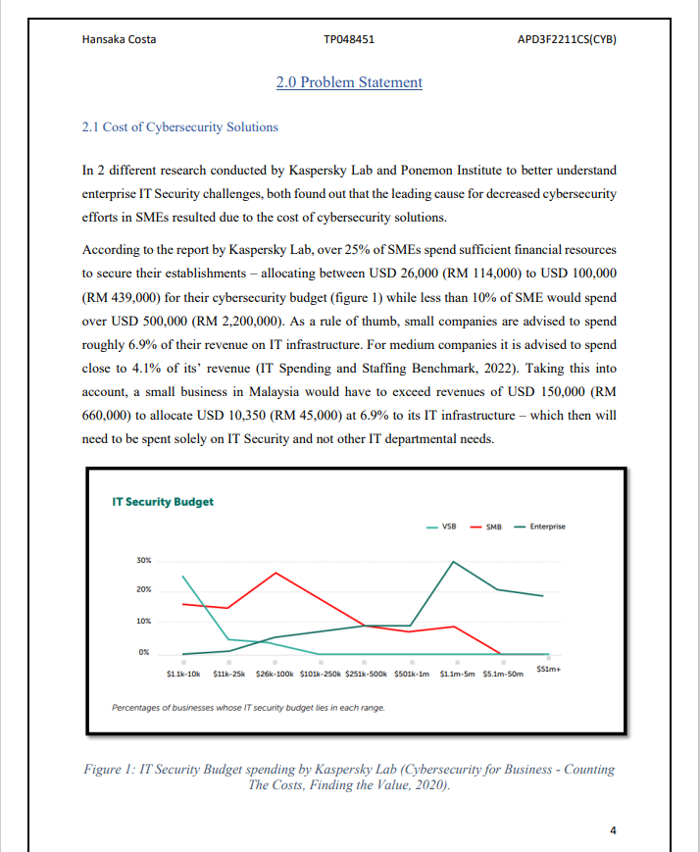

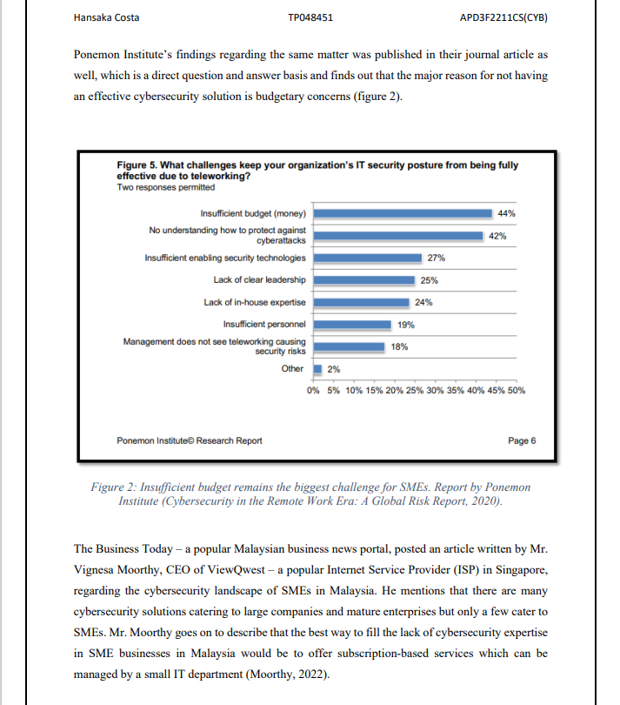

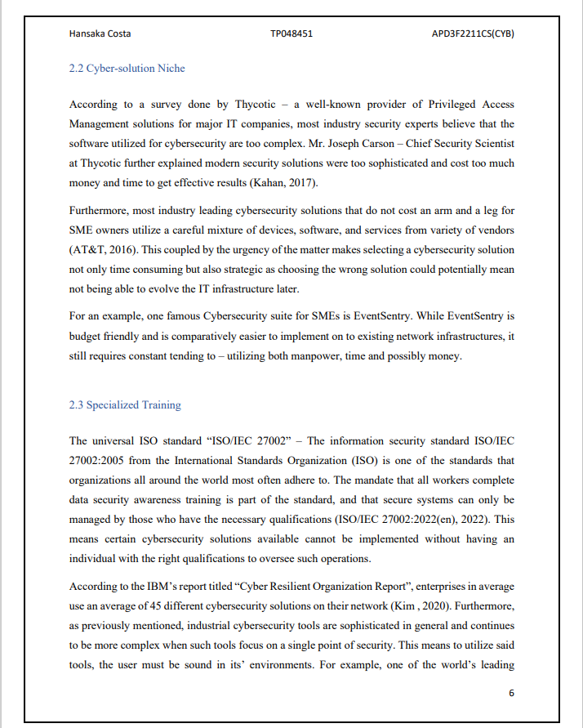

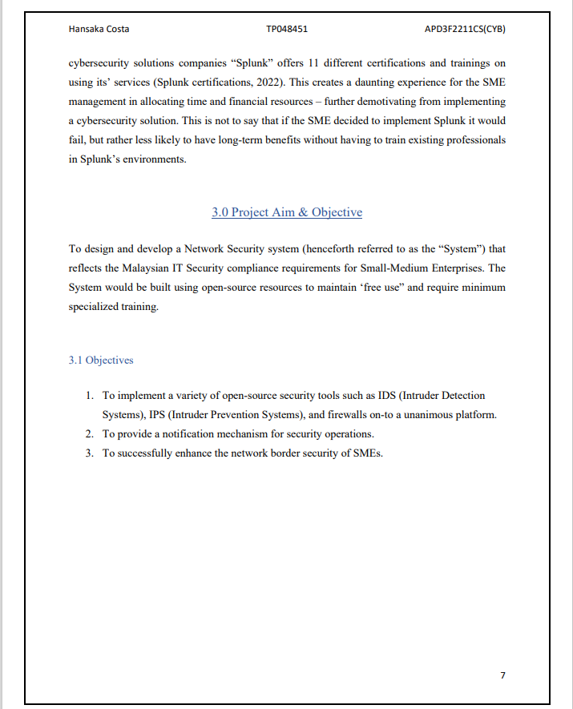



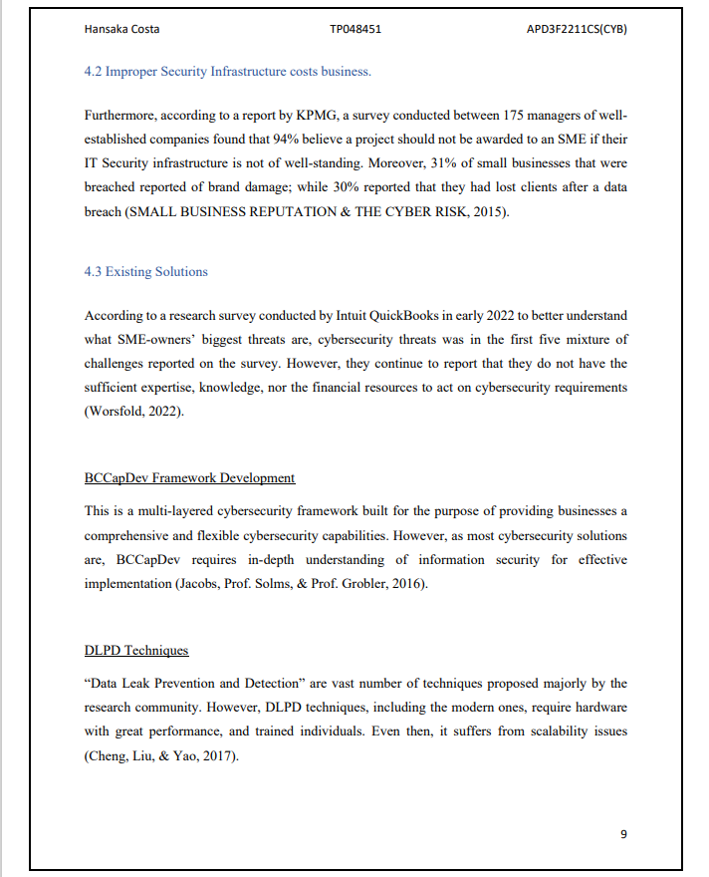

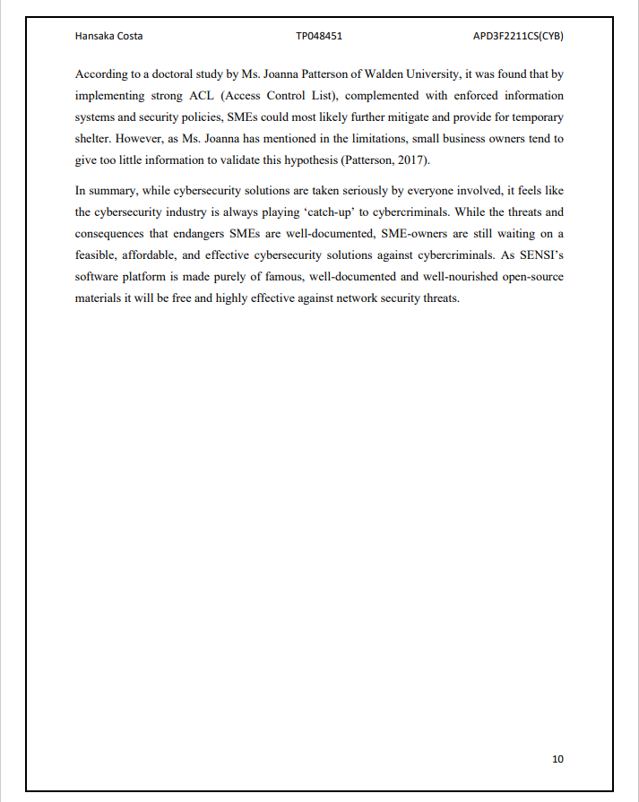

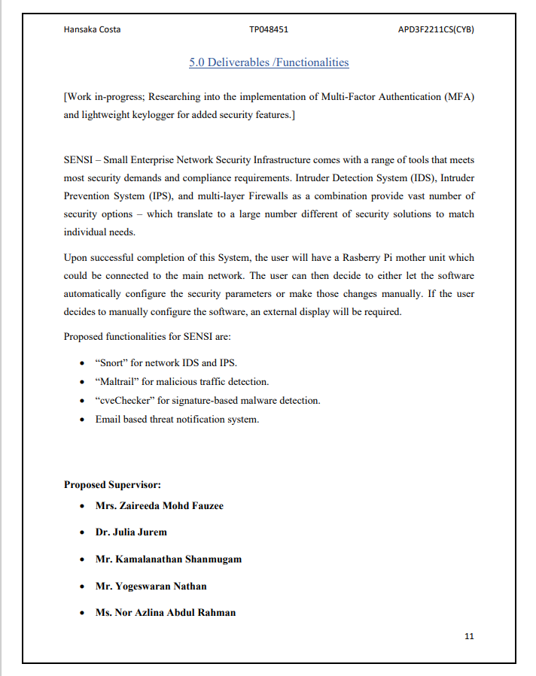

## **ETHICS FORM**







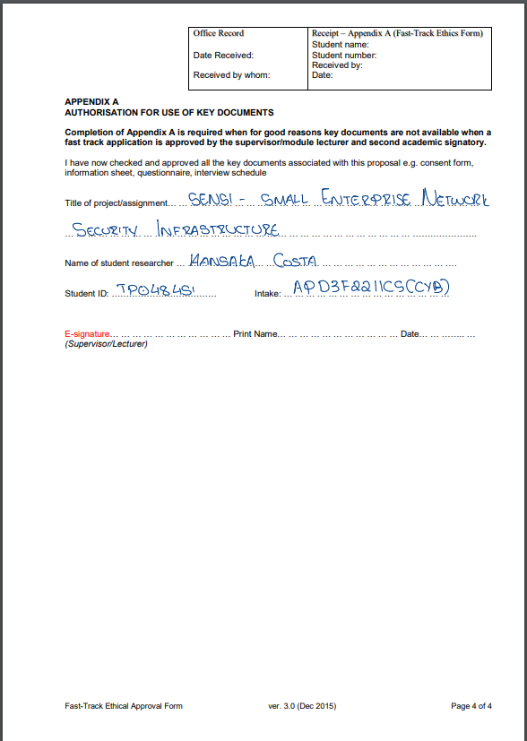

## **LOG SHEETS**

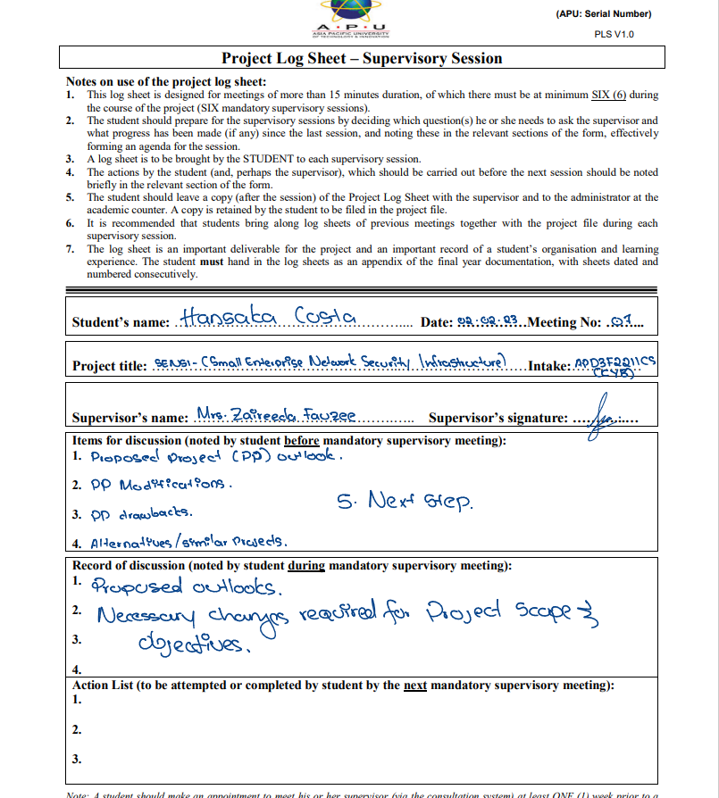





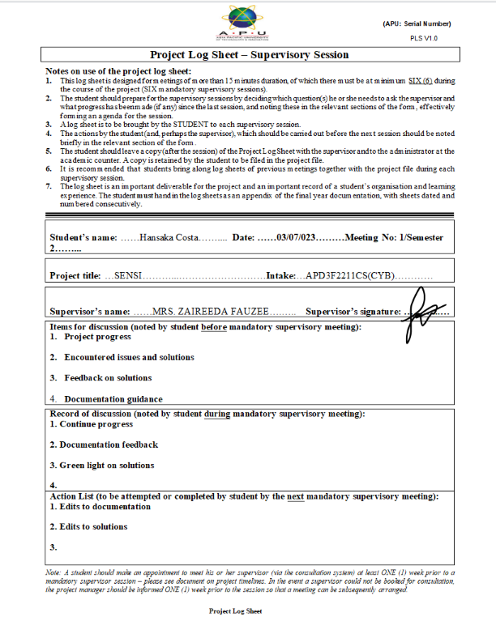





## **THESIS CONFIDENTIALITY**

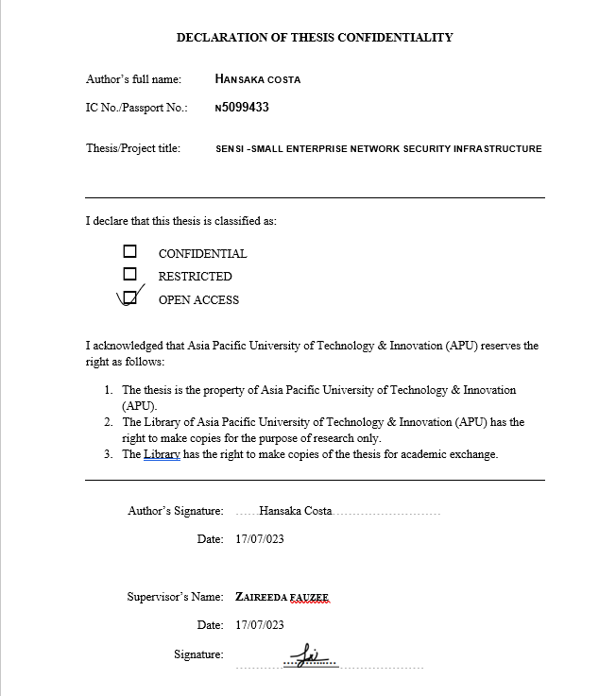

## **LIBRARY CATALOGUING FORM**

